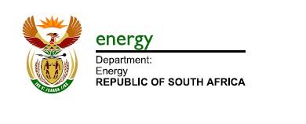




United Nations Development Programme
Annotated Project Document template for nationally implemented projects
financed by the GEF/LDCF/SCCF Trust Funds

Project title:
Leapfrogging South Africa’s markets to high-efficiency LED lighting and high efficiency distribution transformers
Country:  South Africa | Implementing Partner:  Department of Energy |  |  |  |  | Management Arrangement: National Implementation Modality (NIM)
UNDAF/Country Programme Outcome: Increase in the number of sustainable ‘green jobs’ created in the economy; Stabilisation and reduction of carbon emissions and climate change mitigation and adaptation strategies fully operational
UNDP Strategic Plan Output: Inclusive and sustainable solutions adopted to achieve increased energy efficiency
UNDP Social and Environmental Screening Category: Low risk |  |  | UNDP Gender Marker:  GEN1
Atlas Project ID (formerly Award ID): 00100653 |  |  | Atlas Output ID (formerly Project ID): 00096730
UNDP-GEF PIMS ID number: 5728 |  |  | GEF ID number: 9083
Planned start date: July 2019 |  |  | Planned end date: June 2023
PAC meeting date: TBD
Brief project description:
Electric appliances and equipment have become an essential part of the lives of practically all of South Africa. This includes lighting, which is used in all sectors, residential, commercial-productive, and in street lighting. Outside of the home and buildings, transformers deployed in Eskom’s and municipal electric distribution grids work around the country and around the clock. Large savings can be achieved through a global widespread shift from conventional lighting technologies like incandescent, halogen and fluorescent lamps to lighting products based on light-emitting diodes (LEDs). Regarding distribution transformers newer high-efficiency models are on the market that have lower energy losses. However, the transition to an economy using high-efficiency lighting and distribution transformers is hindered by the persistence of barriers and challenges that limit the market penetration of high-efficiency lighting and distribution transformers.
The Project aims to tackle these barriers by promoting an integrated approach, including appropriate regulatrory-legal instruments, such as mandatory minimum energy performance standards for LED and other lamps and distribution transformers, supplemented by energy and informative labelling for lighting products, including the administration of an effective monitoring, verification and enforcement systems. This will be supplemented by skills enhancement programmes, information dissemination and awareness campaigns that inform users (residential and municipal), lamp and equipment suppliers and intermediaries (finance, consulting). Financing support for investments by municipalities may help address the initial cost barrier by offering new financing modalities in addition to government grant funding (e.g. shared-savings transactions through energy service companies, ESCOs). Last, the Project will look at environmentally sound management, including the handling, collection and disposal of lamp waste (including mercury recovery from fluorescent lamps), and investigate the issues and option of replacing mineral oil by vegetable oil in liquid-immersed distribution transformers. The Project’s GEF-supported interventions are expected to lead to behavioural change and investment decision favouring energy-efficient technology in the country as a whole. Over time this is expected to contribute to expected energy savings in the order of 38 terawatt-hours over 2019-2023 with corresponding greenhouse gas emission avoidance of 35 million tonnes of carbon dioxide.

Financing Plan
GEF Trust Fund |  |  |  | USD 10,000,000
- Total Budget administered by UNDP |  |  |  | USD 5,000,000
(2) Total Budget administered by DBSA |  |  |  | USD 5,000,000
Parallel co-financing (all other co-financing that is not cash co-financing administered by UNDP)
DoE (grant and in-kind) |  |  |  | USD 42,650,000
UNDP (in-kind) |  |  |  | USD 600,000
UN Environment (in-kind) |  |  |  | USD 30,000
GELC (in-kind) |  |  |  | USD 150,000
DBSA (grant and in-kind) |  |  |  | USD 17,100,000
Eskom (in-kind) |  |  |  | USD 19,000,000
- Total co-financing |  |  |  | USD 79,530,000
- Grand-Total Project Financing (1)+(2) |  |  |  | USD 89,530,000
Signatures
Signature: print name below |  | Agreed by Government |  |  | Date/Month/Year:
Signature: print name below |  | Agreed by Implementing Partner (DOE) |  |  | Date/Month/Year:
Signature: print name below |  | Agreed by UNDP |  |  | Date/Month/Year:
Signature: print name below |  | Agreed by DBSA |  |  | Date/Month/Year:

Table of Contents

1. Table of Contents 3
List of boxes 5
List of acronyms and abbreviations 7
2. Development Challenge 10
2.1 Introduction 10
2.2 Problem analysis and the project’s objective 12
3. Strategy 18
4. Results and Partnerships 24
4.1 Expected results 24
4.2 Partnerships 34
4.3 Risk and assumptions 35
4.4 South-South and Triangular Cooperation (SSTrC): 37
4.5 Stakeholder engagement 37
4.6 Mainstreaming gender 38
4.7 Sustainability and scaling up 40
5. Project Management 42
5.1 Cost efficiency and effectiveness 42
5.2 Project management 43
6. Project Results Framework 45
7. Monitoring and Evaluation (M&E) Plan 50
8. Governance and management arrangements 54
9. Financial Planning and Management 56
10. Total UNDP Budget and Work Plan 58
11. Legal Context 62
12. Risk Management 62
Annexes
Annex A. Multi-Year Work Plan 65
Annex B. Consultancies and subcontracts 67
Annex C. terms of reference of PSC and project staff 70
Annex D. Gender analysis and action plan 75
D.1 Gender mainstreaming analysis 75
D.2 Gender action plan 79
Annex E. Report on baseline Conditions on Markets, Stakeholders, Policy and Regulations for LEDs and Distribution Transformers 83
E.1 Power sector and energy efficiency institutional-regulatory framework 83
E.2 The market for LED lighting in South Africa 92
E.3 Distribution transformers in South Africa 99
E.4 Waste management and recycling 102
E.5 Financing of energy efficiency and the market for energy services 103
E.6 Key consideration for the Project-supported Energy Efficiency Financial Instrument (EEFI) 114
Annex F. GEF CORE INDICATORS AND calculations of greenhouse gas emission reductions 119
Annex G. Stakeholder engagement and communication plan 128
Annex H. Additional budget and co-financing tables 131
Annex I. Social and environment screening report 133

List of boxes

Box 1 Electricity generation, South Africa 10
Box 2 Linkages of energy with the SDGs 12
Box 4 Overview of barriers and challenges 14
Box 3 Theory of change: development challenge, causes and expected results 17
Box 5 Theory of change: pathway from outcomes to impacts 20
Box 6 Proposed incremental activities that address barriers while supplementing baseline activities 21
Box 7 Monitoring, verification and enforcement (MVE) 26
Box 8 Energy Efficiency Financial Instrument (EEFI) to support LED and distribution transformer application 31
Box 9 Project risks, including impact and probability, and mitigation measures 35
Box 10 Role of stakeholders in the Project 37
Box 11 Summary of direct greenhouse gas emission reduction 43
Box 12 Mandatory GEF M&E requirements and M&E budget 53
Box 13 Project management and organization structure 54
Box 14 Cofinancing and sources 56
Box 15 Gender-related indicators and targets (from the project Results Framework) 79
Box 16 Gender and social inclusion action plan: a gender mainstreaming measurement tool 80
Box 17 Gender-aspects in Theory of Change 81
Box 18 South Africa, power generation capacity 83
Box 19 Historic and future Eskom price trajectories 84
Box 20 Historic Eskom tariffs 85
Box 21 Energy efficiency standards and labelling in South Africa 90
Box 17 Municipal revenues and expenditures 91
Box 23 Annual lamp sales in South Africa in 2016 (DoE study on residential lighting) 92
Box 24 Energy-efficient lighting: an overview 93
Box 25 Estimates of annual lamps sales and installed stock in 2014 94
Box 26 Lamp supply chain in South Africa 95
Box 27 Street lighting characteristics in South African cities 96
Box 28 Local production of LED street lighting luminaires 97
Box 29 Energy label, bulbs 97
Box 30 Promotion of street lighting 98
Box 31 Examples of transformers 99
Box 32 South Africa transformer benchmarking 99
Box 33 Efficiency, losses and transformers 100
Box 34 Government schemes for Eskom and municipal energy efficiency 105
Box 35 Energy Efficiency in Public Buildings and Infrastructure Programme (EEPBIP) 110
Box 36 Advantages and disadvantages of various financing models 113
Box 37 Transaction cost of grant-based vs. debt financing by EEFI 116
Box 38 Basic fund data and key indicators, EEFI 117
Box 39 Cash flow modelling 118
Box 37 South Africa – pathway to energy efficiency (U4E) 119
Box 38 Assumptions and base data calculations, HE transformers, energy savings and GHG reduction 120
Box 39 Assumptions and base data calculations, LED lighting, market share and prices (2017) 121
Box 39 Assumptions and base data calculations, LED lighting, energy consumption per device 122
Box 40 LED and other lamps stock South Africa - baseline and GEF alternative scenario 123
Box 41 Distribution transformers stock South Africa – baseline and GEF alternative scenario 124
Box 42 Peak power demand reduction and avoided mercury content 124
Box 43 Monetary savings due to replacement per type of lamp 125
Box 44 Potential energy savings and avoided emissions in South Africa in 2030 127

List of acronyms and abbreviations

ADAM Approach to Distribution Asset Management
ADF Agence Française de Développement
AMEU Association of Municipal Electric Utilities
CAPEX capital expenditure
CDR Combined Delivery Report
CEO Chief Executive Officer
CEO ER CEO Endorsement Request
CFL compact fluorescent lamp
CFU Carbon Finance Unit (of DBSA)
CO Country Office
COMESA Common Market for Eastern and Southern Africa
CPD Country Programme Document (UNDP)
CSIR Council for Scientific and Industrial Research
CSO civil society organisation
LFL linear fluorescent lamp
CO₂ carbon dioxide
DBSA Development Bank of Southern Africa
DEA Department of Environmental Affairs
DoE Department of Energy
DPE Department of Public Enterprises
DSM Demand-side management
DTI Department of Trade and Industry
EDIH Electricity Distribution Industry Holding Company
EE energy efficiency
EE-DSM energy efficiency and demand-side management
EEFI Energy Efficiency Financial Instrument
EEPIP Energy Efficiency in Public Buildings and Infrastructure Programme (V-NAMA)
EE S&L Market Transformation through Energy Efficiency Standards & Labelling of Appliances
EPC energy performance contracting
ESCO energy service company
e-WASA e-Waste Association of South Africa
FPIC Free Prior and Informed Consent
FSP full-sized project
GDP Gross domestic product
GEF Global Environment Facility
GEFSEC Global Environment Facility Secretariat
GHG greenhouse gas
GIZ Gesellschaft für Technische Zusammenarbeit
GWh Gigawatt-hour (billion watt-hours)
HE high efficiency
HID high-intensity discharge
HPS high-pressure sodium
IA Implementing Agency
IDC Industrial Development Corporation
IDM Integrated demand management
IEO Independent Evaluation Office (of UNDP)
IESSA Illumination Engineering Society of South Africa
INDC Intended Nationally Determined Contribution
K Kelvin (degrees)
kVA kilovolt-ampere
kWh kilowatt-hour
LoA Letter of Agreement
LED light-emitting diode
lm lumen
LSM Living Standard Measure
MEEDSM Municipal Energy Efficiency and Demand-side Management Programme
MEPS minimum energy performance standard
MFMA Municipal Financial Management Act
MSP medium-sized project
MTE mid-term review
MV mercury vapour
MVA megavolt-ampere
MVE monitoring, verification and enforcement
MW megawatt (million Watt)
MWh megawatt-hour (million Watt-hours)
NAMA Nationally Appropriate Mitigation Actions
NBI National Business Initiative
NCRS National Regulator for Compulsory Specifications
NEES National Energy Efficiency Strategy
NERSA National Energy Regulator of South Africa
NGO non-governmental organisation
NMISA National Metrology Institute of South Africa
NPD National Project Director
OPEX operational expenditure
PAC Project Appraisal Committee (UNDP)
PCB polychlorinated biphenyls
PIF Project Identification Form
PIR GEF Project Implementation Report
PJ petajoules (10¹⁵ Joules)
PM Project Manager
PMU Project Management Unit
POPP Programme and Operations Policies and Procedures
PPG Project Preparation Grant
PPP public-private partnership
PPPF Preferential Procurement Policy Framework
ProDoc project document
PSC Project Steering Committee
ROAR Results-Oriented Annual Reporting
RRMC Risk Reduction Management Centre
SABS South Africa Bureau of Standards
SACN South African Cities Network
SADC Southern African Development Community
SALGA South African Local Government Association
SANAS South Africa National Accreditation System
SANEDI South African National Development Institute
SAPP Southern African Power Pool
SDG Sustainable Development Goal
SOC Steering and Oversight Committee
TA technical assistance
TA Technical Advisor
tCO₂ ton of carbon dioxide
TE terminal evaluation
TWh terawatt-hour (trillion watt-hours)
U4E United for Energy
UN United Nations
UNDP United Nations Development Programme
UNEP United Nations Environment Programme (UN Environment)
USD United States dollar
V Volt
V-NAMA Vertical Nationally Appropriate Mitigation Actions
W Watt
WG Working Group
WOB women-owned business
ZAR Rand

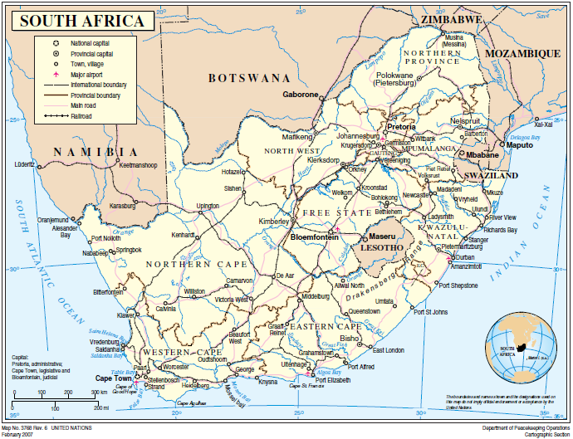

Development Challenge

Introduction

Context

Total electricity consumption in South Africa has hovered around 200 TWh a up to a total of about 208 in 2015, and is projected to grow further at about 2-3% percent annually. South Africa has one of the world’s highest grid emission factors – about 0.94 tonnes of CO₂ emitted per MWh of electricity consumed, because of its heavy reliance on coal, which accounts for about 92% of national domestic electricity production.

Box 1 Electricity consumption, South Africa
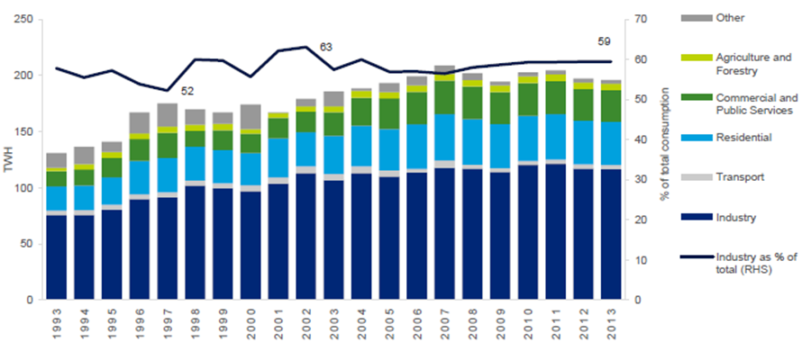

Source: STATS SA, taken from An overview of electricity consumption and pricing in South Africa
An analysis of the historical trends and policies, key issues and outlook in 2017 (Deloitte, Eskom, 2017)

Electric appliances and equipment have become an essential part of the lives of practically all of South Africa’s citizens – women and men, across all age categories, regions, and income levels. This includes lighting, which is used in all sectors, residential, commercial-productive, and in outdoor and street lighting. Lighting accounted for about 62 TWh of electricity consumption in 2016 (out of 240 TWh of electricity transmitted).

Outside of the home, electrical equipment deployed on a wide scale also has an inordinately high impact. There are about 660,000 distribution transformers deployed on the electric grid around the country, operating around the clock. Taken together, lighting and distribution transformers accounted for an estimated 72 TWh of electricity consumption in 2017, that is about 37% of the nation’s total and responsible for the emission of 67 million tCO_{2.}

For a more detailed description of the South Africa electricity sector is referred to Annex E.1, while a description of the status of lighting in South Africa is presented in Annex E.2, followed by a discussion on distribution transformers in Annex E.3.

Alignment with national priorities

The overall framework for energy efficiency is present in the form of policy documents, such as the National Energy Efficiency Strategy of (2005, reviewed in 2008) and the Post-2015 National Energy Efficiency Strategy (draft published in the Government Gazette in Dec 2016 for public comments, see Annex E), which aims for energy efficiency improvement by 2030 of 16% (using a baseline of 2015) to be achieved in a number of areas, buildings, appliance & equipment, lighting, transport, industry, energy utilities.

A number of national standards are relevant to the Project. The standard SANS 941 on Energy efficiency of electrical and electronic apparatus covers energy efficiency requirements, measurement methods and appropriate labelling of energy-efficient electrical and electronic apparatus. The Compulsory specification for energy efficiency and labelling of electrical and electronic apparatus (VC 9008) was enacted in 2014 and came into force in 2015, making the SANS 941 a compulsory standard. It requires that a range of electrical and electronic apparatus (dishwashers, washing machines, tumble dryers and/or washer-dryers, refrigerators and/or freezers, electric ovens, storage water heaters) adhere to certain minimum energy performance standards. It also requires that all appliances listed display the energy efficiency rating on the appliance. SANS 1544 Energy performance certificates for buildings specifies the methodology for calculating energy performance in existing buildings. It will initially be a voluntary standard but may become a mandatory standard through the NRCS regulation process (the regulations for the mandatory display of energy performance for buildings have been published). There are no energy performance standards on distribution transformers.

The National Environmental Management Waste Act (2008) has implications for e-waste management and makes it illegal for individuals or companies to send e-waste to landfills. DEA is considering to split the two categories, e-waste and lighting, and to be dealt with separate waste management plans. In November 2011 the National Waste Management Strategy (NWMS) was established to achieve the objects of the Act.

The National Development Plan (NDP) for South Africa provides a “2030 vision” to guide the country‟s development trajectory such that poverty is eliminated and inequalities are reduced by 2030. Furthermore, the NDP states that climate change is already having an impact on South Africa and recognises the need to ensure that society and the natural environment are protected from the adverse effects of climate change. South Africa aims to put in place a mitigation system, to realise the opportunities of a low-carbon economy while being mindful that a just transition requires time and careful development.

The mitigation component of South Africa’s Intended Nationally Determined Contributions (INDC) envisages five-year periods of implementation at the national level for policy instruments under development, including a carbon tax, desired emission reduction outcomes for sectors, and company-level carbon budgets. The aspiration in the long-term is that total annual GHG emissions will be in the range of 212 to 428 million tons of CO₂ by 2050, having declined in absolute terms from 2036 onwards.

Relevance to the SDGs

The National Sustainable Development Strategy has been integrated into the National Development Plan, which contributes to global Sustainable Development Goals (SDGs). The ‘transition towards a green economy’ is one of the priority areas mentioned. More specifically this priority area includes “economic growth and employment, while preventing environmental degradation and pollution”, with ‘clean energy and energy efficiency’ as one of its focus areas.

The 17 Sustainable Development Goals (SDGs) were adopted in 2015 by the international community, including South Africa, as part of the UN 2030 Agenda for Sustainable Development. Goal 7 specifically deals with sustainable energy and energy efficiency. It is also aligned with Goal 13 on climate action and its targets of integrating climate change measures into national policies, strategies and planning, and of improving education, awareness-raising and human and institutional capacity on climate change mitigation. In addition, there are various indirect linkages of sustainable energy with some of the other SDGs (number 8, 9, 11, and 12). Box 2 shows the relevant SDGs and how these are linked with energy-relevant low-carbon development

Relevance to GEF priorities
Box 2 Linkages of energy with the SDGs

Sustainable Development Goals | Linkage with energy efficiency
Sustainable energy
7.2 Increase substantially the share of renewable energy in the global energy mix  7.3 Double the global rate of improvement in energy efficiency | 7a. Enhance international cooperation to facilitate access to clean energy research and technologies, including renewable energy, energy efficiency, and advanced and cleaner fossil fuel technologies, and promote investment in energy infrastructure and clean energy technologies  7b. Expand infrastructure and upgrade technology for supplying modern and sustainable energy services for all in developing countries
Other SDGs:
8. Promote sustained, inclusive and sustainable economic growth, full and productive employment and decent work for all | Energy efficiency and conservation influence the country’s energy intensity and carbon content of economic growth
9. Build resilient infrastructure, promote inclusive and sustainable industrialization and foster innovation | Resilient infrastructure and public-private partnerships are required to ensure access to energy for all and to maximise energy efficiency
11. Make cities and human settlements inclusive, safe, resilient and sustainable | Municipalities require careful electricity planning and efficient power distribution
12. Ensure sustainable consumption and production patterns | The residential and buildings sector is a key part of a future in which there is sustainable consumption of energy and products
13. Take urgent action to combat climate change and its impacts | The carbon-intensive energy sector (based on fossil fuels) is a key driver of climate change.
Compiled from Transforming our World: the 2030 Agenda for Sustainable Development (UN, 2015), Indicators and a Monitoring Framework for the Sustainable Development Goals, Sustainable Development Solutions Network (SDSN)

The project falls within the GEF-6 programme area “Promote the timely development, demonstration, and financing of low-carbon technologies and mitigation options” (Programme 1) of the Climate Change focal area’s Objective #1 (CCM-1), “Promote Innovation, Technology Transfer, and Supportive Policies and Strategies”. Three Outcomes mentioned in the GEF-6 Results Framework (under Programme 1) are relevant, namely Outcome A (Accelerated adoption of innovative technologies and management practices for GHG emission reduction and carbon sequestration), Outcome B (Policy, planning and regulatory frameworks foster accelerated low GHG development and emissions mitigation), and Outcome C (Financial mechanisms to support GHG reductions are demonstrated and operationalized).

Problem analysis and the project’s objective

Currently, the world consumes consume 2,900 terawatt-hours (TWh) of electricity per year for lighting. Over the next two decades, lighting services are projected to rise by approximately 50% relative to current levels of demand. UN Environment has estimated that electricity demand for lighting can be reduced by 2030 to 2,160 TWh per year, saving up to 640 TWh of electricity and thus avoiding the emission of greenhouse gases of 390 million tons of CO₂ annually. These large savings can be achieved through a global widespread shift from conventional lighting technologies like incandescent, halogen and fluorescent lamps to lighting products based on light-emitting diodes (LEDs). There are multiple advantages of energy-efficient lighting for governments Energy-efficient lighting is usually the lowest life-cycle cost option. It reduces peak loading, lowers customer bills and reduces mercury (present in fluorescent lighting).

Transformers are static devices in electricity systems that transfer electrical power between circuits through electromagnetic induction. Their application enables significant energy savings in the power transmission and distribution system by increasing the voltage and decreasing the current, since losses are proportional to the amount of current flowing
through the wire. In 2017, all electric power transformers in service globally are estimated to have 1,100 TWh of losses. Although most transformers have efficiency levels greater than 98%, the energy consumed during a transformer’s service life (from 15 up to 40 years), operating almost non-stop, is the dominant factor contributing to the environmental impacts over its life cycle. Technical solutions to improve the energy efficiency of transformers are commercially available, and the market penetration of highly-efficient transformers has significant room for growth.

Development challenge

The development challenge, then, is to achieve this energy efficiency potential and curtail consumption of (coal-fired) electricity and associated global environmental impact from appliances and equipment.

Long-term solution

The long-term solution promoted in the Project is the more widespread use of high-efficiency lighting and distribution transformers) in South Africa.

LED lamps and luminaires are rapidly expanding into general illumination applications all over the world. As LED technology improves in performance and becomes less expensive, this market expansion will accelerate, replacing traditional light sources with more efficient and better performing LED technology. LEDs are highly energy efficient when measuring light output for watts of electricity input. In the market today, the most efficacious LED lamps operate at around 130 lumens per watt. This is much better than the energy performance of a CFL and over 10 times more efficient than an incandescent lamp. Annex E.2 provides more details comparing various type of lamps. As the technology continues to evolve in the coming years, efficacy will improve and costs decline. For countries choosing to phase-out incandescent lamps and jump straight to LED, the electricity savings for consumers will be more than 85 per cent, without compromising light quality and while enjoying much longer service life. LED lighting is becoming the standard EE technology when improving lighting energy performance and addressing environmental concerns. However, most of the existing stock and even new sales of lighting equipment in South Africa does not reflect the latest LED technology, which can be used to replace conventional compact and linear fluorescent lamps, halogen lamps and high-intensity discharge lamps. For an overview and background information of lighting in South Africa, the reader is referred to Annex E.2

Older distribution transformers can be replaced by newer high-efficiency models that have lower (load and no-load) energy losses. A transformer can be made more energy-efficient by improving the materials of construction (e.g. better-quality core steel or winding material) and by modifying the geometric configuration of the core and winding assemblies. The most common transformer is liquid-filled with windings that are insulated and cooled with a liquid. These transformers are most often used by electric utilities and can be found in all stages of the electricity network, from generation step up through transmission and distribution. They are usually filled with mineral oil. There is large scope or replacing this with vegetable oil. For more info on the context and overview of distribution transformers, the reader is referred to Annex E.3.

Barriers and challenges analysis

The transition to an economy with increased use of high-efficiency appliances and equipment is faced by substantial challenges and barriers. The core problem is that the persistence of barriers and challenges that limit the market penetration of high-efficiency lighting and distribution transformers. Addressing the core problem requires attention to the underlying root causes (posed by various challenges and barriers). The description of the project in the Child Project Concept, updated with the stakeholder input during the several project preparation mission by the PPG team of consultants in 2017 and 2018 and the stakeholder validation workshop in March 2019, facilitated identification of the main causes to address and underlying challenges (causes and barriers). These barriers and challenges are described in detail in Box 3, while a graphical overview is presented in Box 3 and explained below.

One main challenge (cause) is formed by limited planning and lack of mandatory standards and/or labelling system (existing for a number of household appliances, but not for lighting products or distribution transformers). A second main challenge is the weakness of market signals to consumers about the value of energy efficiency, which arises from a lack of awareness and information for residential users on energy-relevant characteristics (e.g., initial and lifetime benefits and costs of lamps, performance and quality of lamps). This is linked with the above-mentioned barrier of the absence of effective labelling (energy, information and/or endorsement) for consumers.

A major barrier is formed by insufficient human resources (with adequate technical EE and financial skills) and insufficient access to financial resources. Current government (national, municipal) financing alone cannot achieve a full transition towards higher efficiency LED lighting and distribution transformers. On the other hand, it is difficult to get (conventional) debt financing for a multitude of small EE investments, due to high transaction cost, and high-risk perception of small EE investments. New modalities, such as involving energy service companies (ESCOs) are still in their infancy.

Regarding, environmentally sound management, the issue of PCB-contaminated oil in transformers is being addressed. On the other hand, the recycling and waste separation if used lamps can be much improved, while the potential use of vegetable oil as a replacement for mineral oils has not been seriously investigated yet.

Box 3 Overview of barriers and challenges

Planning and regulations
- Lack of coherent and comprehensive data on energy performance and characteristics of lighting products (lamps) and distribution transformers
Lamp suppliers, customs, Department of Energy, municipalities all have some data on lighting products, but this is neither aggregated to a national level nor is there a consistent breakdown per type, size, capacity, energy, application, and sub-sectoral use. For example, a recent DoE study focusses on the residential sector, but does not cover commercial and public buildings and the industrial sector). Data exist at a local level, but for individual larger municipalities only. ESKOM will have data on distribution transformers, but these are not compiled in a readily available way. There is no consistent set of information on (the energy performance) of distribution transformers in municipalities. This paucity of information hampers design of policies and complicates the evaluation of results.

- Limited planning and regulatory instruments (S&L, and (mandatory) standards and/or labelling system in particular
There are no local compulsory local standards for LED lamps. A few products are certified against voluntary standards SANS 62560 and IEC 62560 applied by suppliers and specifiers. In the absence of a compulsory standard, LED lamps performance claims, lifespan and power-consumption, by opportunistic suppliers cannot be validated by buyers. Some products appear with the European (“CE”) mark as manufacturer’s claim to a certain quality standard. LED lamps are not regulated by the NRCS to carry out surveillance and compliance monitoring. Consequently, many low-quality LED lamps have entered the market. There is a black market of incandescent lamps; market research found that incandescent lamps for sale at only 8-10 Rand each.
Transformers have to meet the SANS 78O regulations, of which, however, the load and no-load loss specifications have not changed since the late 1960s. Transformers are prescribed by SANS 780 in its contracts with local transformer manufacturers, but municipalities may apply different standards.
There may be resistance from municipal distributors and transformer suppliers, regarding MEPS as these may be clashing with their own product specifications and fear MEPS/labels will be introduced without their involvement in the process.

Challenges for residential and commercial end-users
- Lack of awareness of and information for residential and other users on initial and lifetime benefits and costs of lamps and of performance and quality of lamps
The Eskom CFL roll-out programme started in 2005 with 64 million CFL lamps. Eskom directly procured these lamps, which were distributed for free and have mostly been delivered to the house and physically installed. Through the Eskom DSM lighting initiative CFL’s have become the standard lamps used currently in South Africa; the word CFL has become synonymous to ‘energy saving lamp’. LED lighting is still not commonplace in South Africa. The Eskom program focused on providing CFL lamps instead of LED due to the incipient technological development of LED lighting at that time. Low-income households were the main target group of the previous lighting replacement program from Eskom. It has helped the transition away from incandescent and halogen lamps. However, it has conditioned the (lower-income) residential users to the reception of “free” lamps and has decreased the economic benefit of transitioning to “expensive” LED lamps, even when LED prices are now approaching CFL prices. These households will replace their CFL lamp with LED lighting in the case of equipment failure, and not as retrofit of existing equipment.
A large part of the lighting installed in high/middle households consists of halogen spotlights. These households tend to buy higher-quality lamps sold in the main retail chains and in this range, LEDs are still relatively expensive. Some households are reverting back to halogens given their closeness to incandescent lamps because of people like their light quality (brightness) and because the lifecycle (and monetary and energy savings) are not fully understood by all. In fact, halogens are well suited for replacement by LED lamps, and achieve attractive payback periods (see Annex E).
In addition, due to the lack of regulation, cheaper LEDs are entering the market that gives the product a bad name. Given the broadening technical considerations applicable to LED lamps (different types of light bulbs, brands, technical standards, and price levels), consumers are often confused and conservative in their purchase decisions. Almost all LEDs on the market have a power factor of 0.5 and although this has no implications for end-users, it does have a significant impact on Eskom, especially now when there are supply shortages.
Challenges for municipalities and barriers to alternative financing modalities with ESCO involvement
- Current government (national, municipal) financing alone cannot achieve a full transition towards higher efficiency LED lighting and distribution transformers
Government grant programmes that benefit municipalities include the MEEDSM and Integrated National Electrification Program (administered by the Department of Energy), the Municipal Infrastructure Grant (administered by the Department of Cooperative Governance) and the Urban Settlements Development grant (administered by the National Treasury). These programs, in their current form, have been important, but not sufficient to realise a full transition towards higher efficiency LED lighting and distribution transformers. Their funding is often used to reduce the backlog of issues in the infrastructure. Low-resource municipalities are accustomed to sourcing a substantial part of their revenue from grants, and they will not realise energy efficiency projects without such grant funding or a clear financial benefit.
The Municipal Financial Management Act (MFMA) legislation gives substantial freedom to the municipalities on the management of their finances (for example, it does not set pre-defined limits to the amount of long-term debt that the municipalities may borrow). Their funding takes place as part of an integrated budget planning. Energy efficiency proposals will compete for funding from other capital expenditures presented by the various departments that may be more popular with the electorate. The decision of which project should be included in the budget is, therefore, a delicate balancing exercise between the various service provision mandates of the municipalities. In addition, municipalities carry out their procurements within the requirements set by National Treasury, i.e. official national-level procurement guidelines aim at ‘lowest cost’ rather than lifecycle or environmental considerations
Metropolitan municipalities have investment-grade ratings, facilitating their borrowing processes and achieving similar borrowing costs as those of the central government. However, debt financing for capital expenditure is typically part of the annual budget planning, and not for a specific project. The MFMA requires the municipalities to engage in a broad consultative process to engage in financial obligations that span for more than three years; this hinders realization of specific energy efficiency projects through a shared-savings ESCO model. Also, the MFMA does not have any provision for the allocation of financial liabilities to ESCOs.
Current trends in international financial accounting (e.g. IFRS 16) limit the situations in which organizations may record this type of projects off-balance sheet. This approach substantially limits the benefits of this model, as the projects would have to be approved through the capital expenditure process of the municipality and an associated long-term liability towards the ESCO would have to be recorded in its balance sheet. In other markets, these complexities have resulted in the issuance of a guidance note by the corresponding accounting authority (e.g. Eurostat in the European Union). The South African municipalities consulted have not received any guidance on the financial accounting of these projects. The result is that the benefit of this ESCO model for the larger and more technically capable municipalities is unclear at this point.
In the case of less technically capable municipalities, the utilization of a shared-savings ESCO model may still be beneficial, as it transfers the complexities of project engineering, procurement and construction to a specialized organization. More importantly, this model allows the utilization of private financing sources to fill the gap of public funding and achieve the transition towards higher efficiency LED lighting and efficient transformers. As a result, it has the full support of the Department of Energy. A portion of the EEFI funding will be made available to support this model through a credit guarantee mechanism for loans to qualifying ESCOs.
• Under-resourced municipalities do not have the resources (skilled staff, or financial) to prepare municipal EE strategies or sound and bankable EE investment plans
Apart from having low financial resources, smaller (often, rural) municipalities have limited internal staff capacity to formulate energy projects (e.g., the economic benefits of LED lighting and high-efficiency transformers may not be well understood) and to formulate procurement requirements for lighting and other technical equipment. They often rely heavily on external (consultancy) support and this has resulted, for example, in street lighting projects developed under the MEEDSM program with wildly varying costs and outcomes for rather similar equipment.
The metropolitan municipalities do have teams of competent technical staff that are able to perform the basic engineering design of such projects and prepare tenders for the supply and installation of equipment. However, the proposals often tend to be very technical and do not reach the financial analysis that would make them a “bankable project” for (development) finance institutions.
Local production of high-efficiency lighting and transformers
- Setting up production for new innovative products with local content (e.g. local LED lamp manufacturers or high-efficiency transformation) may be judged too high a risk
Companies interested in setting up production for new innovative products with local content (e.g. local LED product integrated lamp and luminaire for various applications) manufacturers or high-efficiency transformation face uncertainty on the market uptake. Lack of capital and short time thresholds for payback in updating production facilities - will continue to hamper investment by suppliers/manufacturers in LED lamps and in high-efficiency transformers. There is a need for staff skills enhancement and technical assistance support to local manufacturing industry and introduce new locally manufactured lamp-luminaire integrated LED products in the local market.

Environmentally sound management
- Insufficient recycling and waste separation of used lamps
Most lamps electronic materials and HID and fluorescent lamps contain hazardous materials (mercury). Recovered quantities and types of material is highly dependent on the market demand, price and industry organised collection, buy-back, and storage systems. Households may bring to recycle points at retail chains or waste and recycling service providers. However, informal sector salvaging, both at the street level, and at the landfill, constitutes the bulk of recycling activities in South Africa. Lamps end up with other waste on municipal waste disposal and landfill facilities. Many households in low-income or rural areas these often not ‘within walking distance of points of sale or retailers that can serve as a central location for collection. As a consequence, waste separation and formal recycling remain a concept foreign to many South African households.
- Vegetable oils and transformers
Most distribution transformers used in South Africa (about 80%) are of the liquid-immersed type that uses mineral oil for insulation. Vegetable-oil natural esters can be used in distribution transformers as insulating oil instead of mineral oils. Apart from its greenhouse reduction impact as a replacement for mineral oils, vegetable oils have the advantage that the transformer can be loaded at a higher rating and/or have an extended life. In addition, vegetable oils have better fire safety and reduced spread in spillage conditions. However, the use of vegetable oil has been proposed by Eskom, but not implemented.

Box 4 Theory of change: development challenge, causes and expected results

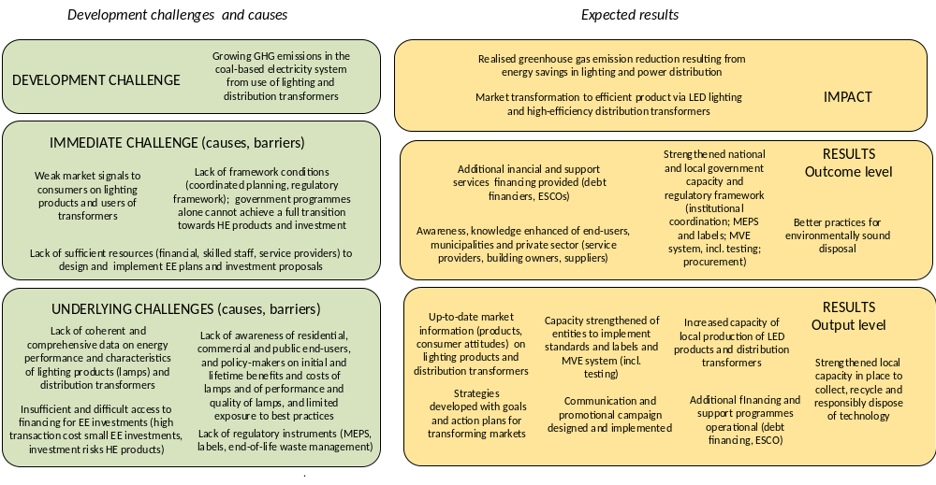

Strategy

Project objective

The previous Section discussed the linkages between the project objective by addressing the development challenge (and core problem) and its causes (gaps and barriers). The core problem underlying the above-mentioned development challenge and that the Project seeks to address is the persistence of barriers and challenges that limit the market penetration of HE lighting and distribution transformers.

Thus, the project’s objective is accelerating South Africa’s efforts to transition the economy to energy-efficient products, by a) developing South Africa’s market for LEDs on the electricity demand-side, and b) developing South Africa’s market for high-efficiency distribution transformers on the electricity supply-side, resulting in climate change mitigation, stable power supply and therefore economic development and improved energy access.

The project seeks to achieve this objective through integrated activities targeting these causes and barriers by achieving the following four outcomes that are grouped in three project components:

Component 1 Development of national strategy and regulatory mechanisms
- Strengthened government capacity and regulatory frameworks for LEDs and distribution transformers

Component 2 Support mechanisms to accelerate market penetration of LEDs and HE distribution transformers
- Awareness, knowledge and capacity enhanced of end-users, municipalities and private sector
- Financial support programmes designed and operational

Component 3 Environmentally sound management of lighting products and distribution transformers
- Environmentally sound management and waste disposal practices

The figure in Box 4 on the previous page summarises the theory of change of the project, showing the development challenge and underlying barriers and challenges. The figure shows the hierarchy of expected results of the project, from overall impacts, the above-mentioned outcomes, and individual outputs. Box 5 shows the dynamic aspects of the theory of change, i.e. how the various outcomes are linked and work over time to address the challenges in transforming the lighting and distribution markets to higher efficiency. The Project envisions an integrated approach that consists of the following main elements:
- Regulatory-legal instruments
Minimum energy performance standards (MEPS) cover a collection of requirements defining which products can be sold and those that should be blocked from the market. Energy labelling provides information on the energy (efficiency) rating. MEPS and labels help to transform the market in concert; MEPS define a new floor, pushing the entire market of products towards higher energy efficiency, while labels define a new performance target, pulling the market towards increased innovation. The mandatory implementation of standards and labelling (S&L) depends on effective MVE, monitoring (i.e. check product efficiency), verification (i.e. check declarations of performance), and enforcement (i.e. actions taken against non-compliant suppliers), including testing on the energy performance.
- Financial and support programmes
These are necessary to ensure a smoother implementation of standards and regulations, and to achieve a broad acceptance amongst users and suppliers. Supporting programmes include skills enhancement programmes, information and awareness campaigns that inform users, suppliers and intermediaries (finance, training, consulting) to change or modify their behaviour. Financial (and fiscal incentives) may help to address first-cost challenges in manufacturing and purchase of energy-efficient products. Financing may help address the initial cost by offering dedicated (government) funding and debt finance, accompanied with innovative modalities (e.g. shared-savings transactions through energy service companies, ESCOs).
- Environmentally sound management of lamps and transformers
Transformers already enjoy a high level of recycling due to the scrap metal value, but care should be taken to clean these if these contain polychlorinated biphenyls (PCBs) that are a hazardous substance. Fluorescent lamps contain small amounts of mercury (another hazardous substance). In general, the handling, collection of electric and electronic waste (e-waste) should be in accordance with global best practices (in particular when containing such hazardous substances).

The project has been designed to address specific underlying causes (barriers) of the development challenge, as articulated in the theory of change while reflecting both proven international practice and the baseline situation regarding energy efficiency policy implementation and baseline situation regarding energy efficiency and standards and labelling in South Africa. The baseline situation is described in detail in Annex E. For a discussion on gender-aspects in the theory of change, the reader is referred to Box 17 in Annex D and to the discussion on genders aspects in Section 4.6.

To address the barriers regarding lack of strategy, as well as the problem of insufficient knowledge, market information and awareness amongst decision-makers in decision-makers in national and local government and private sector and exposure to best practice, the Project will support:
- Capacity needs assessment of local manufacturers and suppliers and the needs assessment of institutions involved in the MVE system, including the capacity for photometric testing;
- Establishment of working groups of policy-makers, private sector representatives, and other stakeholders;
- Formulation of action plans developed with goals, strategy, work plan and key tasks of institutions involved;
- Deliver information on international best practice (in conjunction with U4E) and lessons learned (including from analogous GEF-supported projects on lighting and transformers)

To address the barrier of lack of regulations (MEPS and/or labels; procurement guidelines) the project will:
- Deliver technical assistance for the formulation of appropriate MEPS for lighting products and transformers and definition of energy performance categories for lamps, based on the existing EE label format;
- Support the strengthening of the existing MVE system linked with appliance standards and labelling to incorporate lighting technology and distribution transformers, including guidance to certification laboratories and organise their accreditation, and provide technical (and as needed, financial) support to properly equip test laboratories;

To address the challenge posed by insufficient information about the lighting and transformers market, the project will:
- Carry out a market assessment on demand and supply of lighting products in the various sectors and on distribution transformers, including consumer awareness and preferences and on current practices in municipalities (public buildings, public lighting, distribution system);
- Assess current practices and provide recommendations regarding collection, disposal, and recycling of distribution transformers and lighting products

To address the problem of lack of consumer awareness of energy performance of appliances and the issue of first-cost bias and weak market signals about the lifecycle value of EE lighting and transformers the Project will:
- Conduct public-relations outreach to residential and professional-commercial consumers about the energy performance of lighting and information campaign to municipal authorities.
- Build on and cooperate with ongoing initiatives undertaken by the Government (DoE’s MEEDSM and support for municipal power distribution; Eskom’s activities on integrated demand management and upgrading power distribution)
- Support lighting product (lamps, luminaires) suppliers and transformer manufacturers in preparing bankable proposals for the financing of upgrading or setting up production lines, as well as support local authorities and commercial building owners in formulating bankable proposals to the above-mentioned DoE and Eskom grant funds as well as for financing by development and other banks;
- Set up an Energy Efficiency Financial Instrument (EEFI) to provide partial grant financing and support new modalities for municipalities and energy service providers (credit guarantees for loans to ESCOs) and investment in EE production.

This all is envisioned to lead to a change of market and enabling framework conditions to create a market pull for energy-efficient lighting in the residential, commercial and public building sector and in public infrastructure. The policy/regulatory provisions are supposed to push the market towards a situation with low-entry barriers for energy efficient lighting and high-efficiency transformers. The desired behavioural change induced by this changed market situation includes increased mobilization of investments and financed by the private sector (suppliers, finance) as well as intensifying use of efficient lighting by consumers and energy-efficient public infrastructure (lighting, power distribution).

Various baseline activities are undertaken by South African government and private sector, supported by multilateral and bilateral organisations and donors that address the barriers and problems identified in the previous Chapter 2. The Project aims to build on past activities and closely cooperate with ongoing or planned baseline actions and only applies for GEF funding for incremental activities. A detailed description of the baseline situation is given in Annex E. The reader can find in Box 6 a summary of the baseline activities and how these, together with proposed incremental activities, address the barriers discussed in the previous Section (see Box 4). The incremental reasoning forms the basis for the definition of the Project’s outcomes and outputs that are presented in the next Section.

Box 5 Theory of change: pathway from outcomes to impacts

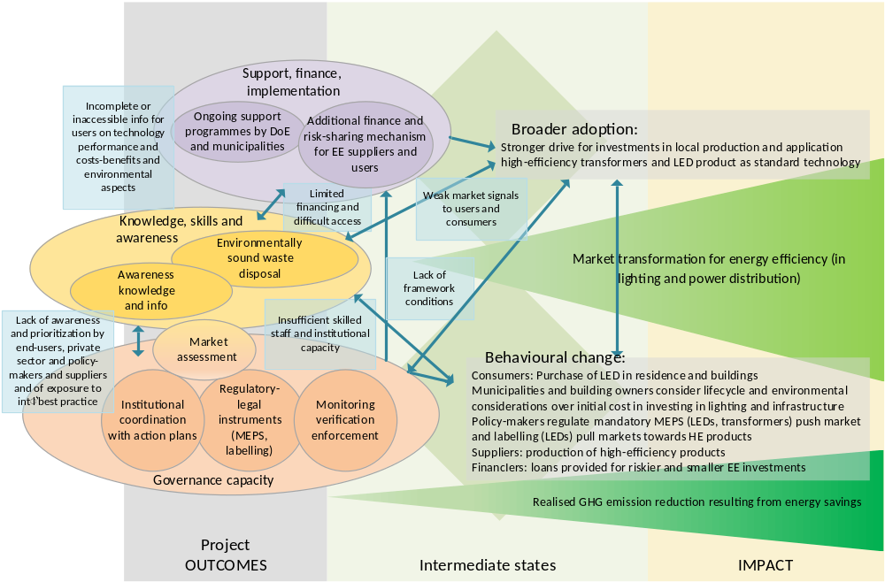
challenge/cause/barrier GEF project result progress towards impact impact influence/link
Box 6 Proposed incremental activities that address barriers while supplementing baseline activities

Planning and regulations

Barriers
- Lack of coherent and comprehensive data on energy performance and characteristics of lighting products (lamps) and distribution transformers
• Limited planning and regulatory instruments (S&L, and (mandatory) standards and/or labelling system in particular
Baseline activities  - The UNDP/GEF project on energy efficiency standards and labelling (EE S&L) in South Africa is developing a mandatory product registration database for appliances which must comply with MEPS (VC 9006 and 9008) to be managed by the NRCS. The Project will build on this activity and work together to expand the database with information on lighting products and distribution transformers  - For household appliances, mandatory labelling is already in place, and minimum energy performance standards (MEPS) have been introduced or are proposed for most of the major categories of appliances, as described in detail in the baseline report of Annex E. DTI/DoE have published A guide for energy efficiency labelling, that provides the basis for the voluntary labelling system in South Africa of electric appliances.  - The UNDP/GEF EE S&L Project is supporting DOE to undertake the following activities during 2018-19:  - Currently, there are two voluntary standards (safety and performance) in place for self-ballasted LEDs.. Neither cover energy performance requirements.  - Introduction of information and/or endorsement label as additional info to the customer alongside the existing energy label  - Info support (national awareness website; guideline and training material)  - The UNDP/GEF S&L project is supporting the capacity enhancement for appliance energy performance testing of selected laboratories as part of the MVE system. A few labs have obtained SANAS accreditation as a photometric test facility. | Incremental reasoning:  - A comprehensive national-level market baseline across the various lighting subsectors (residential buildings, public buildings, commercial and industrial; street lighting) will provide a snapshot of the products and their suppliers available in a market at a given point in time. This helps policy-makers to have a proper understanding of product availability, performance, pricing and other important factors influencing policy development. The same comprehensive baseline study to distribution transformers (type of transformer, size in kVA; numbers and capacity installed in Eskom and municipal networks; costs; suppliers)  - There is a need to develop and obtain industry agreement on a transparent, easy-to-understand LED labelling and mandatory MEPS for LED lamps as well. Expansion of MEPS to LEDs is greatly needed in order to ensure that consumers remain confident in the large savings potential that they offer. If MEPS and clear labelling are not implemented for LEDs, it is likely that poorly-performing products will continue to enter the market, while without labels consumers will continue to be misinformed on price-performance-energy consumption  - Although the government has initiated the process towards S&L of LEDs, it may take a long time to get agreement and to implement legislation and S&L for LEDs. Support by the proposed Project will speed up the process (e.g., through information dissemination, public-private sector meetings, workshops, technical studies, coordination meetings).  - Expanding SANS 780 with international-level no-load and load loss specifications and adherence to the improved standard will help the country in reducing energy losses in its power distribution system.  - Having a well-functioning MVE system is crucial for the effectiveness of a mandatory MEPS or labels regime for lighting and transformers. Elements of such a MVE system are a) pre-certification and product registry systems, b) verification and testing), c) market monitoring, and d) enforcement.  - Public procurement for infrastructure and buildings has to include lifecycle investment and operating cost considerations.

Municipalities, ESCOs and financing

Barriers
- Current government (national, municipal) financing alone cannot achieve a full transition towards higher efficiency LED lighting and distribution transformers
• Under-resourced municipalities do not have the resources (skilled staff, or financial) to prepare municipal EE strategies or sound and bankable EE investment plans with while regulatory frameworks are lacking
- Lacking regulatory frameworks on the financial accounting of ESCO contracts.
Baseline activities  - The V-NAMA project being developed by GIZ since 2011 is expected to be relaunched in 2019, providing technical assistance for project development and a risk- guarantee mechanism for the financing of ESCOs. The total funding for the program is EUR 20 million, of which part will be used to provide risk guarantees. On the request of the DoE, EEFI funding will also be available to support ESCOs under a similar modality.  - Under DOE’s Municipal EE-DSM (MEEDSM) programme, supported by GIZ selected municipalities receive grants for the planning and implementation of energy efficient technologies ranging from traffic and street lighting to energy-efficient technologies (incl. lighting) in buildings and water service infrastructure. By means of Calls for Proposals, municipalities can submit energy efficiency proposals. | Incremental reasoning:  - The DoE MEEDSM programme will continue with funding of about ZAR 200 million a year (ca. USD 15 million). This level of funding is not enough to cover all the potential demand by municipalities (only about 12% of municipalities receive MEEDSM support each year). In fact, larger municipalities with sufficient human resources have applied, while many under-resourced municipalities will not have the resources (skilled staff, or financial to hire external expertise) to prepare sound (bankable) proposals. Municipalities need additional financial support and technical advice (by longer- or shorter-term experts) to develop EE business/action plans (including secondment of staff for a limited period as energy efficiency advisor or expert)  - The funding allocation from all the infrastructure grant programs has resulted in that rural municipalities are accustomed to receiving grant funding for these projects and makes it difficult for non-grant programs to be developed. On the other hand, the financially stronger metropolitan municipalities receive relatively little grant funding for these purposes and the presence of competing capital expenditure projects has resulted in a small allocation of municipal budgets for LED lighting and efficient transformers. Municipalities in South Africa are typically risk-averse and have kept their debt within the limits of what is sustainable for the public finances (particularly the metros). The pure economic benefits of these technologies have not been sufficient to be deployed on a mass scale in the South African context. The proposed Project aims to support approval of these projects in the municipal budget process by two means: a) by stressing the additional benefits of these projects (increased road safety, reduced crime rates, improvement of commercial/tourist districts, improvement on electricity supply, are political selling points for municipal officials); b) encouraging the municipalities to invest in this infrastructure through favourable terms and conditions with blended finance. This financial support will be provided by EEFI. Due to the diverse nature of the municipal technical/financial situation, it will provide both partial grant-financing for self-developed projects, and a risk guarantee mechanism for qualifying loans provided to ESCOs.

Private sector end-users of lighting

Barriers
- Lack of awareness of and information for residential, and commercial-industrial users on initial and lifetime benefits and costs of lamps and of performance and quality of lamps
- High transaction costs associated with setting up the financing of a relatively small EE projects
Baseline activities  - The UNDP/GEF EE S&L project has developed and implemented during 2017-2018 a communication campaign towards manufacturers, importers, distributors, retailers, and consumers about appliance energy efficiency while carrying out a trial and awareness programme on LEDs in Gauteng area. Increasingly suppliers realise that moving customers to the higher-end LED lamps requires a better consumer education and guidance on the energy savings aspect.  - ESKOM is currently facing serious financial and structural challenges, which are not expected to be overcome in the short term. The underlying reasons for the continuation of the lighting (CFL) exchange program by ESKOM DSM (now IDM) are not currently present in the market, and the CFL roll-out programme has been terminated. It is not foreseen that ESKOM will relaunch this program with LED technology lighting.  - In the case of commercial and industrial buildings, several financial institutions have dedicated funding available for energy efficiency programs. Deployment of funds has been nonetheless slow due to the high transaction costs associated with the small size of these investments. Finance products that have been made available in the past have not always been most appropriate for the energy efficiency market, i.e. many energy efficiency opportunities are small in size and banks are often targeting larger sized projects within larger organisations  - Many end-users may not have the internal capacity for energy efficiency projects, thus creating opportunities for ESCO interventions. | Incremental reasoning:  - Continuing consumer education is needed targeting residential as well as corporate (public and private) users on the cost and lifetime benefits of switching to LED lighting. Consumers need to be informed on the interpretation of energy labelling.  - Accelerated market penetration of quality LEDs at low prices can be achieved through the development of an LED mass-procurement program and its integration with existing energy programs of the municipalities and/or lighting retailers. Depending on the success of the program this may be expanded to the commercial and industrial sectors through project preparation and financing support;  - The key to reducing financial transaction costs for small energy efficiency projects is offering financial products that are most appropriate for the energy efficiency market, for example, by aggregating projects through ESCOs, or financing through a lower default instrument, such as on-bill financing.

Environmentally sound management

Barriers
- Insufficient recycling and waste separation of used lamps
• Use of environmentally friendly oils in transformers not considered
Baseline activities  - About 100 million CFLs are installed in residential and other buildings and Eskom and retail chains organise collection of lamps. In South Africa, a number of companies collect and/or recycle various types of lamps and separate into fractions, including the recovery of mercury.  - Worldwide, vegetable-oil natural esters are increasingly being used in distribution transformers as insulating oil. One proposal being discussed at Eskom is for new contracts on transformers to aim for a percentage using vegetable oil. Environmentally sound management and disposal of PCBs is subject of a GEF proposal currently under preparation by DBSA and which will include the issue of PCBs in transformers | Incremental reasoning:  - The effective collection of CFLs (and other lamps) rely heavily on a comprehensive education campaign as the current levels of awareness relating to all waste matters regarding recycling is very low and recycling will be part of the awareness campaign;  - A detailed assessment of the use of vegetable oil for transformers, current production of suitable (recycled) vegetable oil type and costs, and techno-economic assessment of upgrading current manufacturing facilities to produce vegetable-oil-based transformers.

Global programme

This project is one of several “child projects” of a global United for Energy (U4E) program, funded by the GEF, entitled Leapfrogging Markets to High Efficiency Products (Appliances, Including Lighting, and Electrical Equipment). The project taps U4E’s core strengths – its global network of experts, private-sector collaborators, and compiled best practices – in policy and program development as well as quantitative assessment. The initiative (see www.u4e.org) proposes an integrated approach to achieving market transformation consisting of a) supporting policies, b) standards and regulations, c) monitoring, verification, and enforcement, d) financing and financial delivery mechanisms, and e) environmentally sound management. Various country initiatives (including South Africa) are linked with the global programme.

Results and Partnerships

Expected results

This Section describes in detail activities under each output of the three components of the Project and which GEF Agency is responsible for which Outcome. For a description of partner organisations, the reader is referred to Section 4.4 and Annex E.1.

Component 1 Development of national strategy and regulatory mechanisms

Output | Activity
Outcome 1 Strengthened government capacity and regulatory frameworks for LEDs and distribution transformers
1.1 National coordination, assessment and strategy realised | 1.1.1 Market assessments implemented on lighting products and distribution transformers  1.1.2 Establishment of working groups on lighting products and distribution transformers  1.1.3 Strategies and action plans developed for HE lighting and HE distribution transformers
1.1 National coordination, assessment and strategy realised | Main partner: DOE, DTI, DEA, NERSA, Eskom, DPE, CoGTA, UNEP-U4E  Other partners: AMEU, SALGA (municipalities), IESSA, Manufacturer/supplier associations or organisations; SANEDI
1.2 S&L and MVE system developed for LED lighting and distribution transformers | 1.2.1 Proposals for (mandatory) labelling and MEPS (S&L) for lighting and MVE system  1.2.2 Proposal for setting up MEPS/regulations and MVE system for distribution transformers  1.2.3 Capacity strengthening and stakeholder engagement on standards and labelling
Main partners: DOE, DTI; SANEDI, NRCS, NERSA, SABS, DPE, Treasury
Other partners: Manufacturer/suppliers and associations or organisations; Customs, AMEU, IESSA; UNEP-U4E
1.3 Strengthened capacity of testing labs and testing of products | 1.3.1 Assessment of capacity needed to do photometric test (lighting) and transformers in accredited facilities  1.3.2 Provide assistance to upgrade testing facilities and support accreditation  1.3.3 Testing of selected products carried out and publication of results
Main partners: SABS, SANAS, NMISA
Other partners: IIESA, Manufacturer/suppliers and associations or organisations
Responsible GEF Implementing agency: UNDP

The following paragraphs describe the Activities that will be conducted to deliver the expected Outputs to contribute to realization of Outcome 1.

Output 1.1 National coordination, assessment and strategy realised

Activity 1.1.1 Market assessments and databases implemented on lighting products and distribution transformers
The Project will undertake its own market assessment of existing lamp stocks (installed lamps in residential, commercial and public buildings as well as in street and outdoor lighting), trends in the purchase and operation of lighting products for the various subsectors, distinguishing between various lamp wattages and type of lamps (incandescent, fluorescent, HID, etc.), together with a description of the supply chain (retail channels, prices, most commonly sold products; quality of the products). A key element will be an assessment of consumer knowledge, priorities regarding lighting products, using various methodological approaches (focus groups, surveys) and generating gender-relevant data. The U4E partners (Philips, Osram, other) provide market intelligence (e.g. data) on lighting products and Eskom on distribution transformers. Similarly, a market study on distribution transformers will be carried out (installed transformers technology, type, size, and losses; costs) at Eskom and municipalities, including sales by manufacturers and suppliers.
The activity will be complemented by setting up a nation-wide database on sales and efficiencies of LEDs and other lamps) and one for distribution transformers (indicating type, capacity and no-load and load losses). The database will be tracking tool of products for enforcement of MEPS and can also serve as a source of information to consumers, vendors, and suppliers about what products comply with MEPS. The UNDP/GEF project on energy efficiency standards and labelling (EE S&L) in South Africa is developing a register of products that comply with national MEPS and labelling requirements (see Box 21, Annex E), managed by SABS. The Project will build on this activity and work together to expand the database with information on lighting products and distribution transformers.

Activity 1.1.2 Establishment of working groups on lighting products and distribution transformers
There are ongoing interdepartmental efforts (DOE, DTI, SABS, NCRS, NERSA) to design market transformation programmes (including minimum standards and labelling) for appliances covered by the current (mandatory) standards and labelling scheme. The Project will help to extend such cooperation efforts to include lighting and distribution transformers and to include private sector and stakeholders in these areas, by setting up Working Groups on LED and Lighting and, on Efficient Transformers and Distribution, and on Financing. Apart from the government department and agencies involved, the WGs will have representatives from local government (municipalities), Eskom, development banks (e.g. DBSA, IDC) and private sector (suppliers and manufacturers, consultancy and service providers, financial intermediaries) and NGOs (consumer organisations, green building associations).

Activity 1.1.3 Strategies and action plans developed for HE lighting and HE distribution transformers
The strategies will provide the overall framework by defining the scope, product ranges in focus, and the overall goals of South Africa, one for LED and lighting and one for high-efficiency distribution transformers. The strategies will be based on a review of existing policy-regulatory framework and experiences with appliance S&L in South Africa, and taking stock of current electricity use and market assessments (see Output 1.1). The result will be a set of recommended possible scenarios with action plans (roadmaps) for the faster market introduction of LED lighting and high-efficiency distribution transformers with benchmarks that are based on international best practices. The action plans will include a selection of the preferred scenario and will be accompanied by recommendations for improved regulations and incentives for energy efficient lighting and transformers, including possible financial support mechanisms and a timeline for the introduction of regulations regarding energy efficiency. Stakeholders will be engaged through the Working Groups (see Activity 1.1.2) and by regular meetings and training seminars to achieve consensus by policy-makers and stakeholders.
Another activity will ensure that the Project’s activities are implemented within the regional context provided by the Southern African Power Pool (SAPP), the Southern African Development Community (SADC) and the Common Market for Eastern and Southern Africa (COMESA) by means of regular meetings (to achieve consensus by policy-makers and stakeholders) and participation in international events and lighting fairs and in regional meetings on alignment of standards and cooperation.

Output 1.2 MEPS and MVE system developed for LED lighting and distribution transformers

Activity 1.2.1 Proposals for (mandatory) labelling and MEPS for lighting and MVE system
A common system of labelling is needed for lamps that clearly represents the performance of the lamp, such as light output, efficiency, lifespan, and colour rendering, and the system has to be translated into user-friendly and helpful product packaging and labelling. This has been done by the UNDP/GEF S&L Project for the residential sector but can be extended to the commercial and public sector. The Project will help energy classes and required lamp energy performance on labels and MEPS thresholds that are technologically feasible and economically and environmentally acceptable in and define EE labelling specifications for LEDs (building on the label introduction activities of DOE, supported by the UNDP/GEF EE S&L Project). The market study of Output 1.1 will provide the sales and market data necessary, building on market assessments (in residential sector) done under the UNDP/GEF S&L Project. Further engineering analysis and impact study of the introduction of MEPS and labels, will provide the info necessary to place products in the appropriate category in the A-E labelling system and define the MEPS threshold. The activities will promote regional alignment on standards and labelling for LED and other lamp types (SADC, COMESA).
The Project will continue the activities undertaken by the UNDP/GEF S&L Project of supporting DOE in information labels in addition to the existing energy label. These could be information labels at retail stores at the lighting product shelves that provide comparative info between various type of lamps (incandescent, halogen, CFL, LED) on light output (lumens and colour rendering), life expectancy (duration in hours of operation), energy usage, and cost indication. Another option is an endorsement label, indicating that the product is endorsed by DOE.
Having a well-functioning MVE system is crucial for the effectiveness of such a mandatory S&L regime. Elements of such a MVE system are a) market baseline and assessments (see Activity 1.1.1), b) pre-certification and product registry systems, c) market monitoring, verification and test laboratories (see Output 1.3), and d) enforcement. Conformance to the MEPS, guidelines and/or labels will need to be enforced through monitoring and enforcement similar to the MVE system for household appliances. Based on the results and experiences of the EE S&L project, a review will be carried out on issues and options in MVE system with respect to lighting products. Based on the review, the Project will provide advice and assistance to DOE, DTI, and agencies on setting the definition the regulations and administration model of the MVE system (see Box 5).

Activity 1.2.2 Proposal for setting up MEPS/regulations and MVE system for distribution transformers
Guided by the market assessment of Output 1.1, the Project will conduct an engineering analysis and impact study of the introduction of MEPS (accompanied with practical procurement guidelines for municipalities) for transformers with low no-load and load losses. Eskom has developed an in-house efficiency and performance standard for distribution transformers, which is not formally endorsed yet. These activities will form the basis for formulating the Minimum Energy Performance Standard (MEPS) for the country, not only to be followed by Eskom but by the municipal utilities as well. The MEPS might be based on voluntary agreements between the electricity companies and the government or as part of a mandatory regulatory and control framework.
Box 7 Monitoring, verification and enforcement (MVE)

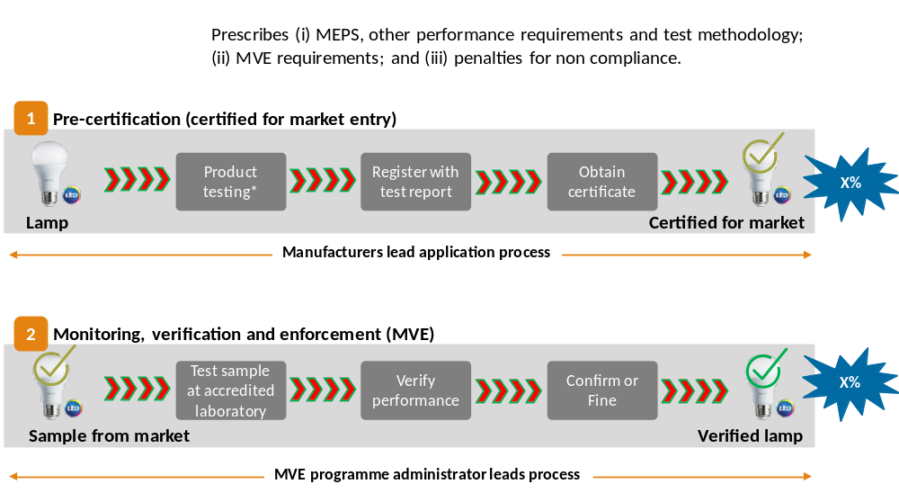
Source: Standards and labelling programme: Efficient lighting component, PowerPoint by DoE (February 2018)

Activity 1.2.3 Capacity strengthening and stakeholder engagement on standards and labelling
The Project will support stakeholder and capacity enhancement by means of workshops and technical training (on trends in LED technology and applications, high-efficiency transformers and international best practice; MEPS and labelling programmes, design and implementation of MVE mechanisms.
The Project will capitalize on the efforts processes that have already been established in South Africa, incorporating the international experiences in other regions, to further expand the scope of MEPS in South Africa to these two products. The U4E partners (e.g. U4E Centre of Excellence) will make available training packages and tools on lighting products and training for government officials and private sector representatives. A public consultation process will be required to engage industry stakeholders regarding the proposed MEPS (see Output 1.1). The benefit of drawing on international experience includes using material that had already benefitted from stakeholder consultations in other countries. In addition, the Project and its U4E partners will support bundling the lessons learned, technology-neutral lifecycle cost considerations, guidelines, manuals into a harmonised set of guidelines and/or made these and/or their weblinks available on the Project/DoE website.

Output 1.3 Strengthened capacity of testing labs and testing of products

Activity 1.3.1 Assessment of capacity needed to do photometric test (lighting) and transformers in accredited facilities
The Project will carry out an assessment of capacity needed to do photometric test for energy requirements in accredited facilities (status, expected volume of lamps) with recommendations for next steps to get the required accreditation (including Project technical assistance to be provided in Activity 1.3.2). Similarly, the Project will do an assessment of capacity needed to do transformer testing by independent labs for energy requirements in accredited facilities (e.g. looking at status and capacity, accreditations, expected annual volume of lamps to be tested).

Activity 1.3.2 Provide assistance to upgrade testing facilities and support accreditation
The Project will provide assistance to strengthen testing facilities (e.g., basic equipment; participation in international training/workshops; visit of staff to state-of-the-art lighting test labs and learning-by-doing). The Project will work to achieve accreditation of testing facilities and enforcement institutions and to get accreditation for lighting and transformer testing.
For a test laboratory to become part of the international accreditation network (headed by ILAC) thereby gaining international recognition for their testing methods and associated test reports, the laboratory will need to obtain accreditation from the national accreditation body (SANAS in South Africa) for each of the desired test methods and demonstrate their compliance with ISO17025 “General requirements for the competence of testing and calibration laboratories”. The project will ensure South Africa has a well-functioning system of SANAS-accredited photometric testing facilities for LEDs. The U4E partner GELC (Global Efficient Lighting Centre; China) can provide technical expertise and training on developing and operating a lighting test laboratory. A similar approach can be followed for testing of transformers.

Activity 1.3.3 Testing of selected products carried out and publication of results
The Project will support the MVE agencies involved with testing of a sample of products carried out and reporting with the establishment of a product registry and communication through a web portal (see Activity 1.1) on compliant products.

Component 2 Support mechanisms to accelerate market penetration of LEDs and HE distribution transformers

Output | Activity
Outcome 2 Awareness, knowledge and capacity enhanced of end-users, municipalities and private sector
2.1 Communication and promotional campaign designed and implemented | 2.1.1 Development and implementation of a gender-sensitive campaign for households and businesses on efficient lighting and waste disposal  2.1.2 Capacity strengthening of staff of retailers and wholesalers on EE lighting promotion  2.1.3 Capacity strengthening of (commercial) building owners and ESCOs
Main partner: DoE, DEA
Other partners: selected municipalities, SALGA, wholesale and retail chains,
Manufacturer/suppliers and associations or organisations
2.2 Capacity strengthened of municipalities to formulate EE programmes | 2.2.1 Capacity and knowledge strengthening of municipal staff and decision-makers  2.2.2 Technical assistance support to develop municipal energy efficiency planning
Main partners: DoE
Other partners: selected municipalities, SALGA, AMEU; SACN
2.3 Increased capacity for local production of LED products and distribution transformers | 2.3.1 Technical support for manufacturers of local LED products  2.3.2 Technical support to suppliers to manufacture high-efficiency distribution transformers
Main partners: DoE, DTI
Other partners: IIESA, NBI, chambers of commerce and industry
Responsible GEF agency: UNDP

Output 2.1 Communication and promotional campaign designed and implemented

Activity 2.1.1 Development and implementation of a gender-sensitive campaign for households and businesses on efficient lighting and waste disposal
Building on the awareness creation efforts carried by DOE with the support of the S&L Project on energy-efficient appliances, and taking into account is lessons learned and experience, the Project continues with awareness and knowledge campaigning focussing on lighting (for residential and commercial lamp users), which will be gender-sensitive and tailored to different groups of end-users. The campaign will stress energy and cost savings of different types of lamps and environmentally sound disposal. It is envisaged hat DOE works with municipalities, SALGA, NGOs. The Project support will be for campaign design and materials, flyers/pamphlets and mass media advertisements to be supplemented by private sector activities (retailer displays, special offers, multiple lamps pack offers). Accompanying the campaign, the Project will support bundling the lessons learned, guidelines, manuals into a harmonised set of guides for municipalities and/or made these and/or their weblinks available on the existing Project/DoE website (www.savingenergy.org.za).

Activity 2.1.2 Capacity strengthening of staff of retailers, wholesalers on EE lighting promotion
The campaign will be carried out in cooperation with wholesalers and retailers to realise a rapid uptake of LEDs. This includes a nation-wide training program (with seminars and on-the-job support) for distributor and retailer sales staff, focusing on the sales of LED products. This will take into account lessons from the trial run with a major retailer carried out by the UNDP/GEF EE S&L Project (in Gauteng area) in 2018/19.

Activity 2.1.3 Capacity enhancement of private sector entities and energy service providers (ESCOs)
The Project will support increasing the knowledge of commercial buildings owners and energy service providers on energy efficiency opportunities (on high-efficiency lighting in particular) and the role of energy efficiency financing (loans, grants, PPP, performance contracting) and regulations. For ESCOs, financing modalities in working with the public sector will be discussed and explained.

Output 2.2 Capacity strengthened of municipalities to formulate EE programmes

Activity 2.2.1 Capacity and knowledge strengthening of municipal staff and decision-makers
The Project will support awareness creation in seminars and technical capacity enhancement in special workshops for municipal staff (technical and decision-making) that work on public infrastructure, public building and municipal power distribution on the role of LED lighting in public building and street lighting. This will be accompanied by technology information sheets, procurement guidelines and training material for municipal staff. Similarly, information and know-how packages on distribution transformers for municipal staff and utilities.

Activity 2.2.2 Technical assistance support to develop municipal energy efficiency planning

The Project will support partner municipalities to develop pipeline of bankable proposals on energy efficiency in municipalities to present to traditional financing sources (government funding, such as MEESP, infrastructure grants and own budget) or for more innovative financing (e.g. with ESCO involvement, see Annex E.5), including the Project-supported Energy Efficiency Finance Instrument (EEFI). In collaboration with the existing programs of DoE and GIZ, the technical assistance will also support the monitoring of the projects developed. Technical assistance may be delivered by short-term expert or by means of secondment of staff to selected municipalities to provide advice on the design, financing and implementation of EE plans and specific LED and distribution transformer projects, accompanied by business-plan development workshops.

The project will also seek a peer-to-peer exchange between municipalities on the benefits of LED street-lighting and distribution transformers. The peer-to-peer exchange will address both the operational-level staff and the higher-levels of the municipal organization. This is expected to lower the awareness and capacity barriers of smaller municipalities and enhance the access to government and other funding and sources of financing.

Output 2.3 Increased capacity for local production of LED products and distribution transformers

Activity 2.3.1 Technical support for manufacturers of local LED products

The Project will support the assessment of issues and options and capacity building needs for local production of LED lighting products. The project will organize training sessions to enhance the capacity of the energy service firms, designers, architects, and market partners to install efficient and effective lighting (LED luminaires) in buildings. The Project can provide technical assistance support to local manufacturing companies to introduce these locally manufactured in the local market (feasibility studies). Companies will be selected in a competitive basis, e.g. in a Call for Proposals.

Activity 2.3.2 Technical support to suppliers to manufacture high-efficiency distribution transformers

Similarly, the Project will carry out a detailed assessment of the state of local production of transformers with recommendations for technical and/or financial support (see Output 5.2) to the local manufacturing industry to enhance skills of staff and upgrade production facilities to be able to produce high-efficiency transformers. Companies will be selected in a competitive basis, e.g. in a Call for Proposals.

Output | Activity
Outcome 3 Financial support programmes designed and operational
3.1 EEFI set up and providing financing to municipalities, municipally- owned entities, ESKOM | 3.1.1 EEFI governance structure set up  3.1.2 Financing is provided by EEFI for high-efficiency lighting and distribution transformers projects
Main partner: DBSA (EEFI), DOE
Financial institutions, municipalities, private sector (ESCOs)
3.2 Financial advice services provided to prospective applicants | 3.2.1 Advice services provided to prospective applicants on financing modalities and structuring of proposals
Main partner: DBSA (EEFI), DOE
Financial institutions, municipalities, private sector (ESCOs; manufacturers and suppliers)
Responsible GEF Implementing agency: DBSA

The Project will supplement and/or continue the funding provided through GIZ-supported programmes (street lighting retrofits, V- NAMA) as well as the National Budget (DoE municipal funding for energy efficiency). The Project’s will help set up an Energy Efficiency Financial Instrument (EEFI) which is designed to complement current and planned these programmes without making it dependent on their success. A description is provided in Box 8. Co-financing requirements are included by default in the EEFI. Since the EEFI financing recipients are not known at this stage, this co-financing can only be confirmed during project implementation as part of the agreed package for each applicant. The estimated co-financing figures of the Project are given in Section 9.

Output 3.1 Financial support to municipalities, municipally-owned entities, ESKOM or ESCOs, and local suppliers

Activity 3.1.1 EEFI governance structure set up
With GEF financial support, DBSA will set up the Energy Efficiency Financial instruments (EEFI) that is to provide partial grant financing for end-users in addition to a credit guarantee facility for loans to ESCOs investing in high-efficiency lighting and distribution transformer applications. The governance structure, operational modality and conditions and requirements for loans and application process will be defined at project inception. EEFI is described in more detail in Box 8.

Activity 3.1.2 Financing is provided by EEFI for high-efficiency lighting and distribution transformers projects
The main function of the Project’s EEFI is to make grants and/or a credit guarantee facility available as co-financing for a) LED street lighting and LED lighting (for application in buildings), and b) high-efficiency distribution transformer projects.
The main targeted group of EEFI consists of the public sector end-recipients is formed by municipalities or municipally-owned entities, Eskom and ESCOs. A condition for the disbursement of EEFI’s financing for a project will be the sourcing and partial disbursement of co-financing by the applicant. The level of co-financing of the Instrument will depend on the type of technology (street lighting, residential lighting, lighting in public buildings, distribution transformers) and type of recipient (small or metro municipality, with or without ESCO involvement) and may range between four and eight for grants and a guarantee of between 50 % and 75% for eligible loans to ESCOs. Co-financing funds may include other loans to ESCOs (e.g. through IDC), internal budgets of municipalities/ESKOM, credit lines from DBSA to municipalities or other private financial institutions loans.
The EEFI can provide bridge finance for the mass-procurement of residential LED lamps, working in collaboration with existing energy programs of the municipalities and/or lighting retailers. Implementing such a mass-procurement program will further reduce the price of LED lights and pushes the market to adapt to these prices. In the programme, LED lamps will be sold at-cost to interested municipalities/distributors. The project will seek to integrate with existing energy programs of one or more municipalities (e.g. Shisa Solar in Durban or the Smart metering program in Johannesburg) to support the mass rollout of LED lamps to residential users. Should the program for residential users be successful, the Project will seek to support these sectors through a municipal utility implementation and financing program, such as an on-bill financing mechanism and relatively low co-financing multiplier.
Although not the main target group, it may be considered during project implementation, to provide through EEFI for one or more companies to set up or expand a local production facility of innovative LED products, and to transformer manufacturers to upgrade their production lines to produce low-loss transformers and/or the production of transformers using vegetable oil (instead of mineral oils).
The same applies to commercial building owners. However, good arguments may raise to expand EEFI’s target clientele. The decision to expand the scope of EEFI to recipients beyond the sphere of municipalities and municipalities-ESCOs would be taken by the DBSA as Fund Manager (in consultation with the Steering Committee). As in other cases, EEFI financing will require substantial third-party co-financing of the project.
Box 8 Energy Efficiency Financial Instrument (EEFI) to support LED and distribution transformer application

The proposed GEF-supported EEFI is outlined in this section. The proposal here described has been based on the analysis of the models, the barriers identified, the feedback from the stakeholders consulted during the PPG (project preparation) phase. The GEF EEFI’s main function is that of a partial funding facility, of which the direct and indirect beneficiaries may include the municipalities, municipally-owned entities, ESCOs, ESKOM, and eligible equipment manufacturers. The possibility to implement a concessional (0% interest rate) debt revolving facility has been considered. Its expected outcomes have been analyzed and compared with a grant funding facility. Due to the long-term maturities needed to match the equipment payback as well as associated fund management costs of such debt facility, the results are rather similar to a grant facility with slightly higher co-financing requirements. The grant funding mechanism is given a higher preference by DBSA due to the similar outcomes, lower operational complexities and higher acceptance by end-users compared to the concessional debt revolving facility.

For public clients it is recommended that this mechanism complements and supports the existing financing models available, i.e. the standard project development (financing the end-client), or a shared-savings ESCO model (financing the ESCO), as described in Annex E.5. The support for the shared-savings ESCO model will be in the form of a partial credit guarantee for eligible loans to ESCOs. The facility will also set for the first year of operation a limit on the funding amounts for each mechanism (grant and credit guarantee), to avoid concentrating the resources on only one of them. Depending on the demand from end-clients, unused funds from a mechanism may be repurposed in subsequent years. The funding available for both mechanisms during the first year are discussed in Annex E.6. The facility may also be used to provide bridge finance for the mass procurement of LED lamps for the residential sector (as explained in the main text).

For the EEFI to achieve scale, the funding recipients will be required to co-finance the projects. This co-funding depends on whether a grant mechanism or guarantee mechanism is used and should initially target eight times for a grant instrument and a ratio of 50% guarantee for qualifying loans to ESCOs. However, should it transpire that the GEF mechanism funds are not be fully deployed in the first two years of the Project, the co-financing requirement may be adjusted to a minimum of four and 75% respectively. The co-financing letter from DBSA for EEFI has considered this “worst-case scenario”, which is nonetheless expected to be surpassed during operation of the Fund.

To ensure the utilization of funds into eligible projects, the EEFI funding agreements shall be structured to include certain conditions precedent to the disbursement. These may include the prior disbursement of third-party loans (if the beneficiary is receiving such for the specific project), or the confirmation from the respective government department on the use of grant funding from one of the government programs. The collaboration with the respective government departments administering the various programs and the EEFI Manager will be essential to ensure a correct use of funds.

The key performance indicators of the fund together with details on assumptions, and base data have been summarized in in Annex E.6)

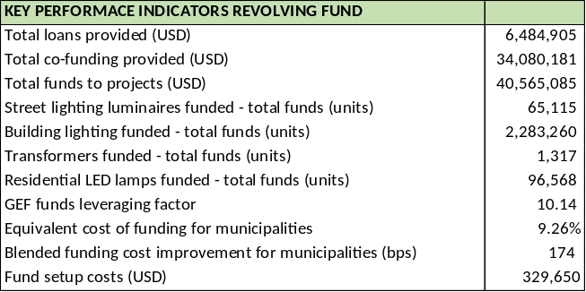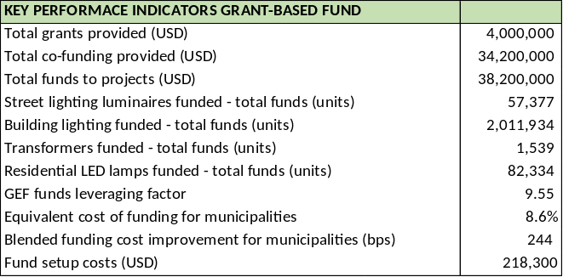

From a purely financial perspective, one aim of an energy efficiency financing mechanism is to create a net positive financial situation for the end-client. In a debt-funded project this is typically achieved through the arrangement of a repayment schedule that matches the expected cost savings that the energy efficiency project will deliver. Based on the cash flow analysis in Annex E.6, the GEF financial mechanism should be able to reach terms of 10+ years if a debt funding system was to be utilized, limiting the rotation of funds and thereby increasing the weight of the fixed fund management costs.
Box 8 EEFI to support LED and distribution transformer application (cont’d)

The EEFI will also set for the first year of operation a limit on the funding amounts to each type of project, to avoid concentrating the resources on only one type of technology. Depending on the demand from the clients, unused funds for certain technologies may be repurposed to finance other technologies. To ensure the utilization of funds for projects, the co-financing multiplier requirement may be adjusted to a minimum of four (grant funding) and 75% for the credit guarantee facility if the GEF funds for EEFI are not fully deployed in the first two years of the Project. For cash flow details of EEFI under the various models considered, the reader is referred to Annex E.6.

Funding is expected to be performed primarily in South African Rands. USD funds will be converted into local currency following funding approval. To reduce operational expenses, the facility will not make use of any currency swap.

The eligibility criteria for the projects financed through EEFI is divided in technical aspects and financial aspects.
- Technical aspects:
- The equipment financed shall meet a set of minimum efficiency requirements. In the case of LED street lighting, this may be a threshold for luminaire efficacy. In the case of transformers, a level to be defined as part of the market study and energy efficiency classification.
- The recipient must provide technical documents of the project to validate the use of funds. These include the engineering design documents, plans/maps, bills of quantities, supplier financial proposals and purchase order contract.
- The projects may include additional components apart from LED lighting and transformers as long as they are directly connected to the project and do not represent more than 50% of the total project cost. Examples of these additional elements include CCTV equipment installed on the same street-lighting infrastructure, public WiFi equipment, etc.
- The projects must comply with all sector norms, standards and legislation.
- Financial aspects:
o The co-financing of funds from EEFI shall be proven. Projects financed shall receive funding from internal resources or external third-party providers. Projects that receive over 50% of their implementation cost as grant funding shall be deemed ineligible.
o Refinancing of existing projects is not eligible.
o The price of equipment financed must be consistent with market benchmarks
- In the case of the mass procurement of LED lamps for the residential sector, equipment from local manufacturers will be favored over projects with imported equipment. This local- equipment preference shall not compromise the economic benefit of the procurement exercise. It is recommended to set a maximum weighting of 20% to this “local-equipment” component, without prejudice of any applicable public procurement localization requirements.

DBSA has recently created a new Climate Finance Unit (CFU) to house its climate finance activities (including GEF projects) including the management of climate finance mechanisms. The Unit will operationalise a new Climate Finance Facility (with USD 55 million financing provided by the Green Climate Fund, GCF, and other contribitors, incl. DBSA). The CFF will most likely finance larger infrastructure projects and governed by its own Board, so the EEFI will be complimentary. In fact, in accordance with GEF guidance, EEFI should bee complementary to existing programs, not only DBSA’s but to other lenders (including IDC and the V-NAMA programme, see Annex E.4 for more details on financing programmes) as well. However, EEFI will cooperate and exchange information with other programmes with the idea of lowering the blended financing cost for recipients (which are supposed to present co-financing to their project proposals, as mentioned earlier) and to avoid duplication of work. For this purpose, the Working Group on Financing can assist in the coordination of project development support and in monitoring of thje the implementation of projects (see project governance diagram in Box 13).

EEFI will be managed separately by DBSA. The governance structure will consist of the EEFI Steering and Oversight Committee (SOC), meeting on an annual or bi-annual basis, and Fund Management and execution. Initially DBSA would be the only donor (with its USD 4 million contribution from the GEF funding for the Project). The composition of the SOC will be the donor(s), i.e. DBSA with a representative from DBSA’s Climate Finance Unit (CFU) and Municipal Finance Unit (MFU), DOE, Treasury, and a number of other representatives. A staff member from DBSA’s Climate Finance Unit (CFU) would be would be best placed to act as Fund manager. The link with the Project would be through the DBSA members participating both in the EEFI as in the Project Board and in then advisory Working Group on Financing. In addition, the Project will make available a ‘Finance Advisor’ and short-term expertise to supplement DBSA staff to form EEFI’s execution team.

Output 3.2 Advice services provided to prospective applicants on financing modalities and structuring of proposals

Activity 3.2.1 Advice services provided to prospective applicants on financing modalities and structuring of proposals
The Project’s experts will add to advisory services provide by DBSA’s Municipal Finance Unit and Carbon Finance Unit in providing support and advisory services in defining EE opportunities and formulating bankable proposals that can be presented to, apart from EEFI, to a mix of financing providers (government grant programmes, and other debt financing sources).

Component 3 Environmentally sound management of lighting products and distribution transformers

Output | Activity
Outcome 4 Environmentally sound management and waste disposal practices
4.1 Strengthened local knowledge on how to collect, recycle and responsibly dispose of lamps | 4.1.1 Assessment of current practice in recycling of (fluorescent) lamps, waste handling  4.1.2 Provide training to municipal officials on environmentally sound management of lamp waste
Main partner: DEA, DOE
Other partners: municipalities and organisations (SALGA, SACN); waste organisations (e-WASA)
4.2 Assessed issues and options of using vegetable oil in liquid-filled transformers | 4.2.1 Assessment of the issues and options of using vegetable oil in liquid-filled transformers
Main partners: DEA, DOE, Eskom
Other partners: municipalities; private sector (transformer manufacturers; vegetable oil producers
Responsible GEF agency: UNDP

Output 4.1 Strengthened local knowledge on how to collect, recycle and responsibly dispose of lamps

Activity 4.1.1 Assessment of current practice in recycling of (fluorescent) lamps, waste handling

An assessment of current practice in recycling of (fluorescent) lamps, waste handling and mercury recovery (fluorescents) and recommendations on how to improve the recovery and installation of CFLs particularly in areas not served by regular recycling channels. The assessment will include aspects as consumer, supplier and municipal awareness and responsibilities; drop-off centres and collection points; transportation; disposal of lamps as hazardous and e-waste; recycling and recovery of hazardous substances. The Project can support the feasibility and business plan formulation of individual investment proposals on lamp waste collection, recycling, and processing that may be submitted to the Project’s Financial Instrument (EEFI) or commercial financiers.

Activity 4.1.2 Provide training to municipal officials and sales outlet staff on environmentally sound management of lamp waste
The Project will provide training to municipal officials on environmentally sound management of lamp waste (in particular fluorescents and strengthening the capacity of waste handling units), linked with the capacity building activities for municipal, private sector staff and decision-makers (2.1.2 and 2.2.1).

Output 4.2 Assessed issues and options of using vegetable oil in liquid-filled transformers

Activity 4.2.1 Assessment of the issues and options of using vegetable oil in liquid-filled transformers

Vegetable-oil natural esters can be used in distribution transformers as insulating oil instead of mineral oils. The Project will carry out a detailed assessment of the use of vegetable oil for transformers, current production of suitable vegetable oil type and costs (incl. recycling and processing of used edible oil), and techno-economic assessment of upgrading current manufacturing facilities to produce vegetable-oil-based transformers. The Project can also support the feasibility assessment and business plan formulation of individual investment proposals on lamp waste collection, recycling and processing that may be submitted to the Project’s Financial Instrument (EEFI) or commercial financiers

Partnerships

This project in South Africa will be implemented as a full-sized project, implemented by the Department of Energy (DoE) with co-financing provided by the Global Environment Facility (GEF) and the support of two GEF implementing agencies, DBSA and UNDP. The project will work closely together with the state utility, Eskom, the Department of Trade and Industry (DTI), and the Department of Environmental Affairs (DEA).

Project partner | Function of the partner; Indicative role in the Project
- Department of Energy (DOE) and agencies (SANEDI) | The Department of Energy (DoE) is the custodian of all energy policies and energy security in South Africa. The Department of Energy is the primary government institution responsible for energy regulation. The South African National Energy Development Institute (SANEDI), under DoE, is responsible for achieving the objectives of the National Energy Efficiency Strategy (NEES). DOE will be the Implementing Partner (IP) and work closely with the Project’s full-time staff and short-term experts. DOE also will take a leadership role in the Project Board in providing direction to the Project. SANEDI may be involved in the implementation and administration of a mandatory MEPS and labelling system for lighting and market assessment of Component 1
- Department of Trade and Industry (DTI) and agencies (SANAS, NRCS, SABS) | The Department of Trade and Industry (DTI) is responsible for the transformation and the development of the trade and industry sectors and will be interested in the promotion of local production (Output 2.3). Its agencies SABS (South African Bureau of Standards), National Regulator for Compulsory Specifications (NRCS), and South African National Accreditation Agency (SANAS) are likely to be involved (with DoE) in administration and implementation of a mandatory MEPS and labelling system for lighting and regulation of standards (with DOE and Eskom) for transformers (Outcome 1)
- Department of Environmental Affairs (DEA) | DEA is the government institution responsible for environmental issues, policy, and planning, including waste and climate change. DEA is the GEF Operational Focal Point and therefore has an overall interest in the Project. DEA will, in particular, be involved in Component 4 on the environmentally sound management of lighting and transformers and will coordinate with other activities it undertakes on waste (PCB contaminated oil; lamp waste disposal and mercury recovery)
- Eskom | Eskom is a public company, which generates about 90% of electricity and owns the national grid (transmission). Eskom also distributes to (rural) residential customers and directly to large consumers. Its IDM (Integrated Demand Management) programme has been involved in residential and commercial-industrial energy efficiency activities. Eskom will particularly play a role in defining a standard and MVE system for transformers (Outcome 1), providing data for market assessment, and general in capacity building and promoting local production activities of efficient transformers (Outcome) and environmental aspects (lamp recycling; high-efficiency transformers, Outcome 3). Given the current financial issues, Eskom has however downsized its IDM activities. Although still committing to the Leapfrogging project (see co-financing letter), Eskom’s involvement will be related in practice to its annual budget in the coming years for IDM.
- DBSA | DBSA is one of the GEF Implementing Agencies (alongside UNDP) and therefore shares the responsibility with GEF for the use of project resources as written in the project Document (or any amendments agreed to it). The two Implementing Agencies will provide daily project execution and implementation oversight, and operational completion. In addition, DBSA will be Manager of the Energy Efficiency Financial Instrument (EEFI), which will be set up with GEF funding. DBSA will coordinate closely with its proposed GEF project (in PPG phase) on disposal and treatment of PCB contaminated oil.
- GIZ and IDC | The German cooperation agency GIZ implements the project “V-NAMA, Energy Efficiency in Public Buildings and Infrastructure Programme (EEPBIP) which aims to use the procurement potential of the public sector to strengthen the market for energy service companies (ESCOs). V-NAMA will provide to provinces and municipalities to develop bankable energy efficiency investment plans for their public buildings and budget will be dedicated as a partial guarantee for loans (to be provided by the Industrial Development Corporation). GIZ and IDC will be important partners with whom the activity of Component 3 (financing support) will be coordinated in order to avoid overlap and find synergies in the efforts by V-NAMA and the Project’s Financial Instrument (EEFI).

Risk and assumptions

The design of the project’s activities reflects a thorough assessment of both barriers and risks affecting the potential success of energy efficiency and implementation of policy instruments. Activities have been designed specifically to lift the barriers, that is, development/harmonization of EE standards and enforcement support for regulatory barriers, material and methodological support to address barriers regarding laboratory testing capacity, labelling and PR for informational barriers, technical support for technical barriers on the supply side, and the Financial Instrument for financing-related barriers.
The risks shown in the table of Box 9 reflect remaining factors that lie outside the direct activities of the project, or along its periphery. As per standard UNDP requirements, the Project Manager will monitor risks quarterly and report on the status of risks to the UNDP Country Office. The UNDP Country Office will record progress in the UNDP ATLAS risk log. Management responses to critical risks will also be reported to the GEF in the annual PIR.

Box 9 Project risks, including impact and probability, and mitigation measures

Description | Type | Risk level  Impact & Probability | Mitigation Measures | Responsible Parties
Unanticipated political opposition and/or weak government support in South Africa inhibit the adoption of mandatory MEPS and labels for LEDs and MEPS for distribution transformers and weakens effective implementation of the MVE system | Political and institutional | Medium  Impact = 2  Probability = 2 | The political enabling environment is especially conducive, based on the recent experience with mandatory appliance and equipment efficiency standards. It can be expected that extending the scheme to new appliances will be widely supported and, regarding lighting, even expected.  Ensure that the action plan not only encompasses measures and strategies, but identifies sources of on-going funding, including government budgets, public-private partnerships, and international donor and investor support (including the V-NAMA on EE in public building). | Department of Energy; Department of Trade and Industry (with NCRS, SABS) regarding standards and labelling, regarding stakeholder
Low-level participation from the private sector actors including ESCOs, manufacturers and distributors | Societal (business) | High  Impact =3  Probability =4 | Broad inclusiveness of stakeholders in development, review, and comment regarding new energy standards will help to retain this consensus by involving the private sector key players from the project design stage in the action formulation (Component 1). Among domestic manufacturers, technical support for compliance will also help to reduce resistance, as well as the effective communication to manufacturers and suppliers about the benefits and economic opportunities to be gained from supply LED lighting and high-efficiency transformers (Components 2 and 3) | The project will provide outreach and technical support and skills enhancement in cooperation with the national partners
Low-level participation from municipalities and resistance from consumers | Societal (consumers) | Low  Impact =2  Probability =2 | Building on Eskom’s IDM efforts, awareness creation will help to reduce confusion, social burdens on the consumer side and communicate the benefits of LED lighting. Capacity technical and financial support within Component 3 will overcome political opposition and institutional barriers (e.g. lack of resources and skills) at the municipal level. | The project will provide outreach and technical support and skills enhancement
Hazardous substances (mercury, PCBs, etc.) in existing and/or new products are not properly handled during production, lifetime and end of life. | Environmental | Low  Impact = 1  Probability =2 | Awareness creation and training will be carried out both policymakers and practitioners on proper handling substances (e.g. lamp disposal and mercury recovery) are an integral part of Component 4 of the Project. The issue of PCB in oil-filled transformers is dealt with separately in a proposed DBSA-implemented project on PCB-contaminated oil. | DBSA, DEA  National partners  Project
Dumping, incorrect documentation, and other illegal practices in importation of LED and other lighting products complicate enforcement | Regulatory and market | Low  Impact = 2  Probability = 1 | Direct activity regarding customs control of imported goods lies beyond the scope of the project, but to a significant extent, the project’s MVE activities in Component 2 (verification and enforcement with testing, market snapshot and publicity, register of products) will help catch non-compliant products (low-quality lamps) that might enter the country. Such cases that are indeed revealed through project activity will be reported to responsible customs authorities and to the mass media. | Project and government agencies involved in MVE
Delayed implementation of activities that are baselines for specific incremental activities of the proposed program. | Organizational | Medium  Impact = 2  Probability = 1 | During the proposed program inception meeting the precise role of each partner and their responsibilities will be established. | DOE, DTI, DEA, and other Board members

Note: Probability scale from 1 (low) to 5 (high); Impact scale from 1 (low) to 5 (high).

South-South and Triangular Cooperation (SSTrC):

U4E will provide broader contacts and coordination, especially with other child projects of the global leapfrogging project, in sharing experience, best practices, and lessons learned and with other recent UNEP and UNDP-supported projects funded by GEF on efficient lighting, appliances and equipment in Costa Rica, Bolivia, Peru, Chile, Morocco, Tunisia, Sudan, Turkey, Jordan, Kazakhstan, Pakistan, Myanmar and Indonesia. UNDP will invite representatives of the projects in these countries to attend the closing (and other) workshop(s) of the project in South Africa, and to deliver presentations and disseminate their own materials.

On new knowledge products and training/conferences etc to be done under the new child project, this will be guided mostly through U4E and UNEP’s lead role in the global Leapfrogging Program Framework Document, and our project in South Africa is one of several in this grouping. It will benefit both from exchanges with sister projects managed by UNDP (in Sudan, Kazakhstan and Indonesia) and others handled by UNEP. On transformers the project will establish and exchange link with the UNDP Kazakhstan project, which also has a focus on transformers. Also, the Project will the project will seek cooperation with relevant international organisations, for example, the International Copper Association, or the inter-governmental Super-efficient Equipment and Appliance Deployment (SEAD) Initiative.

In addition, the Project will promote collaboration on issues and options on efficient lighting and power distribution in the regional context (SAPP, SADC, COMESA) and this is an explicit part of Output 1.2. In this context, the Project will work with U4E on a 1) a regional market assessment (quantitative information and product prioritization); and, 2) to develop an integrated policy approach and policy framework for a transition to energy efficient lighting, appliances and equipment in Southern Africa.

Stakeholder engagement

The project team has met with a wide array of stakeholders during project preparation, including representatives of Department of Energy and Eskom; retailers; manufacturers; representatives of city governments; NGOs and representatives from women’s and vulnerable groups organisations. UNDP will continue to engage with these stakeholders throughout the project period. The Project Steering Committee (PSC) will include a diversely representative array of these groups.

A detailed Stakeholder Engagement Plan is provided in Annex G. Starting immediately during the inception period, the project will engage the stakeholders by means of organising an Inception Workshop. During the subsequent project implementation, there is the opportunity to involve stakeholders at the various workshops, seminars, and technical training. The outreach, technical assistance, and the EEFI finance programmes will be designed in direct recognition of input received from these stakeholders.

Box 10 Role of stakeholders in the Project

Stakeholder | Role
Government and national agencies; Eskom | Policymakers, officials and technical staff within government ministries will play a crucial role in the implementation of the proposed program. These are listed as project partners in Section 4.2. Each project partner is also considered an important stakeholder of the project but is not discussed in detail again here to avoid repetition.
Municipalities and local government associations | Electrical utilities and energy service providers have an incentive to encourage efficiency to lower their operating cost. Municipalities play an important role in designing municipal green and sustainable energy plans and propose investment projects on public buildings (incl. lighting) and infrastructure (incl. street lighting, distribution networks), and play an important role in awareness creation for their citizenry on sustainable practices (incl. proper waste disposal and efficient lighting. The Project will work closely with and municipal organisations, such as the South African Local Government Association (SALGA) and the Association of Municipal Electrical Utilities (AMEU).
Testing laboratories and technical institutions | Test procedures are an important technical foundation for MEPS. Testing laboratories will take part in the process of developing standards and quality control measures.
Environmental advocates and consumer groups | Non-governmental organizations that advocate responsible energy policies will contribute their perspectives during the development of the national strategy for energy-efficient products. They will provide a balancing perspective to manufacturers with regard to the stringency of MEPS and MVE schemes. Input from civil society consumer groups can ensure that regulations do not require overly expensive or less functional lighting and equipment. This includes the role of women groups and organisations (see next Section 4.6)
Manufacturers, importers, distributors and retailers of lighting products, appliances and equipment | Manufacturers, importers, distributors, and retailers are directly affected by energy efficiency regulations. They have valuable information about production costs and market structures. MEPS necessarily impose some burdens on manufacturers and importers, but these can be acceptable as long as they affect all companies equally and also introduce new business opportunities. Domestic and international firms will provide their input. Equipment retailers will comment on the proposed program and its future implementation by characterizing the market and consumer response to product efficiency and pricing, and by actively participating in and supporting energy efficiency awareness campaigning. In order to ensure industry readiness of local industry, the program offers support to local manufacturers and assembly companies to produce high energy-efficient products in a sustainable manner.
UNEP – United for Efficiency (U4E) | UN Environment U4E will part of the PSC and also the Working Groups (Lighting, Distribution Transformers and Finance). This will assist in allowing exchange in both directions between the South Africa child project and the UN Environment global project (U4E).  Reporting to GEF will be shared with U4E to keep the global project informed on progress on the national activities, sharing experiences (from South Africa to other countries and vice versa) and providing technical guidance. In addition, the Global Project (U4E) will convene regular conference calls with the South Africa Project Management Unit to assist in this process as well.

Mainstreaming gender

A detailed Gender Analysis and Gender Action Plan is included in Annex D. This Section highlights the main elements of the gender action plan, outlining what the project will do to mainstream gender in individual components/outcomes.

South Africa is committed to realizing the goal of gender equity by 2063 with a full and inclusive participation by both women and men. To ensure this, the country has embarked on several initiatives and interventions. A few among these is the country’s adoption of a minimum political gender quota of 50% and already, women constitute 42% of parliamentarians; a strong and highly intricate gender related machinery to ensure that the issue of gender equality is adequately addressed. In place too are various several pieces of legislation and legal frameworks.

But there are significant issues that women in South Africa still face, like domestic violence; unfair labour practices; lack of technical skills hence their low participation in the mainstream economy especially at senior management levels.

Gender mainstreaming in this project therefore will attempt to intervene and ensure that the benefits of the projects is enjoyed by both women and men. The development challenge of this project is increasing GHG emissions from appliances and equipment, as well as related issues of energy costs, consumer choice, and assurances of product quality for both enterprises and all citizens, affects all citizen of South Africa equally. However, the project’s Theory of Change, notes various causes that underlie the persistent barriers and challenges that limit penetration of high efficiency lighting and distribution transformers. In addressing these therefore, the project intends to be gender-responsive in the design and execution of the activities that address these causes. The key causes are the following:

- Lack or poor signals to the market on the value of energy efficient equipment- energy efficient equipment. Their value and importance to the users is not clearly or adequately highlighted. This leads to this valuable equipment treated like any other or being compared inappropriately, for example, in terms of aesthetical beauty, etc.
- Lack of or absence of information on gender dimensions of consumer preferences and household decision making dynamics. There is a general lack of information on ownership and consumer preferences in the market regarding appliances of various levels of energy performance, but there is even an acute lack of information disaggregated by gender both quantitatively and qualitatively on decision –making authority and processes within households and enterprises. Although in South Africa, because of the low economic status of women, most of who are characterized by poverty- many women are unemployed, if employed, they earn very low wages, as many are employed as farm labourers or in the informal sector where they are engaged mostly in manual labour etc., with no hope of future investments even in the form of decent pension. Decision-making under these circumstances is usually the prerogative of men, who usually make decisions on large equipment purchases. Only a small per cent of affluent women, especially those in the decision-making echelons in their respective organisations are in a position to make decisions on their consumer choices.

The project will attempt to address this with market research that will include inter alia surveys, and focus groups structured in such a manner as to allow for the disaggregation of outcomes by gender.

- Low income and barriers to purchase of EE items with high initial cost:
Low income citizens, who tend to be women mostly in South Africa, because of their economic status and ranking in the society, tend to face barriers against the purchase of EE items when these have higher initial costs. This is resultant from the fact that women locally have lower average salaries than men; face greater unemployment levels hence they face this barrier more than men do. The situation becomes worse when it comes to women in rural areas, whose conditions are worsened by a severe scarcity of jobs, transport and long distances that they have to travel between places, which also cost money. The project will address this barrier, with incentives and will be delivered with the assistance of national public organisations for the advancement of the welfare of women and pensioners.

- Lack of awareness and prioritisation by end users, private sector and policy makers and suppliers and of exposure to international best practice.
There is a general lack of knowledge and awareness by both women and men; the private sector; policy makers and the public at large about the costs, performance, and benefits of energy efficiency of appliances. While the introduction of the new EE items may be introduced for the benefit of both men and women at a household level, it must be born in mind that they have different roles they play in the household. For example, women are in the frontline in the use of electricity, gas, water etc. while men are often responsible for the selection and the purchasing of costly household items. Hence, outreach programmes would have to be done bearing in mind different gender roles. It would thus be very prudent to target women and men separately and differently, hence the project will address these issues with information outreach to both women and men, including outreach particularly directed at women as warranted by market research. Similarly, professional training and public outreach will be designed with gender equity and responsiveness in mind. It is envisaged that addressing this barrier, many other gender issues will be addressed, e.g. partnering with women in the support to the transitioning to the renewable because of their important role they play in the use of energy; address the issue of stereotyping of gender roles regarding household responsibilities where the kitchen will be portrayed as a responsibility of both sexes.

While gender may be less central to the other program activities, those too will be aligned to gender mainstreaming, to make sure that that both males and females benefit from the project. These will be implemented as follows:
- Wherever possible, and where relevant, the project will include sex-disaggregated data. Guidelines and project documents will be designed and targeted with gender sensitiveness to assess and evaluate potential impacts and related policy integration of gender considerations;
- All training materials will be prepared bearing in mind the avoidance of gender stereotypes; use an inclusive language, avoiding derogatory and inappropriate illustrations. Significant women participation and representation will be encouraged during capacity building workshops, both among trainers and trainees to promote gender parity.
- Where relevant gender-related findings and sex-disaggregated data will have been brought to the fore, and will be taken cognisant of and incorporated in the design;
- The project’s policy and enforcement will benefit women a great deal as women will be targeted to participate in this male dominated sector with measures taken to address the gender stereotyping about women’s employment in these fields through inter alia career counselling, job placement and mentoring;
- When providing technical assistance on domestic manufacturing of EESL compliant products, it is envisaged that many female workers stand to benefit tremendously as their qualifications, skills and job security will be greatly enhanced. This will be a contribution to the much cried about “lack of skills and visibility of women” in technical sectors, especially in the energy sector.
- Information dissemination actions will be designed and targeted, considering gender sensitiveness to assess and evaluate potential impact and related policy integration of specific gender considerations.

Over and above the issues to be addressed as listed above, the project will further implement a cross-cutting gender equality strategy in an effort to further the aims of the country towards realizing gender parity. The strategy will be implemented throughout the project life cycle and will comprise inter alia the following:
- Sensitization of project stakeholders with regards to gender equality. Efforts will be made to promote a balance between male and female participants in the Project’s activities;
- In working teams of the Project governance structure - Project Steering Committee; Project Management Unit, Working Groups - gender balance will be ensured by balancing representation of both male and female participants;
- Gender equality will be promoted during all project’s recruitment of personnel/consultants. All advertised positions will be equally opened to all genders and the text on TORs will be carefully crafted to avoid gender stereotypes and to encourage women to apply;
- Ensure women representation in all capacity building workshops and training, as trainers and trainees;
- Exposure to training opportunities and transfer of skills to be made available to all, regardless of their gender;
- Chauvinistic tendencies, derogatory language, and gender stereotypes will not be tolerated among project staff or project partners;
- All training materials, technology, and methodology of dissemination are to be gender sensitive (i.e. avoiding gender stereotypes, using inclusive language and using appropriate illustrations).

Sustainability and scaling up

Sustainability

Institutional sustainability
As demonstrated in numerous countries around the world and recently in South Africa, standards and labelling for appliances and equipment are inherently conducive to scaling up, as they apply across entire chosen technology sectors, nationwide, encompassing tens or hundreds of thousands of units of appliances and equipment per year. South Africa has mandatory standards and/or labelling for a number of electric appliances. It is expected that by the end of the project period, compulsory lighting (LED) and distribution transformers S&L will have been added. Relevant institutions will be trained and authorized to conduct monitoring, verification, and enforcement (MVE), including equipped and competent testing laboratories by the end of the Project with financial operations based on a sustainable fee-based structure developed by the project. Similarly, the web portal energysavings.org.za is in operation and it is expected that this will continue with added info on MEPS, labelling, and list of certified lighting products and distribution transformers.

Social sustainability
Furthermore, standards and labelling lead to permanent market transformation by prompting changes in manufacturers’ product lines, shifts in consumers’ preferences and knowledge, and new competitive dynamics in the market regarding energy performance as a measure of value and quality for consumers. The Project will raise more awareness on the net benefits of using high efficiency lighting (residential, private and municipal buildings) and distribution transformers (municipal utilities) and build capacity and skills of decision-makers and technical staff in municipalities, ESCOs and private companies.

Financial sustainability
Whilst state support to local government for energy efficiency measures is critically important, new, innovative and sustainable ways to finance public sector interventions, such as working with ESCOs and accessing debt financing, will be explored. In addition, the Project will work with existing public and private financiers to link investments by private sector in energy efficient products and the local production thereof. A diverse mix of funding sources may better mitigate risk, stabilise the availability of funding.

On sustainability, several risks may affect the likelihood of the continuation of the project’s benefits after the project ends. These are listed in Section 4.3 (and possible risk mitigation measures are assessed). The project will expand its strong partnership with private sector companies, technical organizations, and international agencies and initiatives to encourage energy efficiency innovation and in public procurement.

Scaling up and replicability

To encourage replicability the project has adopted a balance between capacity building and strengthening regulations (standards, labelling, procurement) and boosting financing availability to create an enabling environment for investments in high-efficiency lighting and transformers applications and local production. Emphasis on awareness raising and knowledge management (Component 3) will pro-actively identify lessons to inform replication and scaling-up and the institutional arrangements will be put in place to ensure then this reaches national and the local level.

Regarding scaling up, the project has been designed to focus on the public sector (municipalities in particular) to empower it to lead with examples of energy efficiency interventions. The replacement of conventional and obsolete appliances in public institutions is envisioned to be scaled up, starting from a small number of demonstration projects focused on the highest energy consuming public institutions and then expanded to all public institutions through the enforcement of the national policy on MEPS and/or labels for LED lighting and distribution transformers, and the support from the Energy Efficiency Financial Instrument (EEFI) to support new public-private partnerships (e.g. municipalities working with energy service providers, ESCOs). In particular, a learning-by-doing approach is promoted whereby EE lighting and transformers planning and investment proposals will be supported in participating municipalities. This will be followed up with on-going capacity development and on-the-job technical assistance during the normal local planning and budget cycles.

Project Management

Cost efficiency and effectiveness

Socio-economic benefits

Appliance and equipment efficiency standards are well known as being among the very most cost-effective instruments for achieving energy savings, cost savings for consumers, and associated GHG emissions reduction at scale. Standards and labelling offer such remarkable cost-effectiveness because they affect entire market sectors involving annual sales of tens or hundreds of thousands of electricity-intensive products, using policy and an efficient laboratory-based enforcement process, leading ultimately to market transformation that is sustained mostly through consumer demand and competition among producers.

High-efficiency appliances will provide end-users savings on the total lifecycle costs of the product through reduced electricity use, allowing for purchasing power for an improved standard of living. Further, the end-users (men and women) are empowered through increased visibility in the quality and efficiency of the product through energy-efficiency labelling.

Local manufacturers stand to benefit by increasingly stringent energy efficiency standards and strategies by producing higher-efficient products that meet the need of local markets and also the possibility to enter new markets that have existing energy efficiency standards, such as in OECD countries. The project will also provide economic benefits by promoting regional harmonisation of standards (on lighting and transformers). This will reduce the costs of doing business for manufacturers that otherwise would need to comply with different standards in each country. Further, the benefits will be provided across the economy, as businesses will be able to produce goods more efficiently due to improved technologies and the ability to export these within the Eastern and Southern African region (common market arrangements, SADCC, COMESA). Lastly, the economy as a whole stand to benefit from increased energy efficiency in the economy will allow for reduced imports of fuel sources.

Environmental impacts

Unlike GEF-supported projects that involve large investments in a few demos (e.g. wind or solar parks), the Project implies investment/purchase decisions of a multitude of residential and other consumers in small investments of USD 2 to 6,000. The Project defines ‘direct emissions’ not as linked to one or more small investment projects, but based on a calculated difference during the implementation period (2019/20-2022/23) between a market baseline scenario (which assumes a modest replacement of LEDs for other lamps and HE transformers) and an alternative pathway (followed partly due to the Project intervention) which increased purchase or investments in more high-efficiency products. These are based on detailed market growth assessment of the different types of lighting products and their energy consumption, presented in detail in Annex F.

A similar baseline-alternative assessment was carried out by U4E and en.lighten for lighting, refrigerators, air-conditioners, transformers, and electric motors, in which the savings are calculated in a Policy scenario (based on ‘best current’ global MEPS) and a more aggressive BAT scenario (‘current best available technology’). The estimates of impacts combined for lighting and distribution presented in this Project Document (see Annex E) of energy savings of 129 TWh and reduced lifetime GHG emission of 117 MtCO₂ over 2019-2030 correspond with the estimates of impacts in the U4E Policy scenario with energy savings of 120 TWh and lifetime CO₂ emission reduction of 116 MtCO₂ over the period 2020-2030. The direct emission reduction (influenced by the Project over 2019-23) implies a GEF expenditure of under USD 0.19 per tonne of avoided CO₂ emissions.
Box 11 Summary of direct greenhouse gas emission reduction
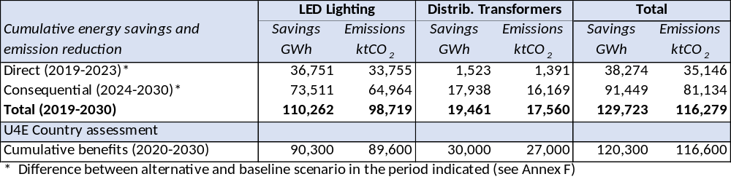
Notes: Based on UNEP/U4E South Africa, Country Assessment sheet (2016), for assumptions and data sources, see http://united4efficiency.org/countries/country-assessments/

Lighting devices are used at peak-load demand. By reducing the peak load, it will not only reduce the occurrence of blackouts but it will also reduce the peak-load generation, which is often the most expensive. By 2030, the peak load reduction of the alternative scenario over the baseline that is attributed to the Project’s (direct and direct) influence will be 223 MW.

Beyond the greenhouse gas emission reductions that will be delivered through increased energy efficiency, the project offers further global and local environmental benefits. For each technology, the project will implement best practices in environmentally sound management:
- Old technology that is phased out and some efficient and advanced lighting technologies may contain hazardous substances, in particular mercury. The project will continue to assist countries to plan collection and recycling programmes to ensure that mercury from spent lamps is not released into the environment and that lighting products classified as electronic waste are properly collected and recycled.
- The Project will be supported research and assessment of issues and options regarding the replacement of mineral oils used in certain type of transformers by vegetable oil. Old transformers may contain polychlorinated biphenyls (PCBs) and ensuring environmentally sound disposal of the PCBs is dealt with in the DBSA/GEF project “Environmentally Sound Management and Disposal of PCBs”. By 2030, the mercury in the lamping stock in the alternative scenario over the baseline that is attributed to the Project’s (direct and direct) influence will be about 2.0 tons of mercury (see Annex F).

Project management

Implementation arrangement
The project management arrangement will be the National Implemented Modality (NIM). The Implementing Partner for this project is the DOE (Department of Energy). The overall governing body will be the Project Steering Committee (PSC) which will be a multi-stakeholder body, in which UNDP, DBSA, and a number of government entities will participate. A Project Management Unit will be established in Pretoria, likely to be at DOE’s premises. A Project Manager will be appointed to manage the project and report to the Project Board. Technical experts may be located to work in offices of participating municipalities. More details on the project management arrangements are given in Section 8.

Risks and risks monitoring
The risks that are shown Section 4.3 and Annex K below reflect remaining factors that lie outside the direct activities of the project, or along its periphery. As per standard UNDP requirements, the Project Manager will monitor risks quarterly and report on the status of risks to the UNDP Country Office. The UNDP Country Office will record progress in the UNDP ATLAS risk log. Management responses to critical risks will also be reported to the GEF in the annual PIR.

Equipment, Supplies and Other Property
Ownership of equipment, supplies and other property financed from the project shall be vested in UNDP. Matters relating to the transfer of ownership by the UNDP shall be determined in accordance with applicable policies and procedures of the UNDP.

Agreement on intellectual property rights and use of logo on the project’s deliverables and disclosure of information
To accord proper acknowledgment to the GEF for providing grant funding, the GEF logo will appear together with the UNDP logo on all promotional materials, other written materials like publications developed by the project, and project hardware. Any citation on publications regarding projects funded by the GEF will also accord proper acknowledgment to the GEF. Information will be disclosed in accordance with relevant policies notably the UNDP Disclosure Policy and the GEF policy on public involvement.

Project Closure
Project closure will be conducted as per UNDP requirements outlined in the UNDP POPP. On an exceptional basis only, a no-cost extension beyond the initial duration of the project will be sought from UNDP and DBSA.

Project Results Framework

This results framework is the same as the one required in the GEF CEO Endorsement template Annex A: Project Results Framework.
Outcomes are short to medium term results that the project makes a contribution towards, and that are designed to help achieve the longer-term objective. Achievement of outcomes will be influenced both by project outputs and additional factors that may be outside the direct control of the project.
This project will contribute to the following Sustainable Development Goal (s): Goal 7: Ensure access to affordable, reliable, sustainable, and modern energy for all (Target 7.3: By 2030, double the global rate of improvement in energy efficiency). Goal 13: Take urgent action to combat climate change and its impacts (Target 13.2: Integrate climate change measures into national policies, strategies and planning; and Target 13.3: Improve education, awareness-raising and human and institutional capacity on climate change mitigation)
This project will contribute to the following country outcome included in the UNDAF/Country Programme Document: Increase in the number of sustainable ‘green jobs’ created in the economy; Stabilisation and reduction of carbon emissions and climate change mitigation and adaptation strategies fully operational
This project will be linked to the following output of the UNDP Strategic Plan:
Output 1.5: Inclusive and sustainable solutions adopted to achieve increased energy efficiency

 | Objective and Outcome Indicators | Baseline (2017/18) | Mid-term project target (MoP, 2021) | End of Project (EoP)  target (2023) | Data collection methods and risks/assumptions
Project Objective:  Accelerating South Africa’s efforts to transition the economy to energy-efficient products, by a) developing South Africa’s market for LEDs on the electricity demand-side, and b) developing South Africa’s market for high-efficiency distribution transformers on the electricity supply-side, resulting in climate change mitigation, stable power supply and therefore economic development and improved energy access. | - Reduction in electricity consumption by high efficient lighting (LED) and distribution transformers | 62.0 TWh of electricity per year consumed by lamps is projected to decline to 49.4 TWh at EoP under business as usual and to 46.0 TWh in 2030.  Losses due to transformers in 2018 were 18.7 TWh which will increase to 21.5 TWh at EoP and 26.1 TWh in baseline | In the alternative scenario, annual energy savings over the baseline (of 53.4 TWh) of 7.5TWh at MoP (2021)  Losses in the alternative scenario are reduced with 0.13 TWh to 20.2 TWh at MoP (2021) | In the alternative scenario, annual energy savings over the baseline of 8.5TWh at EoP (2023) and in 2030 savings of 11.4TWh (energy consumption due to lighting in 2030 is 34.6 TWh in the alternative).  Losses in the alternative scenario are reduced with 0.87 TWh to 20.6 TWh at EoP (2023) and with 3.8 TWh to 22.3 TWh annually in 2030 | The baseline and target values are based on the energy savings and emission reduction estimates that are partly based on information in U4E country assessment (lighting) and Eskom/NERSA data (transformers) and technical information in appliances from other sources, as explained in Annex E to the UNDP ProDoc. Information on baseline values and prognoses (2021, 2030) will be updated in market assessments and other studies the Project will carry out (see Output 1.1 and Indicator 5)  As above.  Assumption: The objectives of the project remain in line with the priorities of the South African government
 | - a. Reduction in GHG emission from electricity consumption by LEDs and high-efficiency transformers (linked with indicator 1)  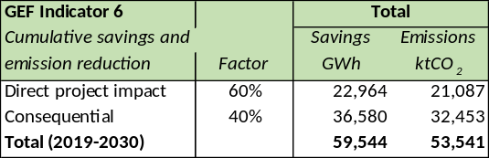  b. Emission reduction attributable to Project  [GEF Indicator 6] | a. 63.4 ktCO₂ of GHG emissions due to lighting is projected to decline to 44.9 ktCO₂ at EoP under business as usual and to 43.4 ktCO₂ in 2030.  Emissions due to transformer losses in will increase to 19.8ktCO₂ at EoP (2023) and 23.1 ktCO₂ in 2030 | a. In the alternative scenario, the additional GHG emission reduction (over the baseline) of 7.5 ktCO₂ at EoP (2021, baseline emissions are 53.5 ktCO₂)  Emissions due to transformer losses in the alternative scenario are reduced with 0.12 ktCO₂ to 19.0 ktCO₂ at MoP.  b. Taking into account a causality factor (CF), cumulative savings 2019-2021 (over the baseline) are 9.1 ktCO₂ | a. In the alternative scenario, the additional GHG emission reduction (over the baseline) of 8.1 ktCO₂ at EoP (2023, emissions are 44.9 ktCO₂) and in 2030 emission reduction of 10.7 ktCO₂ annually over the baseline (GHG emissions due to lighting in 2030 are 32.7 ktCO₂).  Emissions due to transformer losses in the alternative scenario are reduced with 0.81 ktCO₂h to 19.2 ktCO₂ at EoP (2023) and with 3.4 ktCO₂ to 19.8 ktCO₂ annually in 2030.  b. Taking into account a causality factor (CF), cumulative savings 2019-2023 (over the baseline) are 21.1 ktCO₂ (CF=60%) and over 2024-2030
 | - a. Number of households that have LED lamps installed (with gender-relevant data), and  b. Share of LED lamps in stock (of installed lamps) in the country  c. Number of beneficiaries  [GEF Indicator 11] | a. An estimated 0.5 million household purchase LED lamps in 2017  b. Share of 5% by LEDs in lamp stock in 2017  (based on estimates and calculations of Annex F) | a. In baseline 2.6 million HH will have LED lighting installed and 6.1 million in 2021 (alternative)  b. Share of 17% of LEDs by MoP in baseline scenario and 36% by MoP in alternative scenario  c. Based on indicator 3a, 11 million beneficiaries (50% men, 50% women) | a. In alternative 4.1 million HH will have LED lighting installed in 2023 over the baseline, or 12.7 individuals  (households consist of 50% men and 50% women)  b. Share of 20% of LEDs by EoP and 31% by 2030 in baseline scenario and 49% by EoP and 75% by 2030 in alternative scenario  c. Based on indicator 3a, 12.7 million beneficiaries (50% men, 50% women). Using CF=60%, direct beneficiaries are 7.6 million people (2.5 million households) | As above. Surveys will include number and gender of members of the household.
Outcome 1  Strengthened government capacity and regulatory frameworks for LEDs and distribution transformers | - Completed market studies on demand, use and supply of lamps and on distribution transformers | No full comprehensive and coherent market overview exists | Market assessments by yr1:  One (1) on lighting products stock demand and supply; One (1) market assessment carried out on transformers production, installation and stock | End-of-project market assessments carried out, comparing results with the first-year market assessments | Markey survey report and supporting data (Excel, statistical analysis software)  Data to be collected by means of reports, statistical and sales data from suppliers/producers, customs, Eskom, NERSA, supplemented by customer, retailer and supplier surveys (linked with Indicators 11 and 15).  Assumption/risk: willingness of companies and agencies to share data
 | - Status of action plans for large-scale introduction of LED lamps and high-efficiency distribution transformers | No action plans on efficient lighting or high-efficiency transformers at national government level | Action plan formulated for (LED) efficient lighting and one action plan for high-efficiency transformers by end of yr2 | Action plans revised (as needed) in yr 4 based on final the results and achievements of the Project | Minutes of meeting of working groups (on lighting and one on transformers) that discuss draft action plans. Publication of action plans  Assumption/risk:  The Action Plans will be ensured through formation of Working Groups (see Project management section) and as a mechanism for regular consultations. Assumed strong involvement of national agencies in the project
 | - Availability of updated information on products and on their compliance with standards and labels | No register or web portal on energy performance of LED and transformers South Africa | One (1) register/web portal on compliant products and results of MVE (Outcome 3) set up under UNDP/GEF standards and labelling project with new data collected and analysed on LEDs and distribution transformers | Register and web portal are operational, with complete and regularly updated data collection on energy performance of (LED) lighting, and distribution transformers (e.g., as part of existing website) | Assumption / risk: register and web portal will be established and database of compliant products regularly updated. Manufacturers, suppliers contribute to database with reliable and complete data so that integrity is maintained
 | - Status of minimum energy performance standards (MEPS) for LEDs and energy labels for LEDs | Mandatory MEPS and energy labelling for selected appliances, but not yet for LED lamps-luminaires distribution transformers | Proposal for MEPS and energy label categories for LED lamps (under discussion DoE, NRCS, SABS) and MEPS for distribution transformers (under discussion DoE, NRCS, NERSA, SABS) | Compulsory MEPS and energy label categories for LED lamps; and MEPS for distribution transformer | MEPS and labelling regulations to be circulated for public comment and then gazette. Stakeholder consultation reports.  Assumptions/risks: Major stakeholders (public and private) support the project objectives and adhere to the timeline for enactment of the regulations. This assumption will be ensured through the formation of the stakeholder Working Groups and regular consultations. Stakeholders actively participate in providing market data and the review of the engineering /cost-benefit analysis. Necessary legislation is drafted and enacted
 | - Operational status of testing and certification laboratories in support of energy performance standards and labelling for LED (and other lighting products) and distribution transformers | Two (2) labs are accredited by SANAS for photometric testing according to international standards.  Quality control of distribution transformers by Eskom as part of contracts | At least three (3) labs are accredited by SANAS for photometric testing according to international standards. | At least three (3) labs are accredited by SANAS for photometric testing according to international standards and at least one independent lab for distribution transformers testing (or at least the number of test labs needed to be able to test the desired volume of devices needs for the implementation of MEPS and/or labelling)  Note: The exact number and identity of the laboratories will be determined based on detailed analysis during the first project year of laboratory capacity, equipment costs, administrative issues, and expected volumes of equipment to be tested. The indicator is to be assessed based not on number of laboratories, but rather capacity to fully handle all national certification needs | Audit reports of test labs. Product validation reports from test labs. Accreditation confirmation of test labs.  Assumptions/risks: part of MVE activities can be recovered by levies charged by NCRS on the regulated products, in addition to assumed resources committed by the Government. Commitment from the side of suppliers, distributors, manufacturers. Public sector funding to is made available to upgrade test facilities, if not, private sector test lab engagement will be sought
Outcome 2  Awareness and knowledge enhanced amongst technology users, financiers and supplier | - Impact of consumer awareness of energy efficiency, MEPS and labels for lighting products, as reflected in the share of affirmative survey responses (broken out by gender) | Awareness of energy efficiency amongst consumers in lighting exists, but geared towards CFLs (residential-commercial), T8-T5 in LFL and HID-HPS (instead of HID-MV) in outdoor/street lighting. Less awareness on (economic) benefits from using LED lamps.  Municipalities have little or no awareness on high-efficiency transformers | Surveys after first awareness campaigning show 15% increase in affirmative response on benefits (energy and monetary savings) of LED lighting (both men and women)  15% increase in municipalities that consider high-efficient transformers in their EE plans | Surveys after awareness campaigning and other knowledge enhancement activities of the Project show 50% increase in affirmative response on benefits (energy and monetary savings) of LED lighting (both men and women)  50% increase in municipalities that consider high-efficient transformers in their EE plan | Consumer awareness data to be collected in surveys and focus groups at the beginning and final year of the Project linked with the overall market survey (Indicator 5). Surveys will contain data on both the gender of the respondent  Assumption/risks: strong involvement of retailers and distributors (lighting) and manufacturers (luminaires, transformers) in information and campaigning. Retail staff can explain lighting labels to consumers
 | - Share of high-efficiency distribution transformers in production (newly added transformers) | Only a few larger companies can produce high-efficiency transformers. Performance data are not available | No target defined | 90% of annually added new transformers (21,000 out of 22,500 in 2023) are high-efficient (comply with new MEPS) | Manufacturers survey (linked with market assessments, Indicator 5)  Assumptions/risk; involvement of transformer manufacturers and willingness to upgrade their production lines Assumption/risks: Eskom contracts will stipulate % share of transformers using vegetable oil and municipal distributors will follow suit
 | - Number of stakeholders (companies, municipalities), trained by the Project in new requirements of MEPS, labelling programs, local production, environmental management and associated regulations; Number of staff trained per stakeholder | Zero by default | Representatives of at least 20 entities trained | Representatives of at least 40 entities trained | Reports of training events (including participation numbers broken down per gender, participants’ response and satisfaction questionnaires). Training materials made available. Training impact assessment analysis  Assumptions/risks: Strong cooperation between private and public institution on trainings and sharing experiences and lessons learnt. Some training could be directly offered by the project, while other training could be offered internally by companies, institutions, municipalities to their own employees, with the project’s support.
Outcome 3
Financial support programmes designed and operational
 | - Number and amount of funding provided by EEFI and matching co-funding | Zero by default | USD 2 million provided as GEF grant matching at least USD 10 million in co-financing (loans, guarantees) by development banks, commercial banks, or other co-financing sources | USD 4 million provided as GEF grant matching at least USD 20 million in co-financing (loans, guarantees) by development banks, commercial banks, or other co-financing sources. | Reports by the financing institution or development bank concerned. Other financial indicators will be added (number of loans or grants, type of beneficiaries, the purpose of financial support) as well as technology supported (number of lamps installed number of HE transformers installed)
 | - Vulnerable groups and women access loan finance to start participating in projects as shown by the number of Women-Owned Businesses benefiting and participating in the implementation of the project. | Very few women participate in projects especially in the energy sector (see section in the ProDoc on gender). | Initially, an increase of (20%) of women and vulnerable groups access finance and participate in the implementation of energy efficient lighting and equipment | Increase in 50% participation of vulnerable groups including women access loans and participate meaningfully in projects achieving representation that is on par with their male counterparts. | Data is collected from the time the policy facilitating funding of WOBs is implemented. Close monitoring is ensured through surveys in order to detect any side barriers cropping up so that they are addressed promptly.
Outcome 4  Environmentally sound management and waste disposal practices | - Completed assessments of lamp (CFL) disposal and recycling and on the potential of using vegetable oil in transformers | No integrated national-level assessment on lamp recycling. No national-level assessment of use of vegetable oil | Two assessments with policy recommendations of 1) lamp recycling and mercury recovery; 2) use of vegetable oil in transformers | Idem. | Assessment study reports  Assumption/risks:  Retailers, municipalities recycling companies as wells distribution manufacturers are willing to cooperate in data collection and questionnaire surveys
 | - Share of domestically-produced distribution transformers using vegetable oil | Distribution transformers use mineral oil for insulation | 5% of transformers use vegetable (ester) oil | 20% of transformers use vegetable oil | Report by Eskom and municipalities, NERSA  Assumption/risks: Eskom (and municipal) contracts will stipulate % share of transformers using vegetable oil and municipal distributors will follow suit

Monitoring and evaluation are also a key part of the project but are not named as a numbered component as such. M&E does not have any indicators or targets of its own in this framework, but the framework itself represents the project’s M&E tasks throughout. Please see the following section of this Project Document for more details.

Monitoring and Evaluation (M&E) Plan

The project results will be monitored annually and evaluated periodically during project implementation to ensure the project effectively achieves these results. The Project Results Framework (presented in the previous Section 5) includes SMART indicators for each expected outcome as well as end-of-project targets. These indicators along with the key deliverables and benchmarks included in will be the main tools for assessing project implementation progress and whether project results are being achieved.

Supported by Component Four: Knowledge Management and M&E, the project monitoring and evaluation plan will also facilitate learning and ensure knowledge is shared and widely disseminated to support the scaling up and replication of project results. Also, within the other three substantive the GEF-financed project will promote effective management of knowledge (see Section 3.1)

The project will comply with DBSA, and UNDP standard monitoring, reporting and evaluation procedures. Mandatory GEF-specific M&E requirements (summarized in Box 12 and outlined below) will be undertaken in accordance with the GEF M&E policy and other relevant GEF policies. Also, project-level monitoring and evaluation will be undertaken in compliance with UNDP requirements as outlined in the UNDP POPP and UNDP Evaluation Policy. In addition to these mandatory UNDP and GEF M&E requirements, other M&E activities deemed necessary to support project-level adaptive management will be agreed during the Project Inception Workshop and will be detailed in the Inception Report. This will include the exact role of project target groups and other stakeholders in project M&E activities including the GEF Operational Focal Point and national/regional institutes assigned to undertake project monitoring.

The M&E plan will be reviewed and revised as necessary during the project inception workshop to ensure project stakeholders understand their roles and responsibilities vis-à-vis project monitoring and evaluation. Indicators and their means of verification may also be fine-tuned at the inception workshop. General project monitoring is the responsibility of the Project Management Unit but other project partners will have responsibilities to collect specific information to track the indicators. It is the responsibility of the Project Manager to inform DBSA and UNDP of any delays or difficulties faced during implementation so that the appropriate support or corrective measures can be adopted in a timely fashion.

M&E oversight and monitoring responsibilities:
Project Manager: The Project Manager is responsible for day-to-day project management and regular monitoring of project results and risks, including social and environmental risks. The Project Manager will ensure that all project staff maintains a high level of transparency, responsibility and accountability in M&E and reporting of project results. The Project Manager will inform the PSC (Project Steering Committee), the UNDP Country Office and the UNDP-GEF RTA, and DBSA of any delays or difficulties as they arise during implementation so that appropriate support and corrective measures can be adopted.

The Project Manager will develop Annual Work Plans based on the multi-year work plan included in Annex A, including a month-by-month projection of activities, as well as annual output targets. The Project Manager will ensure that the standard UNDP, DBSA, and GEF M&E requirements are fulfilled to the highest quality. This includes, but is not limited to, ensuring the results framework indicators are monitored annually in time for evidence-based reporting in the GEF PIR, and that the monitoring of risks and the various plans/strategies developed to support project implementation (e.g. gender strategy, Knowledge Management strategy etc.) occur on a regular basis.

Project Steering Committee: The Project Board will take corrective action as needed to ensure the project achieves the desired results. The PSC will hold project reviews to assess the performance of the project and appraise the Annual Work Plan for the following year. In the project’s final year, the Project Board will hold an end-of-project review to capture lessons learned and discuss opportunities for scaling up and to highlight project results and lessons learned with relevant audiences. This final review meeting will also discuss the findings outlined in the project terminal evaluation report and the management response. Results of this review, as well as findings outlined in the project terminal evaluation report and the management response, will be presented at a closing workshop open to a broad variety of stakeholders from South Africa and from UNDP, UNEP or DBSA projects elsewhere in the region and/or as part of the global GEF-supported UNEP-U4E project “Leapfrogging markets to high efficiency products (appliances, including lighting, and electrical equipment)”.

Project Implementing Partner: The Implementing Partner is responsible for providing any and all required information and data necessary for timely, comprehensive and evidence-based project reporting, including results and financial data, as necessary and appropriate. The Implementing Partner will strive to ensure project-level M&E is undertaken by national institutes, and is aligned with national systems so that the data used by and generated by the project supports national systems.

Implementing Agencies: The UNDP Country Office and DBSA will support the Project Manager as needed, including through annual supervision missions. The annual supervision missions will take place according to the schedule outlined in the annual work plan. Supervision mission reports will be circulated to the project team and PSC within one month of the mission. The UNDP Country Office and DBSA will initiate and organize key GEF M&E activities including the annual GEF PIR, the independent mid-term review and the independent terminal evaluation. The UNDP Country Office will also ensure that the standard UNDP and GEF M&E requirements are fulfilled to the highest quality in cooperation with DBSA, the other GEF Implementing Agency

Role of UNDP Country Office and Regional Service Centre:

The UNDP Country Office is responsible for complying with all UNDP project-level M&E requirements as outlined in the UNDP POPP. This includes ensuring the UNDP Quality Assurance Assessment during implementation is undertaken annually; that annual targets at the output level are developed, and monitored and reported using UNDP corporate systems; the regular updating of the ATLAS risk log; and, the updating of the UNDP gender marker on an annual basis based on gender mainstreaming progress reported in the GEF PIR and the UNDP ROAR. Any quality concerns flagged during these M&E activities (e.g. annual GEF PIR quality assessment ratings) must be addressed by the UNDP Country Office and the Project Manager. The UNDP Country Office will retain all M&E records for this project for up to seven years after project financial closure to support ex-post evaluations undertaken by the UNDP Independent Evaluation Office (IEO) and/or the GEF Independent Evaluation Office (IEO).

Additional M&E and implementation quality assurance and troubleshooting support will be provided by the UNDP-GEF unit, i.e. the Regional Technical Advisor (based at the Regional Service Centre for Africa in Addis Ababa) and the UNDP-GEF Directorate (at Headquarters, New York) as needed.

GEF monitoring and reporting requirements:

Inception Workshop and Report: A project inception workshop will be held within two months after the project document has been signed by all relevant parties to, amongst others:
a) Re-orient project stakeholders to the project strategy and discuss any changes in the overall context that influence project strategy and implementation;
b) Discuss the roles and responsibilities of the project team, including reporting and communication lines and conflict resolution mechanisms;
c) Review the results framework and finalize the indicators, means of verification and monitoring plan;
d) Discuss reporting, monitoring and evaluation roles and responsibilities and finalize the M&E budget; identify national/regional institutes to be involved in project-level M&E; discuss the role of the GEF OFP in M&E;
e) Update and review responsibilities for monitoring the various project plans and strategies, including the risk log; SESP, Environmental and Social Management Plan and other safeguard requirements; project grievance mechanisms; the gender strategy; the knowledge management strategy, and other relevant strategies;
f) Review financial reporting procedures and mandatory requirements, and agree on the arrangements for the annual audit; and
g) Plan and schedule PSC meetings and finalize the first-year annual work plan (FYAWP).

The Project Manager will prepare the inception report no later than one month after the inception workshop. The inception report will be cleared by DBSA, UNDP (Country Office and the UNDP-GEF Regional Technical Adviser) and will be approved by the PSC.

GEF Project Implementation Report (PIR): The Project Manager, DBSA and UNDP (Country Office and the UNDP-GEF Regional Technical Advisor) will provide objective input to the annual GEF PIR covering the reporting period July (previous year) to June (current year) for each year of project implementation. The Project Manager will ensure that the indicators included in the project results framework are monitored annually in advance of the PIR submission deadline so that progress can be reported in the PIR. Any environmental and social risks and related management plans will be monitored regularly, and progress will be reported in the PIR. The PIR submitted to the GEF will be shared with the PSC. DBSA and the UNDP Country Office will coordinate the input of the GEF Operational Focal Point and other stakeholders to the PIR as appropriate. The quality rating of the previous year’s PIR will be used to inform the preparation of the subsequent PIR.

Lessons learned and knowledge generation: Results from the project will be disseminated within and beyond the project intervention area through existing information sharing networks and forums. The project will identify and participate, as relevant and appropriate, in scientific, policy-based and/or any other networks, which may be of benefit to the project. The project will identify, analyse and share lessons learned that might be beneficial to the design and implementation of similar projects and disseminate these lessons widely. There will be continuous information exchange between this project and other projects of similar focus in the same country, region and globally.

GEF-7 Focal Area Core Indicators: A template is available that will be used to monitor global environmental benefits of RURED, at various stages during the project cycle, at PIF, at CEO ER, at mid-term review (MTR) and the terminal evaluation (TE). The baseline/CEO Endorsement GEF-7 Focal Area Indicator template is included in Annex G to this project document. The template will be updated by the Project Manager/Team, i.e. should not be filled by the evaluation consultants hired to undertake the mid-term review (MTR) or the terminal evaluation (TE), but shared with the MTR and TE consultants before the required review/evaluation missions take place. The updated GEF-7 Core Indicator template will be submitted to the GEF along with the completed Mid-term Review report and Terminal Evaluation report.

Independent Mid-term Review (MTR): An independent mid-term review process will begin after the second PIR has been submitted to the GEF, and the MTR report will be submitted to the GEF in the same year as the 3rd PIR. The MTR findings and responses outlined in the management response will be incorporated as recommendations for enhanced implementation during the final half of the project’s duration. The terms of reference, the review process, and the MTR report will follow guidance prepared by the UNDP IEO, available on the UNDP Evaluation Resource Center (ERC), and DBSA for GEF-financed projects. As noted in this guidance, the evaluation will be ‘independent, impartial and rigorous’. The consultants that will be hired to undertake the assignment will be independent of organizations that were involved in designing, executing or advising on the project to be evaluated. The GEF Operational Focal Point and other stakeholders will be involved and consulted during the terminal evaluation process. Additional quality assurance support is available from the UNDP-GEF Directorate. The final MTR report will be available in English and will be cleared by DBSA, the UNDP Country Office, and the UNDP-GEF Regional Technical Adviser, and approved by the PSC. It is the responsibility of the DBSA and UNDP-GEF Technical Advisor to monitor whether the agreed recommendations are being implemented.

Terminal Evaluation (TE): An independent terminal evaluation (TE) will take place upon completion of all major project outputs and activities. The terminal evaluation process will begin three months before operational closure of the project allowing the evaluation mission to proceed while the project team is still in place, yet ensuring the project is close enough to completion for the evaluation team to reach conclusions on key aspects such as project sustainability. The Project Manager will remain on contract until the TE report and management response have been finalized. TE report will be sent to project stakeholders for comments. Formal comments on the report will be shared in an open and transparent manner. The project performance will be assessed against standard evaluation criteria, looking at the assessment of project performance (in terms of relevance, effectiveness and efficiency), and determine the likelihood of impact and sustainability. The final determination of project ratings will be made by the independent evaluator(s) when the report is finalized.
The TOR, the evaluation process and the final TE report will follow the guidance prepared by DBSA and the UNDP IEO for GEF-financed projects. As noted in this guidance, the evaluation will be ‘independent, impartial and rigorous’. The consultants that will be hired to undertake the assignment will be independent of organizations that were involved in designing, executing or advising on the project to be evaluated. The GEF Operational Focal Point and other stakeholders will be involved and consulted during the terminal evaluation process. Additional quality assurance support is available from the UNDP-GEF Directorate. The final TE report will be cleared by DBSA, UNDP (Country Office and UNDP-GEF Regional Technical Adviser), and will be approved by the PSC. The TE report will be publicly available in English on the UNDP ERC. Once uploaded to the ERC, the UNDP IEO will undertake a quality assessment and validate the findings and ratings in the TE report, and rate the quality of the TE report. Similarly, a review of the quality of the evaluation report will be done by DBSA and submitted along with the report to the GEF Evaluation Office not later than six months after the completion of the evaluation. The UNDP IEO assessment report will be sent to the GEF IEO along with the project terminal evaluation report.
Box 12 Mandatory GEF M&E requirements and M&E budget
GEF M&E requirements | Primary responsibility | Indicative costs to be charged to the Project Budget (US$) |  | Time frame
GEF M&E requirements | Primary responsibility | GEF grant | Co-financing | Time frame
Inception Workshop | UNDP Country Office (CO) and DBSA | USD 11,750 | USD 5,000 | Within two months of project document signature
Inception Report | Project Manager (and consultant) | None | USD 5,000 | Within two weeks of inception workshop
Standard UNDP monitoring and reporting requirements as outlined in the UNDP POPP | UNDP CO | None | None | Quarterly, annually
Monitoring of indicators in project results framework, including updating GEF tracking tool | Project Manager (and consultants) | USD 15,000 | USD 5,000 | Annually before PIR; updating tracking tool before MTE and TE missions
GEF Project Implementation Report (PIR) | Project Manager, DBSA and UNDP (CO and UNDP-GEF team) | None | None | Annually
Lessons learned and knowledge generation | Project Manager | USD 8,100 | USD 20,000 | Annually
Monitoring of environmental and social risks; Corresponding management plans and addressing grievances as relevant | Project Manager  UNDP CO | None | None | On-going
PSC meetings and supervision | PSC, DBSA, UNDP CO  Project Manager | None | USD | At minimum annually
Oversight missions UNDP-GEF; GEF Secretariat learning missions/site visits | UNDP-GEF team, UNBDP CO, DBSA | None | None | Troubleshooting as needed
Independent Mid-term Review (MTR) and management response | DBSA, UNDP CO, Project team and UNDP-GEF team | USD 29,200 | USD 7,500 | Between 2nd and 3rd PIR.
Independent Terminal Evaluation (TE) including management response | DBSA, UNDP CO, Project team and UNDP-GEF team | USD 29,200 | USD 7,500 | At least three months before operational closure
End-of-project report and workshop | DBSA, UNDP and Project Team | USD 11,750 | USD 30,000
TOTAL indicative COST (excluding project team staff time, and UNDP staff and travel expenses |  | USD 105,000 | USD 80,000

It should be noted that, as per GEF instructions, audit services are considered part of ‘project management cost’
Audit service | UNDP, , DBSA | USD 15,000 | None | Annually and/or as per DBSA and UNDP audit policies

Final Report: The project’s terminal PIR along with the terminal evaluation (TE) report and corresponding management response will serve as the final project report package. The final project report package shall be discussed with the Project Board during an end-of-project review meeting to discuss lesson learned and opportunities for scaling up.

Governance and management arrangements

The Implementing Partner (GEF Project Executing Agency) for this project is the Department of Energy of the Government of South Africa. The Implementing Partner is responsible and accountable for managing this project, including the monitoring and evaluation of project interventions, achieving project outcomes, and for the effective use of UNDP resources. A senior representative of the Department of Energy will be named as the National Project Director on behalf of the Implementing Partner and the government of South Africa.

The project organisation structure is as given below:

Box 13 Project management and organization structure

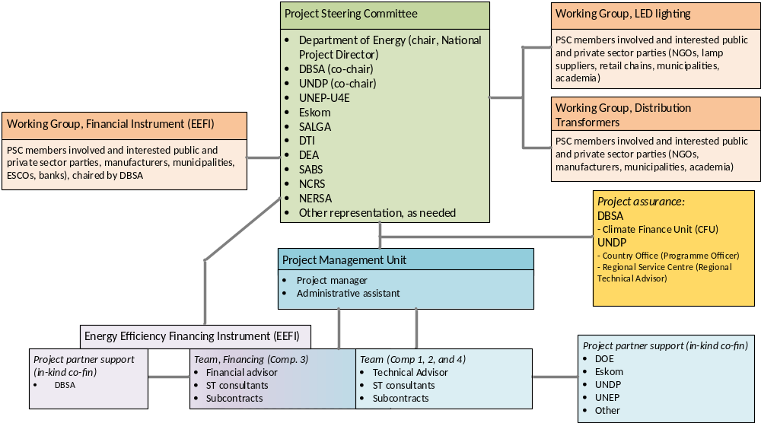

The Project Steering Committee (PSC, also referred sometimes as the Project Board) is responsible for making consensus management decisions when guidance is required by the Project Manager, including recommendations for the approval of project plans and revisions. In order to ensure UNDP and DBSA’s ultimate accountability, PSC decisions should be made in accordance with standards that shall ensure management for development results, best value money, fairness, integrity, transparency, and effective international competition. The PSC will also closely oversee and take account of results from monitoring and evaluation efforts. The Terms of Reference for the PSC are contained in Annex C.

The PSC will be chaired by the National Project Director (NPD). The Director of Clean Energy of DoE, or another senior DoE official, will be appointed by the Director-General of the Department of Energy (DoE) as NPD. The PSC will also include representatives of other Departments (such as DTI, DEA), specialised government agencies (e.g. SANEDI, CNRS, SABS) and non-government stakeholders with voting rights s to be determined at the Inception of the Project. In addition, the PSC can invite organisations to attend without voting rights.

Given the special thematic and technical issues covered by the Project, and to ensure more agile decision-making regarding output-level implementation, the Project governance structure is complemented by three Working Groups that work more on an operational-technical level than the senior management staff that participate in the PSC. The Working Group on Financing will be co-chaired by DBSA (possibly the person that will act as EEFI Fund Manager) and DOE, the WG on LED Lighting by DOE and DTI (or one of their agencies), and the WG on Distribution Transformers is proposed to be co-chaired by DOE and Eskom. Other government entities, associations, academia, institutions, private sector and non-governmental organisations will be invited to send a representative. The WGs will meet on a quarterly basis or as needed

A Project Manager will head a small Project Management Unit (PMU) that will run the project on a day-to-day basis on behalf of the two Implementing Partners within the constraints laid down by the PSC. The cost of the PM is charged entirely to the UNDP budget (see Section 10), but the PM will be responsible for the entire project (both UNDP and DBSA-supported activities. The PMU will be hosted by DOE, although staff may be based at DBSA or housed separately. It is expected that the PMU will be staffed full-time by the Project Manager and an Administrative Assistant, and part-time by the two Advisors. A Financial Advisor will be responsible (with DBSA’s Climate Finance Unit) for day-to-day operations of the Energy Efficiency Financing Instrument (EEFI). A Technical Advisor (part-time) will focus on efficient lighting and distribution transformers in Components 1,2 and 3. There will be no other project office, but project staff will travel regularly to other cities in South Africa, notably municipalities that will receive support services from the Projects especially in the Components 3 and 4), Short-term consultants and experts are likely to be home-based although may be present at the PMU for a specified time. Although not part of the PMU, staff from implementing agencies and partner organisations (DOE, DBSA, UNDP, UNEP) will provide support as part of their in-kind co-financing contributions. For example, DBSA staff will work with the PMU (in particular its Financial Advisor)

The Project Manager function will end when the final project terminal evaluation report, and other documentation required by the GEF and UNDP, have been completed and submitted to UNDP (including operational closure of the project). The Project Manager will act as secretary of the PSC and its WGs and be the interface between Board, WGs, UNDP and DBSA. For the Project amount payable will be charged in the UNDP budget under ‘project management. S/he will also perform technical advice related to the work in the various Components which will be charged to the individual Components. A full-time Administrative Assistant will provide support to the Project Manager in all tasks of the project, including administration, management of information and contacts, logistics, representing the project when the Project Manager is unavailable, and so on. The Project Manager will supervise the Advisors, short-term experts and contracted companies on LED lighting, distribution transformers, and financing modalities. These team will operate in fulfilling the research, policy development, communications and outreach, technical assistance and implementation embodied in all the components. The exact contractual modalities for experts will be determined on a case-by-case basis based on the match of tasks and qualifications (most likely, year-to-year service contracts or individual contracts with lump-sum payments for specific outputs). Experts may be stationed within or outside the project office or may work home-based.

The Project Implementing Agencies, are UNDP and DBSA, who are responsible to the GEF for the use of project resources as written in the Project Document, or any amendments agreed to it by all donors. The two Implementing Agencies will provide three-tier supervision, oversight, and quality assurance role – funded by the GEF agency fee – involving UNDP staff in Country Offices and at regional and headquarters levels and by DBSA staff. Project assurance is independent of the Project Management function. The quality assurance role supports the Project Board and Project Management Unit by carrying out objective and independent project oversight and monitoring functions. This role ensures appropriate project management milestones are managed and completed. UNDP or DBSA cannot delegate any of its quality assurance responsibilities to the Project Manager. This project oversight and quality assurance role are covered by the GEF Agency fee. Organisational costs incurred by UNDP in terms of staff time are charged to the GEF Agency Fee, which is 9% of the GEF budget for the project, equivalent to USD 900,000 (as indicated in the GEF CEO Endorsement Request form) to be divided over UNDP (50%) and DBSA (50%).

Financial Planning and Management

Total financing: The total cost of the project is USD 89,530,000. This is financed through a GEF grant of USD 10,000,000, USD 41,000,000 in cash co-financing and USD 38,530,000 in in-kind and loan co-financing (including USD 600,000 from UNDP).
As GEF Implementing Agencies, UNDP is responsible for the execution of USD 5,000,000 of GEF resources and DBSA is responsible for the execution of USD 5,000,000 of the GEF resources.

Parallel co-financing: The actual realization of project co-financing will be monitored during the mid-term review and terminal evaluation process and will be reported to the GEF. The planned parallel co-financing will be used as follows:

Box 14 Co-financing and sources

Confirmed co-financing source | Co-fin. type | Co-financing (USD) | Planned Activities/Outputs | Risks | Risk Mitigation Measures
DOE | Grant | 41,000,000 | Financial support for municipalities from its MEEDSM programme (ZAR 300 million a year) of which 23% is taken as co-financing (over 4 years) to finance efficient public and street lighting and from the INEP programme and amount of USD 21 million) is earmarked for HE distribution transformers upgrade/expansion | Government diverts funds and priorities to other areas. Treasury will lower the budget for MEEDSM and for electricty networks | The Project will argue for the importance of continuation of energy efficiency support and financing
DOE | In-kind | 1,650,000 | Office space (for project staff and events); Support to and participation of staff in capacity building, planning and regulations
Eskom | In-kind | 19,000,000 | Specification, development, human resources, purchase and installation of transformers (please note that in comparison with the original co-financing letter the breakdown of the total amount of USD 19 million has changed with a higher share of transformer-related activities) | Delayed implementation of transformer replacement and/or replacement with conventional technology (e.g. due to budget cuts) | Eskom has developed an internal standard for transformer with energy performance
Eskom | In-kind | 19,000,000 | IDM activities (advisory services, promotional campaigns, info sharing) on lighting and transformers | Eskom cuts back on IDM activities | Energy efficiency remains a priority in national planning and also for public companies as Eskom
UNDP | In-kind | 600,000 | Implementation costs of (staff) of a policy-advisory, technical and implementation nature essential to deliver development results | Slow roll-out of project funds and activities | Ensuring project roll-out will ensure that GEF (and DBSA/UNDP) funds are also made available in a timely manner
DBSA | In-kind | 1,100,000 | Implementation costs of (staff) of a financial nature essential to deliver development results | Slow roll-out of funds
DBSA | Loan | 16,000,000 | Leveraging of funding in EEFI by clients’ contribution in financing | Client co-funding requirements change or EEFI can provide less funding | Ensuring that EEFI gets promoted and EEFI financial support is provided
UNEP-GELC | In-kind | 150,000 | Technical expertise and training on developing and operating a lighting test laboratory  Supporting the hosting of seminars and forums on energy-efficient lighting | Delays in setting and approving MVE schemes (and defining role of testing labs) | The Project argues for mandatory standards and labels with an adequate MVE system introduced in a timely manner
UNEP | In-kind | 30,000 | Staff time to provide coordination support and strategic advice, and participate in events | Slow roll-out of project funds and activities | Provide collaboration and support

The text below concerns the GEF funds managed by UNDP

Budget Revision and Tolerance: As per UNDP requirements outlined in the UNDP POPP, the project board will agree on a budget tolerance level for each plan under the overall annual work plan allowing the project manager to expend up to the tolerance level beyond the approved project budget amount for the year without requiring a revision from the Project Board. Should the following deviations occur, the Project Manager and UNDP Country Office will seek the approval of the UNDP-GEF team to ensure accurate reporting to the GEF: a) Budget re-allocations among components in the project with amounts involving 10% of the total project grant or more; b) Introduction of new budget items/or components that exceed 5% of original GEF allocation. Any over expenditure incurred beyond the available GEF grant amount will be absorbed by non-GEF resources (e.g. UNDP TRAC or cash co-financing).

Refund to Donor: Should a refund of unspent funds to the GEF be necessary, this will be managed directly by the UNDP-GEF Unit in New York.

Operational completion: The project will be operationally completed when the last UNDP-financed inputs have been provided and the related activities have been completed. This includes the final clearance of the Terminal Evaluation Report (that will be available in English) and the corresponding management response, and the end-of-project review Project Board meeting. The Implementing Partner through a Project Board decision will notify the UNDP Country Office when operational closure has been completed. At this time, the relevant parties will have already agreed and confirmed in writing on the arrangements for the disposal of any equipment that is still the property of UNDP.

Financial completion: The project will be financially closed when the following conditions have been met: a) The project is operationally completed or has been cancelled; b) The Implementing Partner has reported all financial transactions to UNDP; c) UNDP has closed the accounts for the project; d) UNDP and the Implementing Partner have certified a final Combined Delivery Report (which serves as final budget revision).

Project closure: The project will be financially completed within 12 months of operational closure or after the date of cancellation. Between operational and financial closure, the implementing partner will identify and settle all financial obligations and prepare a final expenditure report. The UNDP Country Office will send the final signed closure documents including confirmation of final cumulative expenditure and unspent balance to the UNDP-GEF Unit for confirmation before the project will be financially closed in Atlas by the UNDP Country Office.

Total UNDP Budget and Work Plan

This Table is for the UNDP budget only. The CEO ER template will have budget of all the GEF funding managed by both UNDP and DBSA, while details of both budgets are also presented in Annex H. The DBSA budget (USD 5 million) is in the DBSA Project Document

Total Budget and Work Plan
Atlas Proposal or Award ID: | 00100653 | Atlas Primary Output Project ID: | 00096730
Atlas Proposal or Award Title: | Leapfrogging South Africa’s markets to high-efficiency LED lighting and high efficiency distribution transformers
Atlas Business Unit | ZAF10
UNDP-GEF PIMS No. | 5509
Implementing Partner | Department of Energy

GEF Component/Atlas Activity | Responsible Party (ATLAS Implementing Agent) | Funding ID | Donor Name | Atlas Budgetary Account Code | ATLAS Budget Description | Amount Year 1 (USD) | Amount Year 2 (USD) | Amount Year 3 (USD) | Amount Year 4 (USD) | Total (USD) | Budget Note:
Outcome 1: Strengthened government capacity and regulatory frameworks for LEDs and distribution transformers | UNDP | 62000 | GEF | 71200 | International consultants | 40,000 | 30,000 | 20,000 | 36,000 | 126,000 | 1
 |  |  |  | 72300 | Local consultants | 35,000 | 32,000 | 32,000 | 35,000 | 134,000 | 1a
 |  |  |  | 71400 | Contractual services - individual | 18,783 | 18,783 | 18,783 | 18,783 | 75,132 | 2
 |  |  |  | 71600 | Travel | 15,000 | 10,000 | 10,000 | 13,800 | 48,800 | 3
 |  |  |  | 72100 | Contractual services -company | 190,000 | 190,000 | 100,000 | 140,000 | 620,000 | 4
 |  |  |  | 72200 | Equipment and furniture | 75,000 | 25,000 | 400,000 | 0 | 500,000 | 5
 |  |  |  | 74200 | AV & printing cost | 5,000 | 5,000 | 5,000 | 5,000 | 20,000 | 6
 |  |  |  | 75700 | Training, workshops | 50,000 | 75,000 | 25,000 | 25,000 | 175,000 | 7
 |  |  |  | 74500 | Miscellaneous | 5,000 | 5,000 | 5,000 | 5,000 | 20,000 | 13
 |  |  |  |  | Total outcome 1 | 433,783 | 390,783 | 615,783 | 278,583 | 1,718,932
Outcome 2: Awareness, knowledge and capacity enhanced of end-users, municipalities and private sector | UNDP | 62000 | GEF | 71200 | International consultants | 40,000 | 50,000 | 50,000 | 59,500 | 199,500 | 8
 |  |  |  | 72300 | Local consultants | 75,000 | 75,000 | 50,000 | 77,500 | 277,500 | 8a
 |  |  |  | 71400 | Contractual services - individual | 15,000 | 15,000 | 15,000 | 11,350 | 56,350 | 9
 |  |  |  | 71600 | Travel | 25,000 | 20,000 | 27,500 | 18,600 | 91,100 | 10
 |  |  |  | 72100 | Contractual services -company | 200,000 | 250,000 | 250,000 | 205,000 | 905,000 | 11
 |  |  |  | 72200 | Equipment and Furniture | 25,000 | 25,000 | 0 | 0 | 50,000 | 12
 |  |  |  | 74500 | Miscellaneous | 5,000 | 5,000 | 4,000 | 6,350 | 20,350 | 13
 |  |  |  | 72500 | Supplies | 5,000 | 5,000 | 5,000 | 5,000 | 20,000 | 14
 |  |  |  | 74200 | AV & printing cost | 11,000 | 15,000 | 15,000 | 11,150 | 52,150 | 14
 |  |  |  | 75700 | Training, workshops and conferences | 150,000 | 150,000 | 60,000 | 75,500 | 435,500 | 15
 |  |  |  |  | Total outcome | 551,000 | 610,000 | 476,500 | 469,950 | 2,107,450
Outcome 4: Environmentally sound management and waste disposal practices | UNDP | 62000 | GEF | 71200 | International consultants | 25,000 | 16,000 | 16,000 | 27,000 | 84,000 | 16
 |  |  |  | 72300 | Local consultants | 15,000 | 15,000 | 10,000 | 10,000 | 50,000 | 16a
 |  |  |  | 71400 | Contractual services - individual | 18,783 | 18,783 | 18,783 | 18,783 | 75,132 | 17
 |  |  |  | 71600 | Travel | 8,000 | 8,000 | 8,000 | 6,200 | 30,200 | 18
 |  |  |  | 72100 | Contractual services -company | 100,000 | 75,000 | 75,000 | 50,000 | 300,000 | 19
 |  |  |  | 72200 | Equipment and furniture |  | 50,000 | 50,000 | 0 | 100,000 | 20
 |  |  |  | 74200 | AV & printing cost | 4,000 | 4,000 | 4,000 | 810 | 12,810 | 21
 |  |  |  | 75700 | Training, workshops and conferences | 15,000 | 15,000 | 15,000 | 5,000 | 50,000 | 22
 |  |  |  | 74500 | Miscellaneous | 4,233 | 4,233 | 4,233 | 4,233 | 16,932 | 13
 |  |  |  |  | Total outcome | 190,016 | 206,016 | 201,016 | 122,026 | 719,074
Project management | UNDP | 62000 | GEF | 71200 | International consultants |  | 0 | 0 | 0 | 0
 |  |  |  | 71400 | Contractual services - individual | 106,066 | 106,066 | 106,066 | 106,066 | 424264 | 24
 |  |  |  | 72300 | Local consultants |  |  |  |  | 0
 |  |  |  | 71600 | Travel | 2,025 | 2,025 | 2,025 | 2,205 | 8280 | 25
 |  |  |  | 74100 | Professional Services | 4,000 | 4,000 | 4,000 | 3,000 | 15000 | 26
 |  |  |  | 72200 | Equipment and furniture | 5,000 | 0 | 0 | 0 | 5000 | 27
 |  |  |  | 72500 | Supplies | 0 | 0 | 0 | 0 | 0
 |  |  |  | 74200 | AV & printing cost | 500 | 500 | 500 | 500 | 2000 | 6
 |  |  |  |  | Total PM | 117,591 | 112,591 | 112,591 | 111,771 | 454,544
 |  |  |  |  | PROJECT TOTAL | 1,292,390 | 1,319,390 | 1,405,890 | 982,330 | 5,000,000

 | GEF Component/Atlas Activity | Executing agency | Donor Name | Budget Description | Amount Year 1 (USD) | Amount Year 2 (USD) | Amount Year 3 (USD) | Amount Year 4 (USD) | Total (USD) | Budget Note:
 | Outcome 3: Financial support programmes designed and operational | DBSA | GEF | Staff | 154,000 | 154,000 | 154,000 | 154,000 | 616,000 | 1
 |  |  |  | Consultants | 50,000 | 40,000 | 30,000 | 22,500 | 142,500 | 2
 |  |  |  | Travel | 15,000 | 13,000 | 12,000 | 7,250 | 47,250 | 3
 |  |  |  | Operating | 40,000 | 45,000 | 35,000 | 36,000 | 156,000 | 4
 |  |  |  | Equipment | 15,000 | 6,000 | 0 | 0 | 21,000 | 5
 |  |  |  | Grant | 800,000 | 1,100,000 | 1,200,000 | 900,000 | 4,000,000 | 6
 |  |  |  | Misc | 7,500 | 5,000 | 2,500 | 1,750 | 16,750 | 7
 |  |  |  | Total outcome | 1,081,500 | 1,360,000 | 1,433,500 | 1,122,000 | 5,000,000

Summary table of finance

Summary of project finance | Amount Year 1 (USD) | Amount Year 2 (USD) | Amount Year 3 (USD) | Amount Year 4 (USD) | Total (USD)
GEF (UNDP-managed) | 1,292,390 | 1,319,390 | 1,405,890 | 982,330 | 5,000,000
GEF (DBSA-managed) | 1,086,500 | 1,360,500 | 1,431,000 | 1,122,000 | 5,000,000
DOE | 10,662,500 | 10,662,500 | 10,662,500 | 10,662,500 | 42,650,000
Eskom | 4,000,000 | 5,500,000 | 5,500,000 | 4,000,000 | 19,000,000
UNDP | 50,000 | 50,000 | 50,000 | 50,000 | 200,000
DBSA | 4,275,000 | 4,275,000 | 4,275,000 | 4,275,000 | 17,100,000
UNEP | 7,000 | 9,000 | 7,000 | 7,000 | 30,000
GELC | 50,000 | 50,000 | 50,000 |  | 150,000
Total | 21,423,390 | 23,226,390 | 23,381,390 | 21,098,830 | 89,130,000

Budget notes:
1) For international consultants (36 person-weeks), of which 11 weeks S&L and MVE expert, testing lab expert (11 weeks), lighting & LED expert (7 weeks) and distribution transformer experts (7 weeks).
1a) For national consultants (44 weeks), of which S&L and MVE expert (8 weeks), lighting & LED (14 weeks) and distribution transformation experts (14 weeks), as well as gender expert (6 weeks) and communication consultant (2 weeks)
2) For time spent by Technical Advisor (32 weeks)
3) Travel for project staff, international and national experts (Component 1)
4) For subcontracts on a) Lighting market assessments and low-carbon data (USD 280,000) b) Market assessment distributor transformers (USD 100,000), and c) TA support testing laboratories (USD 240,000)
5) Equipment includes office furniture and IT equipment (Component 1), as well as equipment purchased as part of the laboratory strengthening activities of Output 1.3
6) Audio-visual and printing for project publications, reports and for printed materials for workshops and seminars
7) Organisation of seminar/workshop/training: venue, catering, and support services
8) Component 2 (training, capacity strengthening, awareness creation): For international consultants (49 person-weeks), of which 8 weeks S&L and MVE expert, testing lab expert (4 weeks), lighting & LED expert (14 weeks) and distribution transformer experts (14 weeks). In addition, Component 2 includes expertise for M&E (mid-term review and final evaluation, USD 48,000 in total)
8a) For national consultants (103 weeks), of which S&L and MVE expert (2 weeks), testing lab consultant (10 weeks), lighting & LED (38 weeks) and distribution transformation experts (34 weeks) and expertise of LED applications in buildings (10 weeks), consultants on communication and information (6 weeks) and lamp waste management (3 weeks). In addition, Component 2 includes expertise for M&E (mid-term review and final evaluation, USD 48,000 in total)
9) For time spent by Technical Advisor (33 weeks)
10) Travel for project staff, international and national experts (Component 2)
11) For subcontracted companies for a) Technical support municipalities and public buildings (USD 440,000), b) design and delivery of communication, awareness and knowledge dissemination (USD 250,000) and technical assistance to selected testing labs (USD 200,000)
12) Equipment includes office furniture and IT equipment, video equipment (Component 2)
13) Miscellaneous
14) Office supplies and stationery, as well as audio-visual and printing for project publications, reports and for printed materials for workshops and seminars (Component 2)
15) Organisation of seminar/workshop/training: venue, catering, and support services
16) Component 4 (environmentally sound management). For international consultants (24 person-weeks), of which lighting & LED expert (6 weeks) and distribution transformer experts (10 weeks), and lamp waste management (8 weeks).
16a) For national consultants (20 weeks), of which Lighting & LED (2 weeks) and distribution transformation experts (10 weeks) and waste management (8 weeks)
17) For time spent by Technical Advisor (32 weeks)
18) Travel for project staff, international and national experts (Component 4)
19) Equipment includes office furniture and IT equipment (Component 4), as well as equipment purchased as part of Outputs 4.1 and 4.2 to do research and strengthen waste recycling and mercury recovery facilities and facilities to do research on processing of vegetable oil for transformer manufacturing.
20) Equipment includes office furniture and IT equipment (Component 4), as well as equipment for research and trial production of vegetable oil for oil-filled transformers
21) Audio-visual and printing for project publications, reports and for printed materials for workshops and seminars
22) Organisation of seminar/workshop/training: venue, catering, and support services
24) Time spent on managerial and general organizational-administrative tasks by Project Manager (110 weeks) and Project Assistant (188 person-weeks)
25) Travel for M&E (see Budget Note 23) and project staff (Project manager)
26) Audit fee – Annually as per DBSA and UNDP audit policies
27) Office and IT equipment and operating cost of Project Management Unit

Details of the UNDP and DBSA budgets and co-financing are provided in Annex H.

Legal Context

This project document shall be the instrument referred to as such in Article 1 of the Standard Basic Assistance Agreement between the Government of South Africa and UNDP. All references in the SBAA to “Executing Agency” shall be deemed to refer to “Implementing Partner.”

This project will be implemented by the Department of Energy (“Implementing Partner”) in accordance with its financial regulations, rules, practices and procedures only to the extent that they do not contravene the principles of the Financial Regulations and Rules of UNDP. Where the financial governance of an Implementing Partner does not provide the required guidance to ensure best value for money, fairness, integrity, transparency, and effective international competition, the financial governance of UNDP shall apply.

Risk Management

Consistent with the Article III of the SBAA, the responsibility for the safety and security of the Implementing Partner and its personnel and property, and of UNDP’s property in the Implementing Partner’s custody, rests with the Implementing Partner. To this end, the Implementing Partner shall:
- put in place an appropriate security plan and maintain the security plan, taking into account the security situation in the country where the project is being carried;
- assume all risks and liabilities related to the Implementing Partner’s security, and the full implementation of the security plan.

UNDP reserves the right to verify whether such a plan is in place, and to suggest modifications to the plan when necessary. Failure to maintain and implement an appropriate security plan as required hereunder shall be deemed a breach of the Implementing Partner’s obligations under this Project Document.

The Implementing Partner agrees to undertake all reasonable efforts to ensure that no UNDP funds received pursuant to the Project Document are used to provide support to individuals or entities associated with terrorism and that the recipients of any amounts provided by UNDP hereunder do not appear on the list maintained by the Security Council Committee established pursuant to resolution 1267 (1999). The list can be accessed via http://www.un.org/sc/committees/1267/aq_sanctions_list.shtml.

Social and environmental sustainability will be enhanced through application of the UNDP Social and Environmental Standards (http://www.undp.org/ses) and related Accountability Mechanism (http://www.undp.org/secu-srm).
The Implementing Partner shall: (a) conduct project and programme-related activities in a manner consistent with the UNDP Social and Environmental Standards, (b) implement any management or mitigation plan prepared for the project or programme to comply with such standards, and (c) engage in a constructive and timely manner to address any concerns and complaints raised through the Accountability Mechanism. UNDP will seek to ensure that communities and other project stakeholders are informed of and have access to the Accountability Mechanism.
All signatories to the Project Document shall cooperate in good faith with any exercise to evaluate any programme or project-related commitments or compliance with the UNDP Social and Environmental Standards. This includes providing access to project sites, relevant personnel, information, and documentation.
The Implementing Partner will take appropriate steps to prevent misuse of funds, fraud or corruption, by its officials, consultants, responsible parties, subcontractors and sub-recipients in implementing the project or using UNDP funds. The Implementing Partner will ensure that its financial management, anti-corruption and anti-fraud policies are in place and enforced for all funding received from or through UNDP.

The requirements of the following documents, then in force at the time of signature of the Project Document, apply to the Implementing Partner: (a) UNDP Policy on Fraud and other Corrupt Practices and (b) UNDP Office of Audit and Investigations Investigation Guidelines. The Implementing Partner agrees to the requirements of the above documents, which are an integral part of this Project Document and are available online at www.undp.org.

In the event that an investigation is required, UNDP has the obligation to conduct investigations relating to any aspect of UNDP projects and programmes. The Implementing Partner shall provide its full cooperation, including making available personnel, relevant documentation, and granting access to the Implementing Partner’s (and its consultants’, responsible parties’, subcontractors’ and sub-recipients’) premises, for such purposes at reasonable times and on reasonable conditions as may be required for the purpose of an investigation. Should there be a limitation in meeting this obligation, UNDP shall consult with the Implementing Partner to find a solution.

The signatories to this Project Document will promptly inform one another in case of any incidence of inappropriate use of funds, or credible allegation of fraud or corruption with due confidentiality. Where the Implementing Partner becomes aware that a UNDP project or activity, in whole or in part, is the focus of investigation for alleged fraud/corruption, the Implementing Partner will inform the UNDP Resident Representative/Head of Office, who will promptly inform UNDP’s Office of Audit and Investigations (OAI). The Implementing Partner shall provide regular updates to the head of UNDP in the country and OAI of the status of, and actions relating to, such investigation.

UNDP shall be entitled to a refund from the Implementing Partner of any funds provided that have been used inappropriately, including through fraud or corruption, or otherwise paid other than in accordance with the terms and conditions of the Project Document. Such amount may be deducted by UNDP from any payment due to the Implementing Partner under this or any other agreement.

Where such funds have not been refunded to UNDP, the Implementing Partner agrees that donors to UNDP (including the Government) whose funding is the source, in whole or in part, of the funds for the activities under this Project Document, may seek recourse to the Implementing Partner for the recovery of any funds determined by UNDP to have been used inappropriately, including through fraud or corruption, or otherwise paid other than in accordance with the terms and conditions of the Project Document.

Note: The term “Project Document” as used in this clause shall be deemed to include any relevant subsidiary agreement further to the Project Document, including those with responsible parties, subcontractors and sub-recipients.

Each contract issued by the Implementing Partner in connection with this Project Document shall include a provision representing that no fees, gratuities, rebates, gifts, commissions or other payments, other than those shown in the proposal, have been given, received, or promised in connection with the selection process or in contract execution, and that the recipient of funds from the Implementing Partner shall cooperate with any and all investigations and post-payment audits.

Should UNDP refer to the relevant national authorities for appropriate legal action any alleged wrongdoing relating to the project, the Government will ensure that the relevant national authorities shall actively investigate the same and take appropriate legal action against all individuals found to have participated in the wrongdoing, recover and return any recovered funds to UNDP.

The Implementing Partner shall ensure that all of its obligations set forth under this section entitled “Risk Management” are passed on to each responsible party, subcontractor and sub-recipient and that all the clauses under this section entitled “Risk Management Standard Clauses” are included, mutatis mutandis, in all sub-contracts or sub-agreements entered into further to this Project Document.

Annexes

- Multi-year workplan
- Consultancies and subcontracts
- Terms of Reference of PSC and staff
- Gender analysis and action plan
- Baseline conditions on markets, stakeholders, policy and regulations for LEDs and distribution transformers
- GEF Core Indicators and calculation of greenhouse gas emission reduction
- Stakeholder engagement and communication plan
- Additional budget and co-financing tables
- UNDP Social and Environmental and Social Screening
- Agreements
- UNDP Risk Log (to be completed by UNDP Country Office)
- Results of the capacity assessment of the project implementing partner and HACT micro assessment (to be completed by UNDP Country Office)
- UNDP Project Quality Assurance Report (to be completed after endorsement)

- Multi-Year Work Plan

Output/activity per outome | Year 1 |  |  |  | Year 2 |  |  |  | Year 3 |  |  |  | Year 4
Output/activity per outome | Q1 | Q2 | Q3 | Q4 | Q1 | Q2 | Q3 | Q4 | Q1 | Q2 | Q3 | Q4 | Q1 | Q2 | Q3 | Q4
OUTCOME 1 Strengthened government capacity and regulatory frameworks for LEDs and distribution transformers
Output 1.1 National coordination, assessment and strategy realised
1.1.1 Market assessments implemented on lighting products and distribution transformers
1.1.2 Establishment of working groups on lighting products and distribution transformers
1.1.3 Strategies and action plans developed for HE lighting and HE distribution transformers
Output 1.2 S&L and MVE system developed for LED lighting and distribution transformers
1.2.1 Proposals for (mandatory) labelling and MEPS (S&L) for lighting and MVE system
1.2.2 Proposal for setting up MEPS and MVE system for distribution transformers
1.2.3 Capacity strengthening and stakeholder engagement on standards and labelling
Output 1.3 Strengthened capacity of testing labs and testing of products
1.3.1 Assessment of capacity needed to do photometric test (lighting) and transformers in accredited facilities
1.3.2 Provide assistance to upgrade testing facilities and support accreditation
1.3.3 Testing of selected products carried out and publication of results
Outcome 2 Awareness, knowledge and capacity enhanced of end-users, municipalities and private sector
Output 2.1 Capacity needs assessment conducted for national and local government entities, RE market actors and beneficiaries
2.2.1 Development and implementation of gender-sensitive campaign for households and businesses on efficient lighting and waste disposal
2.2.2 Capacity strengthening of staff of retailers and wholesalers on EE lighting promotion
2.2.3 Capacity strengthening of commercial building owners and ESCO
Output 2.2 Capacity strengthened of municipalities to formulate EE programmes
2.2.1 Capacity and knowledge strengthening of municipal staff and decision-makers
2.2.2 Technical assistance support to develop municipal energy efficiency planning
Output 2.3 Increased capacity for local production of LED products and distribution transformers
2.3.1 Technical support for manufacturers of local LED products
2.3.2 Technical support to suppliers to manufacture high-efficiency distribution transformers
OUTCOME 3 Increased investments in rural RE to meet household demand, PUE and enterprise development
Output 3.1 Designed and implemented off-grid RE solutions and models integrated with PUE implemented in selected villages
3.1.1. EEFI governance structure set up
3.1.2 EEFi funding is made available through GEF’s facility to finance LED lighting and distribution transformer projects
3.1.3 Bridge finance is provided for the mass-procurement of residential LED lamps, working in collaboration with existing energy programs of the municipalities
3.1.4 EEFI funding is made available to suppliers, manufacturer to set up or upgrade the production facility of LED products and transformers
Output 3.2 Financial advice service provided to prospective applicants
3.2.1 Advice services provided to prospective applicants on financing modalities and structuring of proposals
OUTCOME 4 Environmentally sound management and waste disposal practices
Output 4.1 Assessed and facilitated commercial financial support for rural RE energy projects
4.1.1 Assessment of current practice in recycling of (fluorescent) lamps, waste handling
4.1.2 Provide training to municipal officials on environmentally sound management of lamp waste
Output 4.2 Assessed issues and options of using vegetable oil in liquid-filled transformers
4.2.1 Assessment of the issues and options of using vegetable oil in liquid-filled transformers

- Consultancies and subcontracts

The table below gives an overview of short-term staff and subcontracts hired with UNDP-managed GEF funding.

Expertise | Inter-national | National | Description
 | (weeks)
S&L MVE system | 19 | 10 | For lighting and for transformers, the expert(s) will: a) conduct a capacity assessment of the agencies/entities (including Customs) involved in compliance and verification; b) in consultation with the key stakeholders, draft proposals for a strengthened compliance checking and enforcement scheme for lighting products, including organisation of testing, suggested procedures in the case of non-compliance (Component 1). In Component 2, the expert(s) will provide training to the key stakeholders to further develop and implement the adopted schemes;
Lighting and LED | 23 | 53 | The experts will review the existing EE policies and identify gaps and propose changes by taking into account the most recent international developments regarding EE lighting, and provide input in recommended policy-regulatory changes (for lighting). The national expert will assist in the establishment of stakeholder Working Groups (Component 1) and serve as focal point of the project on LED issues. In addition, the experts will provide advice and support to partner municipalities.  International and national experts will be involved in designing and delivering training to build the capacity of the local stakeholders on lighting technology, communication and promotion, and international developments. The experts will work with the Expert S&L and MVE on the regulatory framework (labels, MEPS, procurement). S/he will advise and assess on local production issues and options of lighting products.
Distribution transformers application and production | 31 | 54 | The experts will review the existing EE policies and identify gaps and propose changes by taking into account the most recent international developments regarding transformers and provide inputs for policy-regulatory changes (MEPS, procurement). The national expert will assist in the establishment of stakeholder Working Groups (Component 1) and serve as a focal point on transformer issues. In addition, the experts will provide advice and support to partner municipalities.  National and international experts will be involved in designing and delivering training to build the capacity of the local stakeholders for designing municipal policies on transformers and technical subjects (component 2). The expert(s) will provide advice and analysis on local production of high-efficiency transformers and issued and options in replacing mineral oil by vegetable oil. The experts will work with the Expert S&L and MVE on the regulatory framework (MEPS, procurement)
Testing and accreditation | 15 | 10 | The experts will a) conduct a capacity assessment of the testing facilities to identify the existing gaps and further improvement needs of the existing testing facilities (both in terms of hardware and capacity of the staff) to effectively implement the proposed compliance checking program and achieve accreditation. As applicable, the experts will support training programs and prepare technical specifications for the new hardware to be purchased for testing, together with initial budget estimates (Component 1).
LED luminaires and buildings | 7 | 10 | The expert(s) will provide training sessions for engineering firms, designers, architects, and market partners to install efficient and effective lighting products in buildings
Communications and marketing |  | 8 | Provide support on the communication activities such as the awareness raising and marketing campaigns that will be undertaken by DOE, municipalities and private sector for various income-levels (lower, higher, middle).
Gender and social expert |  | 6 | The gender expert will advise on gender-inclusive data gathering and storage (in particular in the assessments of Output 1.1), on the implementation of the Gender Action Plan (see Annex D) and provide advice on gender-aspects in communication and awareness creation (Output 2.1).
Lamp waste management | 10 | 10 | The expert(s) will assist in carrying out an assessment of existing firms having the required know-how within South Africa or outside on recycling and disposal of lamp waste. S/he will provide advice on management and handling of the mercury content in discarded CFLs and regarding the options of industrial processing and disposal of the collected hazardous waste (mercury) of fluorescent lamps
Lighting market assessments and low-carbon data  (at the beginning and at the end of the Project) | Subcontracts  (USD 280,000) |  | One or more entities will be contracted to collect and analyse the already available information (used for quantifying and characterizing the current state and forecasted market development of lighting products; categories and market share of key products, producers, consumers, distribution networks and energy consumption characteristics). The contracted company will design and facilitate the implementation of specific market surveys, in particular, household/end-user surveys (regarding lamp usage, lamp preferences, perceptions, and attitudes) and to collect the info (mentioned above).  The contractor will support the development of an info system that will collect, store and present information about the existing stock and imports and sale of lighting products by their type and energy performance, taking into account the energy data needed to define the energy categories in the labelling system A-G and MEPs. The contractor will analyse the received information and make an economic analysis (least-cost, statistical analysis of market data) to advise on MEPS and recommend energy consumption categories for the labels A-G.
Market assessment distributor transformers | Subcontracts  (USD 100,000) |  | The contracted party will carry out a market study on distribution transformers will be carried out (installed transformers technology, type, size, and losses; costs) at Eskom and municipalities, including sales by suppliers per type and characteristics.  Support the development of an info system that will collect, store and present information about the existing stock and imports and sale of lighting products by their type and energy performance, taking into account the energy data needed to MEPs and define procurement guidelines (for Eskom and municipalities).
Technical support municipalities and public buildings | Subcontracts  (USD 440,000) |  | Companies will be contracted to identify and carry out technical feasibility assessment of energy efficiency options in low-resource municipalities (incl. lighting in buildings, street lighting, lamp and e-waste, distribution transformers). Staff may be seconded to one or more municipalities for a period of time
TA support for production of vegetable oil-based transformers | Subcontract  (USD 250,000) |  | The contracted party will provide support to prepare a bankable proposal on the production of HE transformers and/or the use of vegetable oil in transformers and subsequent technical assistance to one or more manufacturers of transformers to use vegetable oil and assist in technology transfer to introduce suitable technologies (Component 3, Component 2). Staff may be seconded to one or more municipalities for a period of time.
TA support for CFL (and other lamp) recycling and processing facility | Subcontract  (USD 150,000) |  | The contracted party will provide support (to a selected municipality and/or waste handling company) on management and handling of the mercury content in discarded CFLs and their processing in selected facilities and assist in project preparation and technology transfer to introduce suitable technologies (Component 3)
TA testing labs | Subcontract  (USD 240,000) |  | The contracted party will provide, based on the assessment of the Testing Lab Experts, provide as-needed technical assistance and advice to equip labs and acquire accreditation.
Audit | Subcontract  (USD 15,000) |  | As part of the mandatory M&E, the contracted party will undertake project audits as per UNDP procedure and annual audit plan and prepare final audit report as per UNDP instructions.
Communication, awareness and knowledge dissemination | Subcontract  (USD 280,000) |  | The contracted company will design and deliver a publicity and awareness campaign (broadcasting, newspapers, TV/radio). In addition, the contracted party will help design materials (TV, radio, newspapers, magazines, Internet) on awareness and knowledge on EE lighting for consumers, and on lighting and efficient power distribution for municipality staff. The company will support ST experts in developing case studies, best practices, and lessons learned (Component 2 and M&E).

Component 3

Expertise | Inter-national | National |  | Description
EEFI short-term experts | 15 |  | 36 | On an as-needed basis, short term, experts will be hired to provide consultancy on legal, financial and technical issues surrounding performance contracting and ESCO-based financing modalities. Experts will be involved in training (both in-house at DBSA) as well as beneficiaries (municipalities, ESCOs, building owners, etc.) and help in the evaluation of EEPI loan/grant applications. In providing support to municipalities, the experts will coordinate with the technical experts (lighting &LED; transformers) and consultants of the Contract “Technical support municipalities and public buildings”
Financial assistant |  |  | 208 | S/he will support DBSA management of EEFI (under supervision of the Financial Advisor) on administrative and financial matters of EEFI (incl. regular reporting, filing and record keeping; control replenishment and outflows, provide info loans and disbursement, furnish financial and administrative information for audits and evaluations. In addition, the Assistant will support the organisation of in-country training activities, ensuring logistical arrangements, prepare internal and external travel arrangements for EEFI short-term experts and staff.

- terms of reference of PSC and project staff

Terms of Reference for the PROJECT STEERING COMMITTEE

The Project Steering Committee (PSC) will serve as the project’s decision-making body. It will meet according to necessity, at least twice each year, to review project progress, approve project work plans, and activities under specific Outcomes. The PSC is responsible for providing the strategic guidance and oversight to proje
ct implementation to ensure that it meets the requirements of the approved Project Document and achieves the stated outcomes. These Terms of Reference will be detailed and finalized during the Project Inception Workshop, including the list of members of the PSC. The PSC’s role will include:
- Provide strategic guidance to project implementation;
- Ensure coordination between various donor-funded and government-funded projects and programmes;
- Ensure coordination with various government agencies and their participation in project activities;
- Approve annual project work plans and budgets, at the proposal of the Project Manager;
- Approve any major changes in project plans or programmes;
- Oversee monitoring, evaluation, and reporting in line with GEF requirements;
- Ensure commitment of human resources to support project implementation, arbitrating any issues within the project;
- Negotiate solutions between the project and any parties beyond the scope of the project;
- Ensure that UNDP Social and Environmental Safeguards Policy is applied throughout project implementation; and, address related grievances as necessary.

Terms of Reference for the WORKING GROUPS

The two Working Groups will provide technical advice and inputs relating to project implementation with support from the PM. The members of the Working Groups (on LED Lighting, on Distribution Transformers, and on Financing) will consist of representatives from DoE, DTI, UNDP, DBSA, other relevant government agencies (represented in the PSC), Eskom, research and educational organizations, NGOs, lamp suppliers and distributors, transformer manufacturers, local government associations, and other relevant stakeholders to be agreed by the Board, technical experts may be invited in to discuss specific issues. Indicative Terms of Reference are as follows. These will be reviewed by the PSC during project inception and may be extended as necessary. Tasks will include:
- Review planned activities and ensure that they are technically sound and that, wherever possible, there is integration and synergy between the various project components during planning and implementation;
- Promote technical coordination between institutions, where such coordination is necessary and where opportunities for synergy and sharing of lessons exist;
- Provide technical advice and guidance on specific issues concerning LED and efficient lighting and/or efficient power distribution and transformers, in particular on the formulation of standards and labelling of these devices, and the monitoring, verification, and enforcement;
- Support linkage between the DBSA-managed EEFI (Component 3) and other Project activities
- Provide advice and guidance on the Project’s capacity building needs and training, and the implementation of stakeholder outreach (consumer awareness, knowledge, and information of municipalities);
- Share information on project progress and lessons learned with related stakeholders at the national level;
- The Working Group or a subset of its members may be requested to undertake specific project-related tasks, such as preparing or reviewing analytical reports, strategies and action plans, etc.;

National Project Director

Background
The Director of the Clean Energy Branch, or another senior official from the Department of Energy, will be appointed as National Project Director (NPD), by the Director-General of the Department of Energy, in consultation with the UNDP Country Office and DBSA. He/she will be accountable to the Department of Energy, DBSA and UNDP for the achievement of objectives and results in the assigned Project. The NPD will be financed through national government funds (co-financing).

Duties and Responsibilities
- Serve as chairperson and member of the Project Steering Committee.
- Supervise compliance with objectives, activities, results, and all fundamental aspects of project execution as specified in the project document.
- The National Project Director (NPD) bears the responsibility for coordination of project realization, in the name of the Department of Energy, and supervise compliance of project implementation with Government policies, procedures and ensure consistency with national plans and strategies.
- The NPD provides for coordination among project action steps and corresponding steps made in the framework of government programs and relevant incentives.
- The NPD will coordinate with national governmental representatives on legal and financial aspects of project activities.
- The NPD presents various forms of support for the successful execution of the project and corresponding steps after completion of the project, including the long-term persistence of project results
- The NPD may delegate all needed authority to the Project Manager, for the successful implementation of the project.
- The NPD provides for delivery of financial information (including co-financing inputs) and confirms financial and substantive reports on project realization.; the NPD confirms Annual Work Plans and project budgets.
- The NPD provides for collaboration with partners and coordination with departments of the National Implementing Agency and will coordinate and supervise government staff inputs to project implementation.
- The NPD will participate in project evaluation, testing, and monitoring missions.

Project Manager

Background
The Project Manager (PM), will be locally recruited following UNDP procedure, with input to the selection process from the Project partners. The position will be appointed by the project implementing agencies and funded entirely from the Project. Under the supervision of the UNDP Country Office (Environment & Energy Unit) and DSBA (Climate Finance Unit), the PM will be responsible for the overall management of the Project and day-to-day oversight, including the mobilisation of all project inputs, supervision over project staff, consultants and sub-contractors.

The PM will report to the NPD in close consultation with the assigned UNDP Programme Manager for all of the Project’s substantive and administrative issues. From the strategic point of view of the Project, the PM will report on a periodic basis to the PSC, based on the PD’s instruction and will support the NPD. The PM will perform a liaison role with the government, DBSA, UNDP and other UN Environment, CSOs and project partners, and maintain close collaboration with other donor agencies providing co-financing. The PM will work closely with the three Working Groups.

Duties and Responsibilities
- Plan the activities of the project and monitor progress against the approved work-plan.
- Supervise and coordinate the production of project outputs, as per the ProDoc in a timely and quality fashion.
- Coordinate all project inputs and ensure that they adhere to UNDP procedures (for nationally executed projects) and in accordance with DBSA procedures.
- Supervise and coordinate the work of all project staff, consultants and sub-contractors
- Coordinate the recruitment and selection of project personnel, consultants and sub-contracts, including drafting terms of reference and work specifications and overseeing all contractors’ work.
- Facilitate administrative support to subcontractors and training activities supported by the Project.
- Manage requests for the provision of financial resources by UNDP and DBSA through the advance of funds, direct payments, or reimbursement using the UNDP/DBSA-provided format.
- Oversight of the overall administration of the Project Management Unit; and monitor financial resources and accounting to ensure accuracy and reliability of financial reports, submitted on a quarterly basis.
- Prepare, revise and submit project work and financial plans, as required by the PSC, DBSA, and UNDP.
- Oversee and ensure timely submission of the Inception Report, Project Implementation Report, Technical reports, quarterly financial reports, and other reports as may be required by DBSA, UNDP, GEF and other oversight agencies.
- Disseminate project reports and respond to queries from concerned stakeholders.
- Report progress of the Project to the PSC, and ensure the fulfilment of PSC directives.
- Ensure the Project’s M&E meets the requirements of the Government, the UNDP Country Office, and UNDP-GEF; develop project-specific M&E tools as necessary;
- Oversee and ensure the implementation of the Project’s M&E plan, including periodic appraisal of the Project’s Theory of Change and Results Framework with reference to actual and potential project progress and results;
- Oversee/develop/coordinate the implementation of the stakeholder engagement plan;
- Oversee and guide the design of surveys/ assessments commissioned for monitoring and evaluating project results;
- Oversee the exchange and sharing of experiences and lessons learned with relevant community based integrated conservation and development projects nationally and internationally.
- Manage and monitor the project risks initially identified and submit new risks to the project board for consideration and decision on possible actions if required; update the status of these risks by maintaining the project risks log.
- Liaise with DBSA, UNDP, PSC, Working Groups, relevant government agencies, and all project partners, including donor organisations and CSOs for effective coordination of all project activities.
- Assist company, municipalities, CSOs, staff, and others with the development of essential skills through training workshops and on the job training thereby increasing their institutional capabilities.
- Encourage staff, partners and consultants such that strategic, intentional and demonstrable efforts are made to actively include women in the project, including activity design and planning, budgeting, staff and consultant hiring, subcontracting, purchasing, formal community governance, and advocacy, outreach to social organizations, training, participation in meetings; and access to program benefits.
- Assists and advises the Project Implementation Units responsible for activity implementation in the target sites.
- Regular travel within South Africa to organize and monitor project activity; possible travel outside the country for participation in directly relevant international meetings.

Required skills and expertise; Competencies
- A university degree (MSc or PhD) in management, engineering, energy, economics, marketing, or another field with direct relevance to the project
- At least 10 years of experience in managing large-scale projects on climate change mitigation, energy efficiency, and/or and certification labelling of products in South Africa
- At least 5 years of demonstrable project/programme management experience.
- At least 5 years of experience working with ministries, national or provincial institutions with relevance to the project
- Strong leadership, managerial and coordination skills, with a demonstrated ability to effectively coordinate the implementation of large multi-stakeholder projects, including financial and technical aspects.
- Ability to effectively manage technical and administrative teams, work with a wide range of stakeholders across various sectors and at all levels, to develop durable partnerships with collaborating agencies.
- Ability to administer budgets, train and work effectively with counterpart staff at all levels and with all groups involved in the project.
- Ability to coordinate and supervise multiple Project Implementation Units in their implementation of technical activities in partnership with a variety of subnational stakeholder groups, including community and government.
- Strong drafting, presentation and reporting skills.
- Strong communication skills, especially in timely and accurate responses to emails.
- Strong computer skills, in particular, mastery of all applications of the MS Office package and internet search.
- Excellent command of English. Knowledge of other South African languages an advantage.

Administrative Assistant

Under the guidance and supervision of the Project Manager, the Project Assistant will carry out the following tasks:
- Assist the Project Manager in day-to-day management and oversight of project activities;
- Assist the M&E officer in matters related to M&E and knowledge resources management;
- Ensure all project documentation (progress reports, consulting and other technical reports, minutes of meetings, etc.) are properly maintained in hard and electronic copies in an efficient and readily accessible filing system, for when required by the PSC, DBSA, UNDP, project consultants and other PMU staff;
- Provide PMU-related administrative and logistical assistance.

The Project Assistant will be recruited based on the following qualifications:
- A Bachelor’s degree or an equivalent qualification;
- At least three years of work experience preferably in a project involving biodiversity conservation, natural resource management and/or sustainable livelihoods. Previous experience with UN or DBSA projects will be a definite asset;
- Very good inter-personal skills;
- Proficiency in the use of computer software applications especially MS Word and MS Excel.
- Excellent language skills in English (writing, speaking and reading) and in local languages

Financial Advisor

The Financial Advisor will coordinate activities of the DBSA-managed EEFI and will be in charge of ensuring that the EEFI is delivered according to legal, commercial and financial criteria. S/he will:
- Monitor the exposure of the portfolio and responsible for regular reporting to DBSA management and the Project Working Group on EEFI (and Project Board meetings);
- Oversee financial and administrative performance (financial plan, allocation and transfer of funds
- Provide advice on market engagement and research, development of loan products and modalities;
- Assist in finalising the institutional arrangements;
- Supported by DBSA, the Advisor will perform technical evaluation and due diligence of loan requests;
- Ensure cooperation between the non-financial implementing agencies and partners of the project;
- Network with stakeholders
- Ensure timely preparation of annual project reports, work plans and other relevant project documents.
- Oversee financial and administrative performance (financial plan, allocation and transfer of funds, oversee finance and administration officer
- Prepare Terms of Reference for short-term staff and subcontracts under Component 3

S/he will be recruited based on the following qualifications:
- At least 8 years work experience in financial (project) management.
- University education in Financing and/or Business management
- Strong interpersonal and communication skills
- Ability to take decisions
- Excellent working knowledge of English
- Strong computer skills (Microsoft Office, Internet, e-mail)

Technical Advisor

This is a part-time appointment over the duration of the project.

Job content
- Provides overall technical guidance, advice, and support to local Project Manager and project team;
- Assists the Project Coordinator and project team to prepare a detailed Annual Work Plan of all project activities in line with the programming and approved budget - starting and concluding them accordingly;
- Advises the Project Coordinator and project team on the project strategy and implementation methodology;
- Advises on the monitoring and evaluation strategy of the project;
- Supports the independent mid-term review and terminal evaluation consultants; support management responses;
- Identifies information requirements of on the market assessments (Outcome 1) and the project components concerning monitoring and evaluation;
- Facilitates annual reviews of the project and produce analytical reports from these annual reviews, including case studies, lessons learnt, other knowledge management products;
- Assists in the establishment of energy savings and greenhouse gas emission baselines and reporting (tracking too
- Visits project sites as and when required to appraise project progress and validate written progress reports.
- Advises on the implementation of the project’s M&E plan, including periodic appraisal of the Project’s Theory of Change and Results Framework with reference to actual and potential project progress and results

Qualification
- At least 10 years work experience in project design, management and/or monitoring and evaluation, in particular of GEF funded climate change mitigation projects
- Good knowledge of results-based project management, particularly with regards to M&E approach and methods
- Experience in energy efficiency required; experience with standards and labelling an advantage
- University education in engineering, energy, physics, business management or relevant field (at least MSc-eq.)
- Good interpersonal and communication skills
- Strong computer skills (Microsoft Office, Internet); good language skills in English (writing, speaking and reading)

- Gender analysis and action plan

  - Gender mainstreaming analysis

Introduction

A review of the gender equality gap of South Africa found that the country has a very narrow global gender gap Index according to the 2016 Global Gender Gap Report of the World Economic Forum. Accordingly, South Africa is ranked 15th out of 147 countries. The country has moved three notches up from No 18 in 2006 to where it is now, signifying a lot of improvement in closing the gender gap. Improvements in rankings have also been observed in other areas, like in political empowerment, where South Africa is ranked No. 13. With regards to having women representatives in Parliament, the African Human Development Report (2016) ranks South Africa second only after Rwanda. South African has a 42% representation of women in Parliament. Also, according to the African Human Development Index, South Africa is shown to have made progress in a number of other categories assessed, e.g. gender equality; economic dimensions; education etc.

The many pieces of legislation in place that try to address the issue of gender equality are topped by the Constitution of the country. As if to emphasize its stance, the word “gender” in the Constitution is mentioned 157 times; and in terms of our laws and policies, gender mainstreaming is prioritised, meaning government and business should assess, the implications for both men and women of any planned intervention, including all legislation, policies or programmes. In its opening statements, the Constitution asserts the sovereignty of the country, being a democratic state founded on values of human dignity, the achievement of equality, and the advancement of human rights and freedom. This is the first clause in the Constitution. The second clause refers to non-racialism and non- sexism. This is followed by the equality clause in the section of the Bill of Rights.

South Africa also had an Employment Equity Act that has recently been amended to Broad-Based Employment Equity Act. It aims to effect positive transformation in the business world, by addressing the legacy of apartheid and enable greater black economic participation using a point system; and to ensure that no work would be reserved for a special group of people as was the case during apartheid times. Instead, it tries to redress the past imbalances by ensuring that everybody is granted equal employment opportunity, especially Black men and women who were previously disadvantaged by the previous apartheid laws. The Preferential Procurement Policy Framework (PPPF) is the policy instrument devised to assist in the promotion of participation of women in the economy. However, the application and implementation of the PPPF have been fraught with many irregularities and inconsistencies.

Given the evidence of a positive correlation between gender equality and the economic well-being of countries, this makes a compelling argument for equal opportunities and greater inclusion of Women-Owned Businesses (WOBs) in government supply chains. Internationally, where success has been made with the involvement of WOBs, has been in countries where a conducive policy environment exists, accompanied by set goals like in the USA, where a set goal of 5% of federal procurement expenditure is awarded to WOBs. The other contributory mechanism that guaranteed the achievement of this target was the reserving of contracts for WOBs especially in sectors that are viewed as under-represented. South Africa like other countries is characterized by a hostile business environment – corruption, where progress of WOBs, is inhibited by “well-established communication and cronyism”; bribery- in procurement processes, which has become big business globally; preferential treatment towards established contractors; companies fronting as WOBs; lack of information about procurement processes, etc.

South Africa also made use of PPPF to create greater opportunities for formerly-marginalized groups of society to promote their access and visibility in public procurement spending. However, in spite of the PPPF existing WOBs still face barriers in accessing government procurement and supply chains, and they are under-represented in public procurement when compared to their male counterparts, accounting for less than one-quarter of procurement spend.

Contributing factors to this are seen as:
• The absence of a policy stance that explicitly promotes equality for WOBs and drives the promotion of WOBs in public procurement in South Africa.
• Technicalities such as definitional inconsistencies in terms of what is defined as a WOB;
• Lack of standardized targets for allocation of a share of a public procurement to WOBs;
• And the absence of a homogenous monitoring framework to track public procurement spending awarded to WOBs and a lack of repercussions for not meeting targets.

Broadly speaking, there is a non-progressive approach application of ‘women and employment’ policy with various interpretations across national, provincial and local levels of government as well as state-owned enterprises.

South Africa though has made strides in the legal sphere by way of ratifying and or approving a wide range of international and regional norms and conventions, putting its own policies in place, but the application and implementation of these is often flawed by social norms that exist at national and at local level. There are still some significant issues that women still face in South Africa, such as domestic violence, sexual harassment in the workplace, unequal pay etc. Hence 68 years after the Universal Declaration of Human Rights was ratified, and 61 years after the 20,000 women of South Africa marched to the Union Buildings to petition against unjust laws, until the years of Sustainable Development Goals (SDGs) of today, global attention still remains focused on promoting human rights and eliminating discrimination and inequitable outcomes for women, men, girls and boys.

Gender equality: political dimension

Women’s access to political power and decision-making has improved since the 1994 General Elections. There is a strong representation of women in the national, provincial and local legislative branches of government and in some governments departments. The high representation of women in the political sphere in South Africa is especially visible at the national, where in terms of the 2016 rankings by both the African Human Development Report (UNDP, 2016) and the Global Gender Gap Report (World Economic Forum, 2016) state that women represent 42% of parliamentarians. At the provincial level, the figure is put at 24%, while at local government 19% of councillors are women and 14% of Executive Committees are female. The challenge to political institutions is to change their culture in order to be more responsive to the needs of women politicians and of civil servants. Having a sizable number of women in ministerial positions, the country is ranked 13th on a global scale. However, as far as the literacy rate is concerned, the country is ranked 85th. This helps to explain the poor performance by the country in a number of spheres including energy, as far as the project under review is concerned.

Gender equality demographic and economic dimensions

According to Statistics South Africa, 2016 mid-ear population estimates put South Africa’s population at 55.9 million). Of this total, approximately 51% is female (28.5 million). About 30.1 million of the population is aged younger than 15 years, and approximately, 8.0% (4.5 million) is 60 years or older. Of note is that the proportion of older persons aged 60 years or older is increasing over time. Life expectancy at birth for 2016 is estimated at 59.7 years for males and 65.1 years for females.

In South Africa, the labour market is highly skewed, meaning that women representation in leadership positions across all sectors in the economy is very low. This, despite the, much talked about, correlation that “introducing more women at leadership level simply introduces broader perspectives and new ways to manage problems. Diversity is the key for a successful organisation. It also allows companies and public entities to tap into their talent pool rather than deprive themselves of half of it”. In terms of economic participation and opportunity are concerned, the country is ranked 63rd with wage equality for similar work ranking even more low at 86th - meaning that women do not receive equal pay as their male counterparts for the same job. Today, women participation in the economy of the country is very low, with women at senior management position/decision-making level, being recorded only at 28%. Contrary to what would be the norm, women in are clustered at the lowest of levels, doing unskilled and low-paying jobs, involved mostly in community work which does not necessarily guarantee them any pay at times, hence the poverty of women in a number of aspects they would otherwise be well-off in.

The lack of women enrolment in Science, Technology, Engineering and Maths (STEM) subjects is tracked down from early childhood where girls are oriented into playing with dolls while boys already start making and playing with sophisticated toys like cars made from wire. The care-taking role of girls is nurtured and girls end up doing that role even in the adult lives. The representation of women at senior management level positions is 25.5 as compared to African male of 34.3%. African women feature prominently at the semi-skilled and unskilled levels. At these levels, discretionary decision making is necessary and African women comprised 46.6% and 55. 6% against their African male counterparts who made 35.6% and 36.2% in the same categories respectively.

The Quarterly Labour Force Survey (Oct 2017) shows that the number of people formally employed in ‘electricity, gas and water supply’ sector in South Africa was 147,379, of which 78.6% male and 21.4% female. The industry sector (mining, energy, manufacturing, construction) as a whole employed 3,931,378 people, of which 76.4% male and 23.6% female. Nation-wide employment figures are 16,419,153 (of which 56% male and 44% female).

The structure and components of the national machinery responsible for gender issues

Immediately after the 1994 elections, South Africa put in place a highly complicated structure that was designed to ensure a comprehensive thrust in all facets of South African lives while avoiding duplication. It entailed structures in government, at parliament, independent bodies and civil society right up to the Equality Court (which adjudicates in cases of unfair discrimination and unequal treatment). Key processes and mechanisms had to be adopted to affirm a vibrant national gender programme that would advance the country towards gender equality. These contained in the various structures of the National Machinery. Principal among these are the Office on the Status of Women, Gender Focal Points; Commission for Gender Equality and various organs of society.

As part of strengthening democracy in the country, the Constitution provided for the establishment of the Commission on Gender Equality (CGE), being the main custodian of gender-related issues in the country. The mandate of the CGE is to advance, promote and protect gender equality through undertaking research, public education, policy development, legislative initiatives, effective monitoring, and litigation. Its vision is to have a society free from all forms of gender oppression and equality. In 2014, with the realisation that there was a need to strengthen existing legislation on the promotion of women empowerment and gender equality, the Women Empowerment and Gender Equality Bill was passed by Parliament. The President accordingly restructured his cabinet to establish a Ministry in the Presidency focusing on Women, Children, and People with Disabilities. The Ministry was later configured to focus on women only. Its mandate is to champion the advancement of women’s socio-economic empowerment and gender equality in the country.

Gender Equality Strategy 2015-2063

South Africa heralded 2015 as a landmark year of many activities, e.g. the year when the country observed the Human Rights and Gender Equality as the country’s gender equality and human rights pledges turned twenty. In the same year, the country had to report back to CEDAW Committee on the gains made since the 1995 commitments towards gender equality were made in Beijing and the challenges encountered on the attainment of gender equality. This was also the year that the African Union declared as “The Decade of African women”; the SADC Protocol on Gender and Development was set up measurable goals towards the attainment of gender equality. In 2015 the Sustainable Development Goals were adopted SDGs which has specific goals regarding gender equality (Goal #5).

The Strategy mentions that South Africa is committed to gender equity (in the workplace) by 2030, reduce HIV and AIDS and end violence against women. South Africa has committed to focus on the equal representation and women’s empowerment, women’s health and ending violence against women. Two of South Africa’s legislative mechanisms for equity, the Promotion of Equality and Prevention of Unfair Discrimination Act and the Employment Equity Act, will be fully implemented to reach gender parity by 2030 in line with the African Union’s Agenda 2063. The country will also prioritize the elimination of violence against women at all levels, including through the national dialogues and a public awareness campaign aligned with the UN Women’s HeForShe initiative.

Gender issues in the proposed ‘high-efficiency LED and distribution transformers’ project

Since increasing greenhouse gas emissions from appliances and equipment as well as related energy costs, consumer choice, and assurances of product quality affect all citizens of South Africa equally, without regard to gender, and is the development challenge that is being addressed by the project, similarly, the intended outcomes of the project should also, therefore, create benefits for all citizens with regard to gender.

The Theory of Change notes various causes that underlie the development change, several of which have these gender-related dimensions.

- Incomplete or incorrigible information for users on technological performance, costs, benefits and environmental aspects – Whilst both man and women are exposed to this barrier of market failure to inform end users about the benefits of the products and other offerings of the EE products, women tend to be more at a disadvantage because they are the ones who are front end users of electricity and need to know exactly what is available at what price and what benefits these offer, if they are to make informed choices. Women are also most affected by the devastating effects of climate change-for example, with deforestation which comes as a result of poor or no proper electrification, they have to travel longer distances in search of firewood. The use of coal as a source of energy has negative effects on their health. Because most women in South Africa are in the low-income bracket, need to be the highest benefitting from the envisaged support programs of various government departments. From the gender analysis, it is well documented that women in South Africa do not benefit much from various financing packages hence they are very lowly presented in the supplier organisations. Women need to be equally considered like men in finance mechanisms for suppliers and users.
- Lack of awareness and prioritisation by end users, private sector, policy makers and suppliers to exposures of international best practices- It is a well-documented fact when it comes to technical skills, women rate far below men. Their absence in technical fields, worst in the energy sector, hence the country’s various interventions aimed at encouraging women to participate in STEM subjects. This project therefore lends itself to use as one of those interventions that can encourage women to participate in the technical field through being trained and capacitated to participate in some activities of the project, albeit in the short term. This will give them the necessary exposure to understand the ins and outs of the project; provide them with the necessary information and knowledge about the costs, benefits and value of the EE products and services and encourage them to opt for these instead of the old environmentally destructive products.
- Closely linked to the above point is the barrier or challenge posed by the lack of sufficient skills and institutional capacity in the country. It is a well-known fact that women in South Africa do not feature prominently in technical fields as has been observed form their lack of participation in STEM subjects, including or especially in traditionally male dominated fields like engineering and energy sectors. Promotion of skills/capacity building for women in the energy sector is crucial, it being one of the sectors with a very low number of women participants. Women in South Africa are also faced with the challenge of facing extreme difficulties when they have to access loan finance. This is because of the tedious procedures entailed in accessing loan finance and they do not have loan facilities dedicated for their sole benefit. The project will try however and address the challenge by putting in place such a facility, which will be accompanied by favourable conditions that will not be a hurdle on themselves towards accessing this finance by the incumbents.

This will not only address the gap of women participation, but will also address various other gender sensitive issues that come with this short coming. The issue of high unemployment will be addressed; and so too will be the low-income status of women being addressed.

Gender and stakeholder engagement

At the preparatory phase of the project, a stakeholder mapping exercise was undertaken and accordingly stakeholders were identified both female and male stakeholders of varying ages and from all walks of life were invited to give an input on the project.

Going forward, every effort will be made to ensure that qualified women are invited and encouraged to participate in the project activities, to make sure that a proportional representation of both male and females is attained. A number of institutions will be consulted on gender issues at national and local levels and will include inter alia gender focal points at government ministries, civil society organisations working in the fields of gender and climate change as well as research institutions and development partners working on gender issues.

  - Gender action plan

Gender will be mainstreamed on a number of components of the programme. The table below shows indicators and targets for these activities, taken directly from the project Results Framework, with gender-related conditions highlighted.

Box 15 Gender-related indicators and targets (from the project Results Framework)

Outcome Indicators | Baseline (2017) | Mid-term target | End of Project (EoP)  target (2023) | Data collection methods and risks/assumptions
a. Number of households that have LED lamps installed (with gender-relevant data), and  b. Share of LED lamps in stock (of installed lamps) in the country  c. Number of beneficiaries  [GEF Indicator 11] | a. An estimated 0.5 million household purchase LED lamps in 2017  b. Share of 5% by LEDs in lamp stock in 2017 | a. In baseline 2.6 million HH will have LED lighting installed and 6.1 million in 2021 (alternative)  b. Share of 17% of LEDs by MoP in the baseline scenario and 36% by MoP in alternative scenario  c. Based on indicator 3a, 11 million beneficiaries (50% men, 50% women) | In the alternative scenario, 6.3 million households will have LED lamps installed and in 2030 the figure will be 14.6 million households. | Surveys will include number and gender of members of the household.
Impact of consumer awareness of energy efficiency, MEPS and labels for lighting products, as reflected in share of affirmative survey responses and (broken out by gender) | Awareness of energy efficiency amongst consumers in lighting exists, but geared towards CFLs (residential-commercial), T8-T5 in LFL and HID-HPS (instead of HID-MV) in outdoor/street lighting. Less awareness on (economic) benefits from using LED lamps.  Municipalities have little or no awareness on high-efficiency transformers | Surveys after first awareness campaigning show 15% increase in affirmative response on benefits (energy and monetary savings) of LED lighting (both men and women)  15% increase in municipalities that consider high-efficient transformers in their EE plans | Surveys after awareness campaigning and other knowledge enhancement activities of the Project show 50% increase in affirmative response on benefits (energy and monetary savings) of LED lighting (both men and women)  50% increase in municipalities that consider high-efficient transformers in their EE plan | Consumer awareness data to be collected in surveys and focus groups at the beginning and final year of the Project linked with the overall market survey (Indicator 5). Surveys will contain data on both the gender of the respondent  Assumption/risks: strong involvement of retailers and distributors (lighting) and manufacturers (luminaires, transformers) in information and campaigning. Retail staff can explain lighting labels
Vulnerable groups and women access loan finance to start participating in projects as shown by the number of Women Owned Businesses benefiting and participating in the implementation of the project. | Very few women participate in projects especially in the energy sector, and the main barrier has been identified as lack of finance. | Initially, an increase of (20%) of women and vulnerable groups access finance and participate in the implementation of energy efficient lighting and equipment | Increase in 50% participation of vulnerable groups including women access loans and participate meaningfully in projects achieving representation that is on par with their male counterparts. | Data is collected from the time the policy facilitating funding of WOBs is implemented. Close monitoring is ensured through surveys in order to detect any side barriers cropping up so that they are addressed promptly.
Based on the initial assessment of gender issues in the project, no appreciable gender risks that are likely to jeopardize the project have been identified. As has been noted with regards to gender gap, the country is well advanced with mainstreaming gender policy and representation in legislative branches of government, although in some areas, there is still room for improvement. The project’s efforts, with regard to policy and enforcement, will snugly fit into this national context. Women are expected to take the lead and stand to benefit enormously in terms of their skills being enhanced and securing job opportunities. This should not be viewed as a benefit only to the individuals but has far more reaching implications for the country and the economy as a whole as unemployment rates, especial among female members of society are sky rocketing.

Box 16 Gender and social inclusion action plan: a gender mainstreaming measurement tool

Gender Related Activity | Indicator | Target | Baseline | Timeline | Responsibility
Appliances &equipment comply with new energy performance standards( Minimum High)
Capacity building programmes on technical specifications/regulations, standards, and labelling.  Technical support for manufacturers of distribution transformers | Number of/percentage of women representing various agencies who participate in training and consultative processes via this activity  Number of women working in domestic plants that newly comply with EESL for distribution of transformers | At least 10 women representing at least three agencies.  At least 200 women employees | No prior training provided or on-going  No training before and no compliance by transformers with targeted performance levels. | Training to be provided in the first four years of the project  Years 2-3 | Responsible Project Manager and the Project Team for EESL and laboratory testing.  Project Manager and team for EESL and laboratory testing, plus national and international consultants
Consumers are empowered and recognize and consider energy performance in selection of appliances and equipment
Market studies – in the form of surveys; questionnaires; focus groups etc.  PR Campaigns- in the form of training; workshops; communication and other forms of awareness creation possible. | Number, timing and participation vol. by gender of completed surveys and focus groups  Consumer awareness of energy efficiency, energy performance standards, and labels for refrigerators as reflected in share of affirmative survey responses and broken out by gender. | Completion of nationwide market surveys and focus groups by end of first, third and fifth project years, with 45-55 per cent participation by women respondents  At least 15 % increase by midterm and 30 % increase by end of project in affirmative response rates from consumers (both women and men) that they read, understand and consider EE information (and specifically , official labels ) when purchasing refrigerators. | No previous or on-going market studies  No prior energy performance standards; various labels applied inconsistently and minimally recognized by consumers. Quantitative baseline to be established in the first year of project | Years 1,3,  Years 2-4 | Project Manager and Team assigned market research and consumer outreach programme  Project Manager and team for market research and consumer outreach

Box 17 Gender-aspects in Theory of Change

Goal | Outcomes | Outcome TOC | Outputs | Key Assumptions | Risks and Barriers
Promote gender inclusive energy planning and policies and designs | Energy planning and policy development is gender inclusive, participatory and responsive | If women can engage in energy planning, and policies are responsive to the needs of women and benefit them because evidence has shown that those actors with | Through effective engagement and decision making, women’s capacity to participate in energy planning and policy development is developed.  Gender specific needs and underlying barriers are re-organized and re-assessed.  Targeted energy plans and policies drafted to support women’s access and economic empowerment in the SE sector. | Women place a strong premium on clean energy access. However, they do not have the same influence over investment decisions. | Women’s participation is not translated into gender responsive policies; gender responsive policies are not translated into practice; -strong interest groups favouring fossil fuel assets win over those favouring SE solutions.
Address skills shortage/ lack of information and social norms barriers that currently characterize the industry | Skill, information and social norms barriers for women SE entrepreneurs are removed, as indicated by: % distribution of tertiary graduates by sex and field of study | Women have access to required skills and information and their engagement in the SE sector is supported by enabling social norms and safe working places. | Access to technical education, training and information for women in sustainable energy is improved.  Women’s entrepreneurial skills and knowledge is enhanced.  Increased access to decent employment in SE especially for women. | Decentralized SE technologies are the most cost-effective solutions in a growing number of developing country contexts: -growth of SE will create the much-needed employment opportunities in existing and new sectors; addressing as it were the skilled labour shortage in the SE sector. | Investment in education does not necessarily translate into employment; high skill barriers in the energy service sector; social protection and non-discriminatory policies are not translated into practice; weak education and justice systems.
Promote availability of finance for women entrepreneurs, WOBs and other vulnerable groups. | Financial intermediation services for WOBs are strengthened as observed from:  % of firms identifying access to finance as a major constraint. | Women have access to affordable long-term finance and women entrepreneurs will be able to invest in the SE sector with barriers to accessing finance having been removed. | Explore traditional and innovative options to strengthen financial intermediation services for women entrepreneurs.  Capacity development of local commercial banks and MFIs.  Innovative financial solutions to meet the unique requirements of women SE entrepreneurs designed. | Women have lower levels of collateral due to discriminatory laws, which reduces their credit worthiness and ability to secure long term funding, affordable finance etc. Women are more likely to be affected by under-developed financial sector, particularly the lack of rural bank branches. | High financing barriers in the SE sector; - required financing is not available; - discriminatory social norms regarding investor bias towards women entrepreneurs cannot be shifted in the short term.
Promote women’s productive use of climate friendly gadgets and reduce domestic and unpaid work. | Women’s productive use of SE is promoted and time dedicated to unpaid care and domestic work is reduced. | Women have access to reliable and affordable energy services for domestic and productive uses as well as for public services. | Productive use of reliable and affordable SE in the micro service sector for women is promoted. | Productive use of efficient energy gadgets will be promoted to increase income generating opportunities & end users’ capacity to pay for increased energy consumption services over time. | Women are not included in the design of end products which reduces the adoption rates by women; savings in time and money are not translated into higher disposable income for women due to lack of investment in other productive sectors, and income generating activities.

- Report on baseline Conditions on Markets, Stakeholders, Policy and Regulations for LEDs and Distribution Transformers

  - Power sector and energy efficiency institutional-regulatory framework

Electricity supply, demand, and challenges

Current electricity production in South Africa relies heavily on coal inputs with about 94% of South Africa’s electricity generation comes from coal and, therefore, has a very high greenhouse gas (GHG) emission factor. Around 77% of South Africa's energy needs are directly derived from coal and 92% of coal consumed on the African continent is mined in South Africa. South Africa has 18 coal-fired power stations with an installed capacity of 40,836 MW, conventional hydroelectric power stations and hydro pumped storage schemes at 3,571 MW and gas turbine power stations with an installed capacity of 3,326 MW. Renewable energy contributes to wind energy, small hydro, solar photovoltaics and concentrated solar power with about 3,309 MW and nuclear energy 1,850 MW. Total installed capacity was 53,025 MW in 2017, to which 1,500 MW of imported hydro can be added.

Peak demand in 2011-12 was 37,065 MW (power produced was 49,889 MW). The energy generated in 2012 was 298,752 GWh. Most of this electricity was consumed domestically, but around 13,038 GWh was exported to Swaziland, Botswana, Mozambique, Lesotho, Namibia, Zambia, Zimbabwe and other Southern African Development Community countries participating in the Southern African Power Pool. South Africa supplements its electricity supply by importing around 9,000 GWh per year from the Cahora Bassa hydroelectric generation station in Mozambique via the 1,920 MW Cahora Bassa high-voltage direct current transmission system of which 1500 MW is sold to South Africa. Electricity distributed in South Africa amounted to 229,342 gigawatt-hours (GWh) electricity in 2016.
Box 18 South Africa, power generation capacity

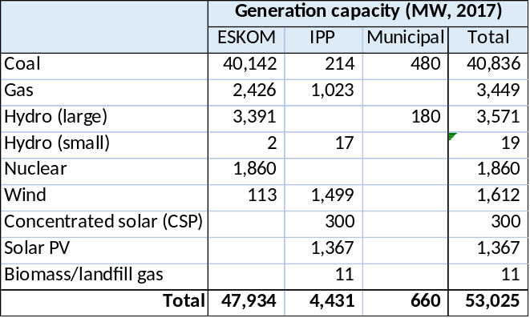
Compiled from: ESKOM, Factsheet Generation Plant Mix (2017); Wikipedia, List of power stations in South Africa (2017/18); Energy Information Agency, US Department of Energy (2018)

In January 2008, SA experienced widespread rolling electricity blackouts due to rapid growth in demand and insufficient investment in generation capacity. To remedy to the inadequacy of supply, load shedding was carried out and lasted until early May 2009. In 2013 South Africa again approached a period of limited capacity during a winter period of higher demands. Power problems escalated in late 2014 when the coal storage silo collapsed at one of the largest coal power plants. Since then,

However, after experiencing chronic power shortages for several years, no major blackout has been experienced in South Africa. Since 2016, South Africa has had a power capacity surplus as a result of and of weaker electricity demand and of new capacity commissioned by both public and private sectors, mainly from independent power producers (or IPPs) which added about 4.5 GW. However, in 2019 the issue of power shortage returned with load shedding of about 4 GW.
Box 19 Historic and future Eskom price trajectories
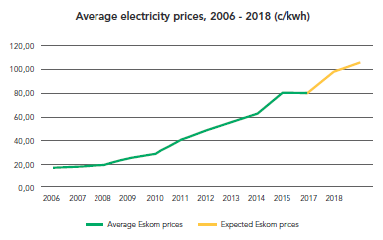
Source: GreenCape, Market Intelligence Report (2016)

However, the power supply remains in a critical situation. Most of Eskom’s coal-based power stations are approaching the end of their lifespan, and are poorly maintained, resulting in substantial operational inefficiencies. Inadequate investment during periods of increased economic growth, rising electricity demand, and mismanagement of the sector have been attributed to the power failures.

The cost of energy from Eskom’s new generation capacity will be significantly higher than its historically low energy costs. As a result of ’s new build programme and the cost of essential plant maintenance, the price of electricity in South Africa has risen significantly over the past decade. This trend, coupled with market pressures for cleaner, renewable, energy sources, has been a significant driver of the growing interest in the rational use of energy. Tariffs have increased significantly. The average power tariffs were R 0.596/kWh in 2011/12 and R 0.847/kWh in 2016/17 with residential customers paying R 0.778/kWh in 2011/12 (R 1.186/kWh in 2016/17), the industrial customers R 0.401/kWh (R 0.769 in 2016/17), commercial customers R 0.639/kWh (R 1.90/kWh in 2016/17), and local authorities R. 0.483/kWh (R 0.814/kWh in 2016/17). While tariffs have increased, South Africa’s electricity generation have declined overall from 2007 to 2016 by more than 4%. As revenue have remained stagnant, Eskom has embarked on a large power station expansion programme for which it has had to borrow significant amounts. In 2018 the utility started teetering on the brink of financial disaster, placing the country’s entire economy at risk.

Electricity market structure: production, transmission, distribution; regulation

Although Eskom does not have exclusive generation rights in South Africa, it does have the practical monopoly on the bulk of electricity in the country, and it maintains the national grid (operating the integrated national high-voltage transmission system). In 2002, Eskom was converted into a public company, although it is de facto a parastatal under the Department of Public Enterprises. In 2003, the Cabinet made a decision to increase private-sector participation in the electricity industry by dividing power generation between Eskom and IPPs. Currently, Eskom still has the majority of the generation rights and generates approximately 90% of the electricity. Of the capacity of 53,025 MW in 2017, about 660 MW was generated by municipalities and 4,431 MW by IPPs.

Distribution activities were unbundled from Eskom in 2003 and the creation of Regional Electricity Distributors (REDs) was begun under the newly-formed Electricity Distribution Industry Holding Company (EDIH). In 2010, after a number of issues relating to backlogs and poor performance, Cabinet decided to terminate the electricity distribution industry restructuring and to discontinue the process of creating ‘regional energy distributors’ with immediate effect.
Box 20 Historic Eskom tariffs

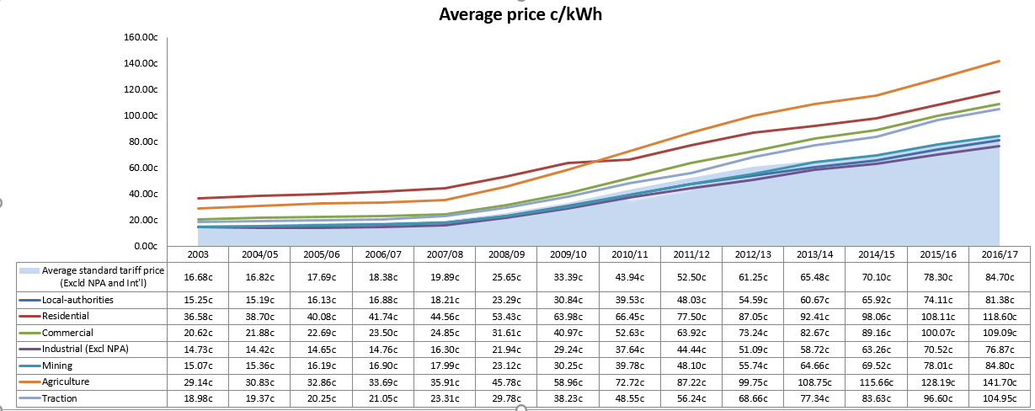
Source: Eskom website (2017)

Power distribution is now in the hands of Eskom (212,107 GWh in 2012), serving 4.848 million customers, private distributors (13,581 GWh), serving 2.047 customers and 178 NERSA-licensed municipal distributors, serving 26.638 million customers (96, 537 GWh). Eskom still supplies directly to large consumers (mines and large industries), commercial farmers and, through the Integrated National Electrification Programme (INEP), to a large number of residential consumers. Municipalities buy electricity from Eskom at a tariff set by the National Energy Regulator of South Africa (NERSA) and aim to offer electricity at a competitive price, with efficient service.

Institutional framework for energy efficiency

National government:
- National Treasury provides funding to all ministries, based on applications made by them.
- The Department of Energy (DoE) is the custodian of all energy policies and energy security in South Africa. The Department of Energy is the primary government institution responsible for energy regulation.
- The Department of Environmental Affairs (DEA) is responsible for protecting, conserving and improving the South African environment and natural resources. Within DEA there is one branch specifically assigned to deal with air quality and climate change.
- The Department of Public Enterprises (DPE) is responsible for the country’s energy infrastructure, primarily through its responsibility for state-owned entities such as Eskom. The state utility Eskom currently owns most of the electricity production and transmission and a large part of the distribution infrastructure. It is an essential player in the electricity sector – especially as a delivery vehicle for numerous government programmes, including energy efficiency and demand-side management programmes. Eskom has set up an Integral Demand Management (IDM) division, formerly known as Demand-side Management (DSM) division, to make deliberate interventions in the marketplace so as to change the configuration or magnitude of the load shape in the residential, commercial, industrial and agricultural sectors.
- The South African National Energy Development Institute (SANEDI), under DoE, is responsible for achieving the objectives of the National Energy Efficiency Strategy (NEES). SANEDI is the result of the merger of the two public research agencies South African National Energy Research Institute (SANERI) and National Energy Efficiency Agency (NEEA) in 2011.
- The National Energy Regulator of South Africa (NERSA) was established in terms of the National Energy Regulator Act of 2004, and is mandated to regulate South Africa's electricity, piped gas and petroleum industries and to collect levies from people holding title to gas and petroleum. National Energy Regulator of South Africa is of particular importance as it sets and approves the annual Eskom tariff, and issues licenses for power producers and distributors
- The Department of Trade and Industry (DTI) is one of the biggest government ministries, and acts as a catalyst for the transformation and the development of the economy, in support of the government's economic goals of growth, employment, and equity. DTI’s mandate is to respond\ to challenges and opportunities in the economy and society as a whole and provides a predictable, competitive, equitable and socially responsible environment for investment, enterprise and trade. The following organisations fall under DTI:
  - The South African Bureau of Standards (SABS) is the national standardization organization, and its core function is developing national standards and maximising the benefits of international standards. Public testing facilities fall under the SABS. National measurement laboratories are housed at the National Metrology Institute of South Africa (NMISA).
  - The National Regulator for Compulsory Specifications (NCRS) was established in 2008 and its role is to ensure that all compulsory specifications, as mandated by law, are adhered to. For this purpose, it also administrates applicable legislation in an independent, effective and efficient way. The MVE (monitoring, verification, enforcement) component of any energy efficiency standards and labelling programme will fall under the NRCS mandate;
  - The South African National Accreditation Agency (SANAS) is recognized by the Government as the single National Accreditation Body giving formal recognition that laboratories, certification bodies, inspection bodies, and ‘good laboratory practice’ test facilities are competent to carry out specific tasks. SANAS is responsible for the accreditation of certification bodies under ISO 17021 and 17024; laboratories under ISO 17025; and inspection bodies under ISO 17020 standards.

Local government and organisations:
- South Africa is divided administratively into 9 provinces. Local (municipal) governments form the third tier of government (after national and provincial government), and is the arm of government closest to many electricity end-users Municipalities are responsible for a large portion of electricity distribution in the country. Local government is implemented through 8 metropolitan municipalities (comprising the largest urbanised and industrialised centres). Outside the metropolitan areas, the local government mandate is pursued by two-tier local government: 228 local municipalities that are grouped into 44 district municipalities.
- The South African Cities Network (SACN) is an established network of South African cities and partners that encourages the exchange of information, experience and best practices on urban development and city management. One working area of SACN is ‘sustainable cities’, with the focus areas of ‘sustainable energy’, ‘waste management’, ‘water management’ and ‘climate change’. SACN has issued a number of publications regarding energy use in cities.
- The Association of Municipal Electrical Utilities (AMEU) is an association of municipal electricity distributors as well as national, parastatal, commercial, academic and other organisations that have a direct interest in the electricity supply industry in Southern Africa;
- Municipalities have organised themselves in the South African Local Government Association (SALGA). SALGA has set up ‘knowledge hubs’ to service its members, of which one focuses on ‘energy efficiency and renewable energy’.

Development and commercial banks
- The Development Bank of South Africa (DBSA) is a state-owned financing institution, whose main purpose is to promote economic development and growth, improve the quality of lives of people and promote regional integration in the (southern) African region through infrastructure finance and development. The DBSA provides planning, financing and implementation support to municipalities in sectors that include water and sanitation, electricity, roads, and telecommunication networks. DBSA’s approach to the municipal sector is to strengthen the capacity of under-resourced municipalities in areas such as project planning, preparation, and packaging, to increase focus on areas with the biggest unfunded gap through project origination initiatives and to providing affordable funding through development subsidies to secondary municipalities and under-resourced municipalities. For this purpose, it has grouped country’s municipalities in secondary (market, M2) and under-resourced (M3) municipalities, in which ‘market 2’ consists of about 27 large and 19 secondary cities (that generally have a moderate to strong economic base and ability to raise capital), 44 districts (that in general tend to attract little interest from commercial; banks and require support in project identification and preparation planning), and ‘market 3’ is formed by 190 small towns and rural municipalities (with usually a weak economic base, little ability to raise capital and requiring extensive support in all aspects of infrastructure project delivery, planning and implementation).
- The Industrial Development Corporation is the state-owned national development finance institution set up to promote economic growth and industrial development. The IDC's funding is generated through income from loan and equity investments and exits from mature investments, as well as borrowings from commercial banks, development finance institutions (DFIs) and other lenders. The IDC funds start-up and existing businesses with a minimum funding requirement of R1 million and a maximum of R1 billion, by means of debt, equity, guarantees, bridging finance and venture capital. Energy is one of IDC’s industrial infrastructure strategic priorities. IDC has provided support to the country’s Renewable Energy Independent Power Producer Programme (REIPPPP).

NGOs and private sector organisations:
- The e-Waste Association of South Africa (eWASA) is working with stakeholders and interested parties to establish a sustainable environmentally sound e-waste management system. Electronic and electrical waste (e-waste) includes ICT equipment, consumer electronics, small household appliances and large household appliances, including lamps and lighting devices. Some e-waste can be considered hazardous waste. For example, mercury is one of the most toxic, yet widely used metals in the production of electrical and electronic applications (mercury vapour and fluorescent lamps).
- The National Business Initiative (NBI), is a voluntary coalition of South African and multinational companies, working towards sustainable growth and development in South Africa, including environmental sustainability. Its, now discontinued, Private Sector Energy Efficiency (PSEE) programme identified and facilitated the implementation of the energy saving opportunities.

International cooperation (relevant to the topics of LEDs and power distribution):
- The Swiss Secretariat for Economic Affairs (SECO) supports ‘climate-friendly and green growth through the development of a low-carbon in South Africa with as sub-priorities a ‘resource-rich private sector’ and ‘sustainable energy’, including the promotion of sustainable and clean technologies, especially in energy, but also water and waste; energy efficiency and cleaner production.
- The German government development agency GIZ has launched the South African-German Energy Programme (SAGEN), in cooperation with DoE and SANEDI, focussing on renewable energy and energy efficiency. The budget for Phase 1 (2011-14) was EUR 12 million and now Phase 2 will be implemented until 2010. Regarding energy efficiency, activities have been a) institutional capacity development and support to national EE incentive programmes, such as DoE’s Municipal DSM (MEESM, see further in the text), support to selected demonstration projects, such as the street lighting retrofit project (see further) and strengthening of investments in energy efficiency, for instance through the development of a market for ESCOs (energy service companies). With DEA, GIZ has been supporting the Climate Support Programme (CSP) during 2013-17. For example, the mitigation potential has been determined for different sectors of the economy, such as energy, industry, and transport, and mitigation targets have been set and approved by the Cabinet. Supported by GIZ and the NAMA Support Facility, the V-NAMA “Energy Efficiency in Public Building and Infrastructure Programme (EEBIP)” was formulated during 2012-2015 and will be implemented during 2019-2023 with an EUR 20 million budget (discussed further in Section E.3).
- With the aim of strengthening the development of renewable and energy efficiency markets, the French Development Agency (ADF) has provided a EUR 120 million green credit facility (concessional loan) to the Industrial Development Corporation (IDC) and the two banks (Absa and Nedbank) for the financing of RE and EE projects. Besides, AFD is setting up a technical assistance facility with SANEDI to support the participating banks in the use of the credit facility by organizing dissemination workshops or by providing them with expertise for the savings verification for example.
- The Danish-South Africa Energy Partnership Program is being phased out. There are still a number of ongoing DANIDA projects waiting to be finalized according to the project plans, where Denmark provides support to strategic areas. The programme has provided technical assistance to DOE in renewable energy (e.g. wind energy) and, in energy efficiency, has supported the development of the Efficiency Strategy (NEES) and Action Plan, the EE awareness campaign, development of a centralized smart metering management and monitoring system, and a study to identify, assess and design a market based economic incentive(s) for energy efficiency appliances in South Africa (see further).

Relevant policy, legislation and regulation

In recent years South Africa developed a considerable energy policy framework, including the mandatory S&L programme for 12 appliance groups. Important with respect to energy efficiency are the following policies and national plans:
- White Paper on the Energy Policy of the Republic of South Africa 1998. Describes the government’s general policy for the supply and consumption of energy until, approximately, the year 2010. This policy sets out the path for development of renewable energy and the improvement of energy efficiency with the ultimate goal of reaching a more sustainable energy mix, in order to achieve South Africa’s macro-economic goals. A successor to this policy was released in September 2009 and aims to overhaul the fiscal, legislative and regulatory regimes in the energy sector, to further promote renewable energy development, and reduce carbon emissions.
- National Energy Efficiency Strategy (NEES, 2015). The draft post-2015 NEES Sets build on the earlier national target (as laid down in the 2008 update of the NEES, 2015) for energy efficiency improvement of 12% provides for a number of “enabling instruments”
- Electricity Regulation Act (Act 4 of 2006). The Act established a national regulatory framework for the electricity supply industry and NERSA as the custodian of this framework. The Act states that NERSA must encourage energy efficiency initiatives.
- The National Energy Act (Act 34 of 2008) was legislated to ensure that diverse energy resources are available to the South African economy, in sustainable quantities and at affordable prices, in support of economic growth and poverty alleviation. The Act takes into account environmental management requirements and interactions among economic sectors. It provides for the development of the Integrated Energy Plan (IEP) and the formation of SANEDI. The IRP (2010) presents scenarios that set out specific targets for renewable energy and the proposed new-build options including renewables, as well as the energy savings expected from demand-side management programmes.
- The Industrial Policy Action Plan (IPAP) 2014/2015 includes the Production Incentive (PI) programme includes a Green Technology Upgrading Grant of between 30-50% for investments in technology and processes that improve energy efficiency and greener production processes.
- Income Tax Act – regulations on tax allowances for energy efficiency savings. S12L allows for additional depreciation allowances of up to 55% for greenfield projects over ZAR 200 million, with energy efficiency savings being one of the rating criteria. S12L provides a tax deduction to a taxpayer who is energy efficient, with a focus on renewable energy. Provisions S12C, S11E and S13 stipulate tax allowances for ESCOs and other compliant businesses that provide for general depreciation of asset allowances.
- The National Environmental Management Act (Act 107 of 1998) (NEMA) provides a principal framework for sound environmental management practices for all development activities. Waste management is provided for in the Act with principles such as ‘the polluter pays’.
- It is envisaged that a Carbon Tax proposed by the National Treasury will be implemented, commencing in 2019 at a rate of ZAR 120 per ton of carbon dioxide equivalent (CO₂) on direct emissions, increasing by 10% per annum until 2020. Tax-free allowances of between 60% and 95% will be provided, based on trade exposure, fugitive emissions, carbon budgets compliance and other factors. See the Carbon Tax Policy Paper (National Treasury, 2013).

A number of national standards are relevant:
- SANS 941 - Energy efficiency of electrical and electronic apparatus is the national standard that covers energy efficiency requirements, measurement methods and appropriate labelling of energy-efficient electrical and electronic apparatus.
- The Compulsory specification for energy efficiency and labelling of electrical and electronic apparatus (VC 9008) was enacted in 2014 and came into force in 2015, making the SANS 941 a compulsory standard. It requires that a range of electrical and electronic apparatus (dishwashers, washing machines, tumble dryers and/or washer-dryers, refrigerators and/or freezers, electric ovens, storage water heaters) adhere to certain minimum energy performance standards. It also requires that all appliances listed display the energy efficiency rating on the appliance. A Guide for Energy Efficiency Labelling, published by DoE/DTI provides the basis for the labelling system in South Africa of above-mentioned electric appliances.
- SANS 50010 – Measurement and verification of energy savings, published in 2011, specifies the methodology for calculating energy savings. This is a required tool for calculating savings for projects submitted on the 12L energy efficiency tax rebate programme.
- SANS 10400-XA - These construction standards require mandatory compliance on energy efficiency and energy use in the built environment, with all new buildings and extensions to buildings requiring energy efficiency initiatives before receiving municipal approval.
- SANS 1544 – Energy performance certificates for buildings. This is a new standard that specifies the methodology for calculating energy performance in existing buildings. It will initially be a voluntary standard but may become a mandatory standard through the NRCS regulation process.
- There exist also compulsory specifications for incandescent lamps (VC 8043) and compacts fluorescent lamp (VC 9091). These set MEPs for CFLs (according to SANS 60969 and SANS 60901) and minimum life requirements of 1000 hrs and 6000 hrs for incandescent and CFL respectively. In addition, incandescent lamps > 40 W will be phased out.

Energy efficiency targets

The National Energy Efficiency Strategy (NEES) was published in 2005 and aimed at achieving overall sectoral energy intensity reduction targets of 12% by 2015. In 2008 and 2011, the NEES was reviewed to discuss its scope and elements. The draft Post-2015 NEES builds on the earlier national target (as laid down in the 2008 update of the NEES, 2015) for energy efficiency improvement of 12% provides for seven priority areas: buildings, appliance & equipment, lighting, transport, industry, energy utilities, and cross-sectoral. The draft document was published for public comment in December 2016 but has not yet been finalised yet. The Post-2015 NEES sets specific targets for individual sectors:
- End-use energy consumption within the public building sector is expected to increase to 125.13 petajoules (PJ) in 2030 from 62.4PJ in 2012 levels (50% reduction). These increases can be curtailed by 19.7PJ, which is a decrease of roughly 16%, by conducting refurbishments and interventions in space heating, lighting and improved building practices based on the current version of the SANS10400-XA. Within municipal services, based on interventions in a sample of major municipalities, energy savings of 47% for bulk-water supply and water treatment, 32% for the municipal vehicle fleet, 25% for street lighting and 16% for buildings and facilities could be achieved.
- In the residential sector, three energy savings opportunities were identified as having sizeable potential, namely appliances, lighting, and buildings. Significant energy savings are possible if the Solar Water Heating and Mass Roll-Out programmes are continued within the residential sector. The electricity savings (12.1 TWh) proposed within the cost-effective scenario would contribute to roughly 20% of revised 2030 baselines. These savings would then translate to roughly 12.75 Mt of CO2 emissions. The proposed savings would mean a 6.8% decrease in household electricity intensity between 2010 and 2030.

Box 21 Energy efficiency standards and labelling in South Africa

The ‘Leapfrogging High-Efficiency Lighting and Distribution Transformer’ Project will build on the existing infrastructure and results of the GEF-financed, UNDP-implemented project Market Transformation through Energy Efficiency Standards & Labeling of Appliances in South Africa (GEF 2692, UNDP PIMS 3277), implemented from 2013 to 2019. The project aims at facilitating a comprehensive transformation of the home appliance market through the introduction of a combination of two regulatory tools, minimum energy performance standards and information labels (S&L), accompanied by a series of associated awareness-building and monitoring activities. The project has focussed on a number of 12 electric appliances: refrigerators, freezers, refrigerator-freezer combinations, front-load washing machines, top-load washing machines, tumble dryers, washer-dryer combinations, dishwashers, air conditioners, electric ovens, audio-visual equipment, and electric water heaters (geysers). The following table gives a summary:

Outputs | Main results and achievements by mid-2017
Outcome 1 Policy and regulatory framework for the S&L programme: Strengthen structures and mechanisms for appliance EE S&L  1.1 Review of existing policies and regulations.  1.2 Evaluation of financial incentives such as the rebate program operated by the Eskom DSM for purchasing efficient appliances. | - Four studies have identified a number of incentive schemes (standards offfer for LED lights, subvention of electric geysers, swap programme, for refrigerators and a rebate system for purchasingg EE appliances), assessed cost and benefits and a fourth study (2017) will assess in the light of current situation and new government policies.
Outcome 2 Define labeling specifications and MEPS thresholds for the products considered by the DoE & DTI for S&L regulation  2.1 Conduct market and engineering analysis for the products selected for S&L regulation  2.2 Adopt labeling specifications and MEPS thresholds for the 12 products selected for S&L regulations | - Market and engineering analysis for all products has now been completed.The Minimum Energy Performance Standards (MEPS) for household electric appliances have been set and promulgated through NRCS regulations VC9008 (described in the main text), MEPS have been approved, and started to be enforced since March 2015 (audio-visual equipment); February 2016 (dishwashers, washing machines, tumble dryers and/or washer-dryers, refrigerators and freezers), August 2016 (air conditioners); and August 2017 (water heaters/geysers)  - The EE label design was completed in September 2015 through a consultative process with appliance manufacturers and relevant government authorities The Guide for Energy Efficiency Labelling, published by DoE/DTI was launched in 2016 and provides the basis for the labelling system in South Africa of above-mentioned electric appliances.  - A trial incentive programme is being designed for Gauteng (starting 2nd half 2018). This would go together with a survey on consumer attitudes and preferences, and will be linked with the presentation of endorsement labels (see also main text at the end of Section E.3)
Outcome 3 Strengthen the capacity of institutions and individuals involved in the S&L programme  3.1 Strengthen institutions (testing facilities, enforcement institution)  3.2 Strengthen employee skills | - A private laboratory (Test Africa) is accredited to test the energy efficiency of electric water heaters, ovens and standby power. SABS is accredited to test for energy efficiency of standby power (audio and visual), lighting, water heaters, ovens and refrigerators, however, only the water heater, lighting and audio/visual labs were operational by mid-2017. SANAS assessed SABS for accreditation in February 2016. The test laboratories for dishwasher and laundry will be operational in 2017. The project assisted SABS with institutional and individual capacity-building.  - NRCS developed modules and training materials to training its inspectors. The modules include the learners’ materials, the trainers’ guide and assessment modules. Modules were completed for audio-visual equipment and white goods
Outcome 4 Awareness raising campaign for standards and labels, targeting manufacturers, distributors, retailers and end-users.  4.1 Test and adopt label design  4.2 Develop communication campaign towards manufacturers, importers, distributors, retailers and consumers about appliances’ energy efficiency  4.3 Develop and deliver training programs for distributors and retailers staff. | - A one-month long market surveillance of retail floor sales staff by the NRCS in all major cities found that recognition and understanding of the label was only at 15%. A communicatoon plan was prepared in 2016. Implementation of the campaign includes stakeholder engagements, development of a training programme for retail sales personnel, messaging (through social media platforms, media releases and advertorials). After the media campaign will be completed (preparation will start in 2017), new research will ascertain the effect of the label on users and retailers.  - Training will be organised 2017-18 to prepare retail sales personnel to understand and to explain the choices available to consumers when purchasing new appliances.
Outcome 5 Implementation of S&L market surveillance & compliance (MSC) regime to ensure energy performance standards is met | - The development of MCS procedures will be assigned to an independent service provider that will work with the NRCS starting 2017  - A database on S&L products developed in 2014/15 was not maintained or updated. A new product registration database is being build and due to go live in April 2019.
Outcome 6 Development of Monitoring and Evaluation (M&E) capacity | - A review of South Africa’s appliance energy classes and identification of the next set of electrical equipment is planned for 2017-18
The UNDP/GEF project has been helping South Africa to embark on a more comprehensive S&L programme development. It is is now important that South Africa develops reliable and appliance-specific Measurement, Verification and Enforcement (MVE) schemes with strict sanctions to ensure that at the end the market is actually compliant with all new requirements.
Source: UNDP-GEF project Document and Project Implementation Review (2017)

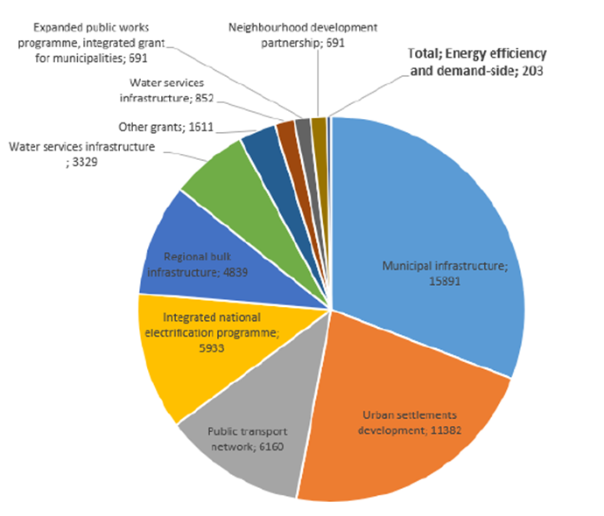
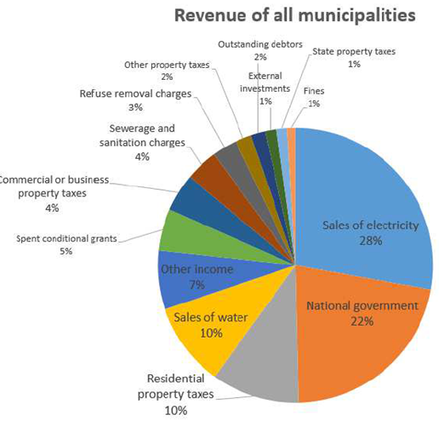
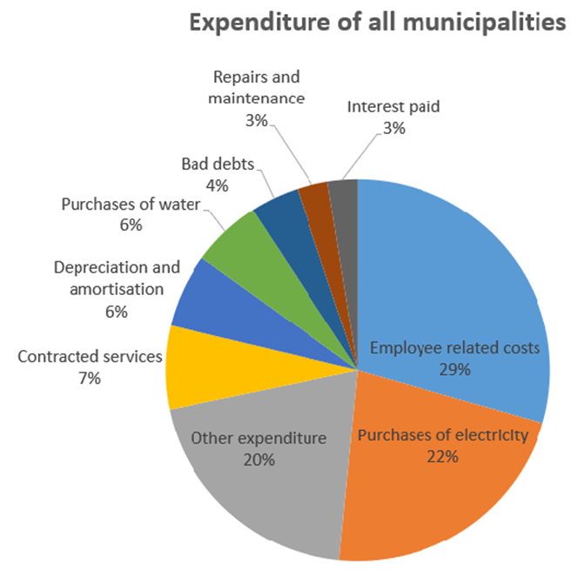
Box 22 Municipal revenues and expenditures

On average, South African municipalities obtain 28% of their income from grants and 72% from internal sources, primarily through property taxes and the sale of basic services (electricity, water, refuse collection). These figures, however, include gross income from electricity and water sales. If the total direct cost of bulk electricity and water purchases by municipalities are taken into account, the total amount of funding from grants is on average 37%. Under this same metric, metropolitan municipalities obtain 26% of their income from grants, and for all the other municipalities this figure reaches 50%.

Source:

The central government grant funding for infrastructure in the metropolitan municipalities is mainly concentrated on reducing the number of informal settlements (Urban Settlements Development Grant - ZAR 11 billion in 2018/19 budget) and on public transport (Public Transport Network Grant- ZAR 6 billion in 2018/19 budget). The Urban Settlements Development Grant may also be used for the provision of infrastructure for the settlements developed.

The Municipal Infrastructure Grant, which is the largest infrastructure transfer to municipalities (ZAR 15 billion in the 2018/19 budget) is distributed primarily to rural municipalities and some districts, while the metropolitan municipalities receive no funding from this grant program. The allocations of this program are dedicated to new infrastructure or upgrading existing infrastructure including basic water and sanitation services, central collection points for refuse, recycling facilities and solid waste disposal sites, sport and recreation facilities, street lighting, etc. A lot of the funding is understood to be spent on clearing the backlog of defective infrastructure.
The Municipal Infrastructure Grant and the Urban Settlements Development Grant are the two largest components of the national government transfers to the municipalities. Another infrastructure grant program that addresses infrastructure relevant for this project is the Integrated National Electrification Programme Grant for municipalities. This program is funded with ZAR 5.9 billion to address the electrification backlog of households and the installation of relevant bulk infrastructure. Of this total budget the municipalities receive ZAR 2billion

Measures contemplated in NEES regarding the public and residential sector include: a) awareness raising of government employees (at national and sub-national level) and awareness raising of the public at large, b) tightening of building energy performance standards, c) mandatory display of energy performance certificates in government-owned buildings, green procurement (incorporating life-cycle considerations), d) broadening the scope of mandatory labelling and MEPS (see Box 21) , as well as introduction of endorsement labels alongside the existing comparison type of energy labelling.

Municipalities will be required to submit energy efficiency strategies, which will be informed by a comprehensive energy audit of their services and activities, and aligned with the provincial strategies. On the basis of the energy audit and municipal strategy, the DoE will assist municipalities in developing energy management plans, associated business plans and financing proposals to source financing for the measures that are prioritised. However, many municipalities have up to now identified isolated measures and do not have adequate data to understand their energy use profile. Alternative financing mechanisms could be exploited, such as energy performance contracts with private sector ESCOs, reducing the investment burden on the government and the municipality (discussed further in Annex E.4).

Considerable reductions in coal usage (22.9%), CO2 emissions (15.5%) and overall electricity usage (15.7%) can be achieved by the year 2030 within the electricity (utilities) sector, if the savings scenario that constitutes a greater share of renewable technologies, employing advanced coal technologies (high-efficiency boilers, integrated gasification combined cycle). It is 22,351 GWh were lost in 2013 in distribution and transmission. Some municipalities report losses of 30-40%. Some are non-technical losses (illegal connection, tampering with meters, etc.), other are technical (losses in transmission; use of old transformers).

  - The market for LED lighting in South Africa

Lighting demand and supply
Box 23 Annual lamp sales in South Africa in 2016 (DoE study on residential lighting)

 | Imports/sales in 2016* | Residential stock  (2016) | Average price  (Rand)**
Compact fluorescent lamps | 5.6 million (53%) | 40,322,347 | 31 (28-41)
Fluorescents (linear) | 0.6 million (6%) | ? | -
Halogen lamps | 2.3 million (22%) | 11,166,188 | 25 (11-39)
LEDs | 1.4 million (13%) | 8,694,813 | 45 (25-75)
Incandescent |  | 1,861,031 | 9
Other | 0.7 million (6%) | ?
 | 10.6 million | 62,034,380

* Period December 2015-November 2016, based on Customs and Excise data. In addition, Eskom brings about 2-3 million CFLs on the market as part of its EE-DSM programme
** Based on survey in 17 retail outlets. Price of incandescent lamp: R 9 (note that sale of most incandescents has been banned since 2015, but are nonetheless sold in ‘informal’ outlets)
Source: DOE (2017)

The lighting market in South Africa can be described as diverse with a mix of older technologies, such as incandescent, halogen, linear and circular fluorescent lamps, high-intensity lamps (HIDs), and newer technologies, such as compact fluorescent lamps (CFLs) and light-emitting diode lamps (LEDs), all prevalent.

There are a number of studies available that do take into account particular market segments, municipal lighting, and street lighting (for one or municipalities) or the residential sector, but, up to now, there is not one consolidated study for the nation as a whole, encompassing all the sectors (residential buildings, commercial and industrial buildings, outdoor lighting, street lighting) and all the types of lamps.

A recent Danish-supported Identify, Assess, and Design a Market-Based Economic Incentive(s) for Energy-Efficient Appliances in South Africa; Final Report (DOE, 2017) provides market details on stock and sales of LEDs and other lamps in the residential sector (see Box 23).
Box 24 Energy-efficient lighting: an overview

The following table gives an overview of various lighting technologies:
 | Incandescent-type |  | Fluorescent lighting |  | Light-emiting diode (LED) | High-intensity dischrage lamps (HID)
 | Incandescent | Halogen | CFL | Fluorescent – tube (TL) | Light-emiting diode (LED) | Mercury vapour |  | High-pressure sodium (HPS) |  | Metal halide
Luminous efficiency (lm/W) | 8-17 | 11-25 | 60-130 | 80-110 | 60-130 | 45-55 |  | 105-125 |  | 80-100
Lifetime (hrs) | 1000-1500 | 2000-3000 | 6000-15000 | 15000-30000 | 20000-60000 | 20000 |  | 15000-24000 |  | 10000-20000
CRI & colour temperature | 100 (CRI)  2600-2800 K | 100 (CRI)  2800-3200 | 70-95  2700-6500 K | 60-95 (CRI)  2700-6500 K | 70-95 (CRI)  2700-6500 K | 15-50 (CRI)  3900-5700 K |  | 25 (CRI)  2000-2100 |  | 65-85 (CRI)  2500-6500
Dimmable | Y | Y | if driver dimmable | if ballast dimmable | if driver dimmable | if ballast dimmable |  | if ballast dimmable |  | if ballast dimmable
 | Produce light by passing electrical current through tungsten metal wire suspended in an inert tmosphere inside a glass bulb. | Halogen lamps are an improvement over  incandescent Contain  a small quantity of  halogen that increases lamp life | The lamps incorporate an electronic ballast and phosphor-lined glass tube. An electrical arc is struck at the tube’s electrodes, causing the mercury atoms to emit ultraviolet (UV) light, exciting the phosphor coating and emitting visible light. Tubular fluorescent lamps are typically classified by their diameter (most common are: T12 = 38mm, T8 = 25mm, T5 = 16mm). CFLs were developed as retrofits for incandesents, and are essentially a miniaturised version of a linear fluorescent lamp (TL). All fluorescent lamps contain mercury. |  | A LED is a semiconductor light source, whose p–n junction diode that emits light when activated –(electro-luminiscence). Many LED products are available that can replace the previous lamp inclduing bulbs and tubular lamps.  There are also LED for street lights and outdoor applications | High intensity discharge (HID) lighting produces light from an electrical arc contained within a capsule of gas (metal vapour) which is sealed inside a bulb. HID lights require a ballast to start and operate, which regulates the voltage.  HID lighting is commonly found in outdoor lighting  applications such as street lighting, area flood lighting and sports stadium lighting. HID lighting is also found in-door in places such as large retail outlets, warehouses and buildings of manufacturing facilities.  A ballast is a piece of equipment designed to start and properly control the flow of power to discharge light sources such as fluorescent and high intensity discharge (HID) lamps
Incandescent comparison | -  40 W  60 W  100 W | ~25%  28-29 W  41-43 W  70-72 W | ~ 75%  9-11 W  13-16 W  23-27 W | 40 W incandescent compares to  40 (T12)-32 (T8) | 80%  5-8 W  10-13 W  20-26 W | Street lighting comparison:
 |  |  |  |  |  | MV  240 W | HPS  160 W |  | MH  180 W |  | LED  80 W
Compact fluorescent lamps were developed in 1970s as a replacement for the less efficient incandescent lamps and could fit in the same volume and the same fitting. However, about 52% percent of the world's total lighting market sales of 15 billion units were still incandescent in 2010. Therefore, countries around the world have started to phasing out inefficient incandescent lamps. Some countries have established effective approaches to eliminate inefficient lamps via mandatory minimum energy performance standards and energy labelling and other policy measures)
LED lamps have a lifespan and electrical efficiency which are several times greater than incandescent lamps, and are significantly more efficient than most fluorescent lamps. Recent developments have produced LEDs and new control systems that are suitable for all apllications, in buildings, traffic lights and outdoor lighting. Market share of LEDs was projected by McKinsey in 2016 (of a total of 11 billion units) to reach 22% (1% in 2010), that of CFLs 25% (up from 17% in 2010), linear fluorescent 20% (16% in 2010), HIDs 2% (also 2% in 2010), halogen 22% (20% in 2010 and incandescents down to 9% of global sales (52% in 2010).
Electricity for lighting accounts for approximately 15% of global power consumption and 5% of worldwide greenhouse gas (GHG) emissions. A switch to efficient on-grid and off-grid lighting globally would save more than USD 140 billion and reduce CO₂ emissions by 580 million tonnes every year. Worldwide, electricity accounts for about 15% of power consumption (and 5% of global greenhouse gas emissions). A reduction to the more efficient lighting would reduce global power demand for lighting by 30-40%. If countries would follow the integrated efficiency policy approach, the energy savings could reach 640,000 GWh in 2030. This is the equivalent of USD 360 billion in avoided investments in 290 large coal-fired plants, or, the savings would be enough to provide 300 million non-connected households with electric energy (assuming a consumption of 2000 kWh per household per year).

Source: Accelerating the global adoption of energy-efficient lighting, UN Environment-GEF ‘United for Energy Effciiency (2016) ; BC Hydro (www.bchydro.com); Lighting the way: Perspectives on the global market, McKinsey (2011). CRI: colour rendering index

The same study also provides estimates on the stock of residential lamps in South Africa, based on the number of rooms per households in South Africa, putting the total stock of installed lamps at about 62-80 million (there are 79,084,776 rooms, according to 2012 General Household Survey). Assuming one lamp per room, this is likely to be an underestimate, as many rooms (even in lower-income households) will have more lamps than just one. On the other end of the range, there is the estimate by the UN Environment-GEF U4E/en.lighten programme (see Box 25) of about 248 million lamps in households (implying 4 lamps per room per household on average, which seems more plausible). In the remaining of this report, we will use the U4E data as an estimate for annual sales and installed stock, also because it encompasses not only households but also sectors (public, commercial and industrial).
Box 25 Estimates of annual lamps sales and installed stock in 2014

Stock (installed lamps)
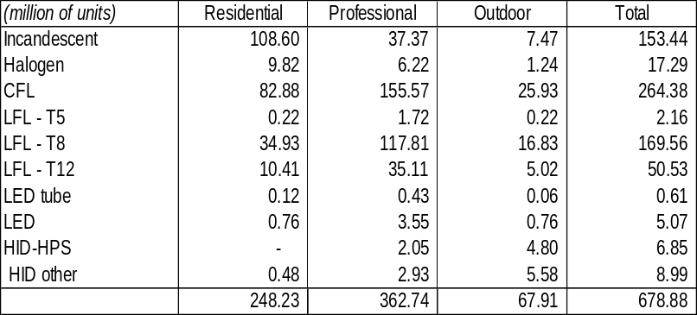
Annual lighting market
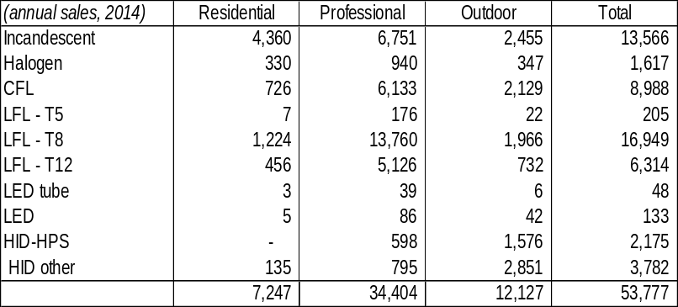Source:
Based on UN Environment-GEF South Africa Country Assessment (2016)

Source: DOE (2017).

Historically, most lamps in buildings were incandescent lamps (often 60 W or 100 W) or linear fluorescent lamps. As part of its emergency ‘energy efficiency and demand-side management programme’ (EE-DSM), the utility Eskom started to exchange incandescent bulbs in homes for more energy-efficient compact fluorescent lamps (CFLs) in 2008. By January 2017, more than 65 million CFLs have been distributed. The Eskom CFL roll-out programme has been one of the biggest energy-saving initiatives of its kind in the world. Eskom-appointed installers going door to door in designated areas to replace (a) energy intensive incandescent light bulbs with new energy saving CFL (Compact Fluorescent Lamps) and (b) spent CFLs with new CFLs in homes across South Africa. As a result, CFL has become synonymous to ‘energy saving bulb’ or just ‘light’. The door-to-door programme was targeted mainly at lower-income groups.

In South Africa, the sale of incandescent bulbs (of 40 W or above) has effectively been banned. However, this also has favoured the sales of new halogen lamps (these operate very similar to incandescent bulbs and more efficient, but less so than CFLs) that are sold at prices below that of CFLs (see Box 23 and Box 24).

Over the past 5 years, LEDs have been entering the market in South Africa, as part of the international trend with rapid LED technology advancements (better light colouring, longevity, efficiency) and lowering of costs. Market feedback and observations of retail shelves suggest that this has shifted significantly over the preceding 12 months with a larger variety of LED bulbs available, a bigger share of shelf space allocated to LEDs and prices competing directly with the halogen and CFL alternatives. Nonetheless, important factors that hinder more widespread use of LED (and other energy efficient) lamps in the market:
- For the lower-income households, Eskom is still distributing free CFLs and in the mindset of many households, these have become the first choice of lighting. By the end of 2016, Eskom still had some 5.9 million CFLs in stock and to be rolled out during 2017-18 (mostly as aging lamp replacements);
- For the average consumer, the comparison of lamps types, brands, performance, and energy efficiency is rather complex and confusing. This will lead to some buyer resistance regarding new LED technology and what to expect.
- Low-quality LED bulbs are being imported with three deficiencies, poor power factor (as low as 0.3), low efficiency (lumens per Watt) and low lifetime. The current lack of minimum standards leads to dumping of these lower-cost, low quality on the market. This causes competition problems for suppliers that want to provide good-quality lamps, and this is made worse by fierce competition amongst LED lamp suppliers. Especially in the higher-income households’ segment, the uptake of LEDs will be hampered by the poor quality which will give the product a bad name.
- Poor quality inefficient lighting options (old stock, illegal imports of incandescent lamps) continue to find their way into homes through obscure retail outlets in the country at very low prices. Thus, the lower-end market segment is flooded with cheap, low quality imported lamps (LEDs, CFLs) and illegal incandescent bulbs that vary in terms of performance. Enforcement of lighting standards (e.g. CFLs) remains flawed due to the dysfunction in the regulatory process.

Supply chain characteristics and potential for local manufacturing

In South Africa, all lamps are imported (most are manufactured by in large-scale factories in China) by multinational brand companies, such as Philips, Osram, Eurolux as well as by house brands. Consumers by the lamps at grocery retailers (such as Pick ‘n Pay, Shoprite, Spar), general household retailers (e.g. Makro, Cash & Carry), hardware stores (e.g. Builders, Mica) and dedicated lighting suppliers. In addition, Eskom has been providing CFLs in its residential replacement programme, as mentioned above.

Manufacture of LEDs is spread out globally, with fabrication plants operating in the United States, Germany, Malaysia, China and India. In comparison, the South African lighting industry is estimated at ZAR 5 billion a year (less than 1% of the global market), which include all types of light fittings such as street lighting, floodlighting, industrial and commercial lighting, control gear, lamps, the domestic and decorative ranges and other specialised lighting. Lamps and commercial lighting each contribute about ZAR 1 billion to the industry, while industrial lighting is estimated to be worth about ZAR 500,000 a year. South Africa has the skills, equipment and manufacturing capacity to manufacture solid-state lighting products and fluorescent lamp, but the small size of the market does not provide economies of scale (yet) in high-intensity LED components manufacturing required for solid-state lighting applications. A typical LED fabrication plant requires an investment of approximately USD 15-350 million, depending on the size, and can take up two to five years before becoming fully operational.
Box 26 Lamp supply chain in South Africa

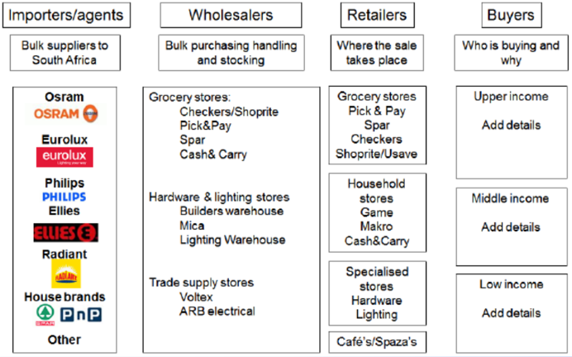
Source: DANIDA, DOE (2017).

Currently, there are about 18 LED suppliers in South Africa. However, the market is expected to grow at a compound rate of 20% each year to reach market penetration in general lighting of well over 60% by 2020. Efficacy values of 300 lumen per Watt could be achieved and cost reduction by 20-30% each year will continue until costs are below that of conventional luminaires.

LED market developments

Globally, the lighting industry is transforming. LEDs are entering all end-use applications in the lighting market, from the non-directional household lamp, directional (or “spot”) light, LED tubular lamps (to replace fluorescent tubes and dedicated LED luminaire. Also, LED street lights, flood lights, high-bay replacements, and many other luminaires and technologies are offered in the dynamic LED lighting market. In the medium to long-term, LEDs are expected by many to be the primary light source in all applications.

In the past, the lighting industry had two general distinct product segments: manufacturers of lamps (i.e. light bulbs) and manufacturers of luminaires (i.e. fixtures) The manufacturers of lamps (or commonly called “light bulbs”) were a small number of large, global suppliers whose majority of business was based around the sale of replacement lamps. Manufacturers of luminaires, where there are a large number of companies, tended to be more application- and regionally focused, specialising in the production of comparatively small batches of a large variety of luminaires. Today the boundaries between the lamp and luminaire businesses have blurred. This is because of the increasing number of LED lamp-luminaire solutions. LED light sources bring the potential for ultra-long service life, which will gradually eliminate the replacement lamp business.

Street and traffic lighting

There are no nation-wide statistics that are readily available on the number of lamps used in street lighting and type of lamps used. The South African Cities Network (SACN) has carried a study on Modelling Energy Efficiency Potential in Municipal Operations in the Nine Member Cities of the SACN (2014) that also include street lighting.
Box 27 Street lighting characteristics in South African cities

 | # of lamps | Mercury vapour (MV) | High-pressure sodium (HPS) | Metal halide
Buffalo City | 128,375 | 82% | 18%
Cape Town | 210,385 | 41% | 59%
Tshwane | 122,638 | 75% | 25%
eThekwini | 129,688 | 76% | 23% | 1%
Mangaung | 21,123 | 72% | 18% | 9%
Total | 712,209 | 67% | 33% | 1%

Source: SACN (2014). For comparsion, in the 25 states of the European Union, the share of sodium lamps was 56%, MV 32%, metal halide 3% and CFLs 8% (2004)

Street and traffic lighting usually account for between 15% and 30% of the total energy consumption within a municipality’s operations and it is one of the easiest energy efficiency (EE) intervention areas. Many street lighting facilities in municipalities are outdated and therefore highly inefficient. Old lighting technology also has higher maintenance requirements. Most of the common technical measures applied to address EE in street lighting can generate between 38% to 54% energy savings per measure and these have very short payback periods.

Mercury vapour (MV) lamps are said to have been introduced in the 1950s and were deemed a major improvement over the incandescent light bulbs. Metal halides are a newer and more efficient than MV lighting technology. HPS lamps have a high efficiency when compared to MV and MH lamps on a lumen/watt scale. CFL luminaires have improved over time although their use in street lighting is rare in South African municipalities. Inefficient MV luminaires make up 62% of the total number of installed luminaires across the nine cities. Substituting MV with LED attractive in the street lighting will result in greater savings of 71% (SACN Report 2014). However, most of the municipalities have been retrofitting with HPS luminaires because LEDs are still regarded with some caution due to lighting characteristic, untested lifespan and costs (SEA). New lighting technologies, such as LED or induction lamps, produce at even higher lumen per watt.
Box 28 Local production of LED street lighting luminaires

The CSIR (Council for Scientific and Industrial Research) has carried out a market assessment and feasibility study for the local production of LED luminaires for street lighting. The annual demand for LED street lighting (for new and retrofit applications) is estimated at 423,000 in municipalities and about 17,000 at national roads (managed by SANRAL). With potential exports of 9 million units to other parts of Africa, this market could make the establishment of a facility for LED street lighting manufacturing an feasible proposition. The establishment of the LED enterprises could result in the creation of sustainable job opportunities, increase local content and lead to economic growth.

The study look into the establishment of a facility that can produce 8,600 LED street light lunimaires annually (150 W for national roads and major provincial roads, 80 W for urban and 50 W for rural roads). The production facility could be set up over a 2-year period costing about ZAR 13.61 million (inclduing design and engineering, company formation, construction and office, workforce training and procurement, installation and commissioning of machinery). Lamps could be sold at slightly below the average market price for street lighting: price (150 W: ZAR 7,774; 80 W: ZAR 5,697, 50 W: ZAR 5,021). Some grant funding with soft loans would be needed to ensure the business will have a positive cash flow and attractive financial indicators.

Source: CSIR Enterprise Creation for Development Business Plan: LED Light Enterprise (2015)

LED lighting has become the standard efficient retrofit technology for traffic lights because LED traffic light fittings last 5 to 8 years, substantially reducing maintenance cost compared to incandescent and halogen lights. Operating costs are also massively reduced due to the same level of illumination available with LED lighting, at a much lower wattage. Buffalo City, Cape Town, eThekwini and Nelson Mandela Bay, have achieved 100% penetration of EE traffic lighting. Opportunities exist for municipalities that have not achieved a 100% retrofit of their existing inefficient traffic lights with LED luminaires to expand their current programmes.
Box 29 Energy label, bulbs

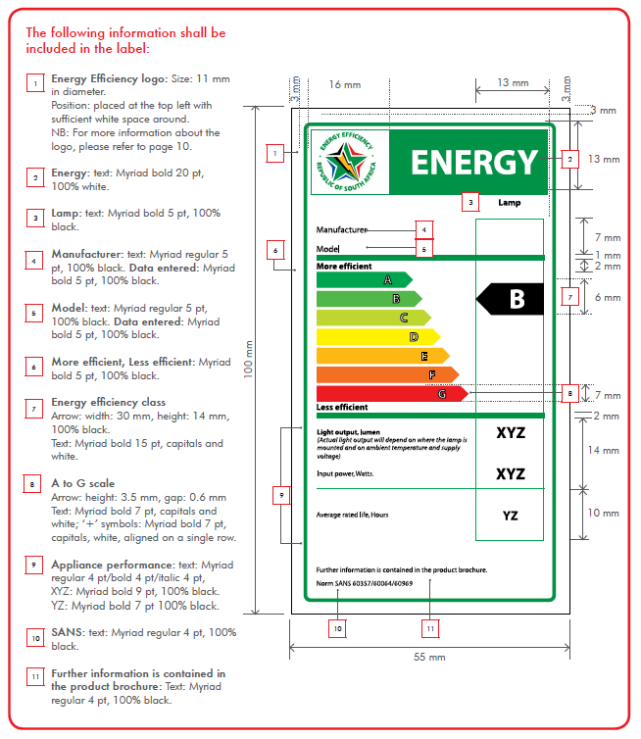
Source: A guide for Energy Efficiency labelling (version 2.0. DoE; 2015)

The Department of Energy’s Municipal Energy Efficiency Demand Side Management (MEEDSM) programme (see Box 34) has supported municipalities in South Africa in implementing energy efficiency measures in street lighting, buildings and in the water and sewage infrastructure. During the period 2009/10-2014/15, the programme managed to replace 459,172 street lights, usually replacing HPS for MV lighting. For example, Mafube replaced 140 MV (250 W) with HPS (150 W); Buffalo City, eKurhuleni, Cape Town en eThekwini also replaced MV lamps with HPS. Nelson Mandela Bay is the only one that has been retrofitting with CFL luminaires, which do offer a considerable energy saving in comparison with HPS luminaires. Remarkably, Msunduzi Municipality has retrofitted HPS luminaires (i.e. already more efficient than MVs) with LED lamps.
Box 30 Promotion of street lighting

A potential approach to remove these barriers is to provide dedicated support to the street lighting teams in the larger municipalities to develop high quality business cases for presentation to the budget committee, including proper financial analysis and the following aspects, to enhance the reception of these projects:
    - Street lighting is highly connected to safety and has been proven to reduce both traffic accidents and crime rates. Designing a program that puts special focus on poorly lit areas with higher traffic accident and crime rates could act as a catalyst to the demand for these projects. Integration of street lighting with other initiatives, such as the installation of crime-prevention surveillance systems will also be key to the success of the program.
    - Street lighting is highly connected to social activities at night, which is of particular importance in commercial and tourist areas. Designing a program that improves the street lighting quality in these areas may therefore result in an appetite by the municipalities for these projects, as a way to improve business activity and consequentially increase tax revenue.
    - Illegal electricity connections, meter tampering and transformer oil theft are understood to be a common issue in the South African electricity infrastructure. The design of a program that incorporates measures addressing these issues is likely to increase the end-client demand of these projects. An example of such measures might be remote transformer monitoring to detect unusual patterns or the collaboration with the smart-meter programs of various utilities to provide LED lighting lamps to residential end-users.
    - Electricity outages have also been a recurrent issue, on some occasions resulting from the illegal electricity connection or equipment theft indicated previously. Again, a transformer monitoring system that enables predictive maintenance of distribution transformers may be presented as a unique selling point of the program.

Labelling of light bulbs

The Department of Energy, supported by the UNDP/GEF Standards and Labelling Programme (see Box 21), has been working on (mandatory) energy performance standards (MEPS) and energy labels. Unlike other electric appliances, there are no MEPS or labels that cover LED, CFLs, halogen and other lighting devices. An energy label does exist, but its application is on a voluntary basis. The proposed UNDP/GEF “Leapfrogging LED and HE Distribution Transformers” will build on the efforts on standards and labelling by looking at) compulsory performance standards, b) awareness and information to promote the existing energy label, and c) trial incentive programme for Gauteng area.

For LEDs, there are voluntary standards on safety and performance, but not covering energy performance considerations. The proposal is to move to mandatory to be regulated by a) DTI, or b) DoE. In the case of DTI regulation, implementation and administration (incl. certification M&V and enforcement) will reside with NRCS. In the case of DoE regulation, the implementing agency could be SANEDI. Another option is that both DTI and DOE regulate with implementation outsourced to a third entity.

A trial incentive programme is being designed for Gauteng (starting 2nd half 2018). This would go together with a survey on consumer attitudes and preferences. The primary target will be middle-higher income households, which has a high potential for savings by LED replacement of halogen downlights. This will be linked with the presentation of endorsement labels (in addition to the existing energy label), by introducing a “information label” (that compare LED, VFL, halogen and incandescent bulbs in light output, life expectancy, and energy usage) on the shelves of retailers and outlets and an “endorsement label” (for products that meet the specifications of the incentive programme). The pilot will be accompanied by awareness campaign, website (www.savingenergy.org.za) and training for retailer staff and salespeople.

  - Distribution transformers in South Africa

In 2011/12, the distribution grid in South Africa had a length of 2.807 million km with 530,374.), of which 0.368 million km (and 148,984 transformers .in the hands of Eskom and 2.439 million km (with 381,390 in the hands of municipalities and private distributors. In 2017 there were about 662,655 distribution transformers installed, of which about 290,000 by Eskom. An estimated 20,000-24,000 newly installed per year about half replacing old retiring transformers, and about half as newly added to the system.
Box 31 Examples of transformers

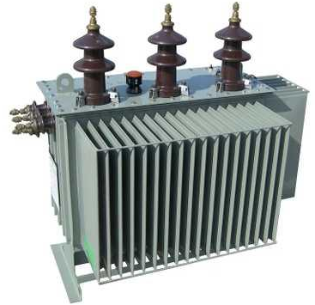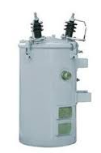
Ground-mounted 3-phase Pole-mounted single-phase

The transformers can be pole-mounted (single phase 242 V with capacities 16-25 kVA, 484 V dual-phase with capacities 31-64 kVA, or three-phase with capacities 25-500 kVA) or ground-mounted (three-phase 11 or 22 kV with capacities 50-2500 kVA).

Most transformers used in distribution systems in South Africa are of the liquid-immersed type made from cold-rolled grain-oriented silicon steel. The available distribution transformers are heavy pieces of electrical equipment with a weight range of 150 kg to 29,000 kg. The lifecycle cost of a transformer takes into account the initial cost and cost to operate and maintain over the product’s lifetime, which could be up to 40 years. In the transformer business, this is often expressed as ‘total cost of ownership (TOC)’ consisting of the cost of purchasing the transformer + value of no-load losses + value of load losses. For example, the article by Amadi and De Cock (see Box 33) compares the case of a standard 315 kVA transformer in South Africa with that of a premium-efficiency transformer. With a load factor of 40%, an assumed lifetime of 40 years and cost of power of R 1.51/kWh, the conventional transformers purchase price was R 64,900 in 2014 with a TOC of R 2.253 million and that of the premium-efficiency transformer costing R 90,672 but with a TOC of R 1.184 million. The investment in a high-efficiency transformer is higher but yields an attractive total cost of ownership (TOC) over the extended life of the transformer (due to lower no-load and load losses).
Box 32 South Africa transformer benchmarking

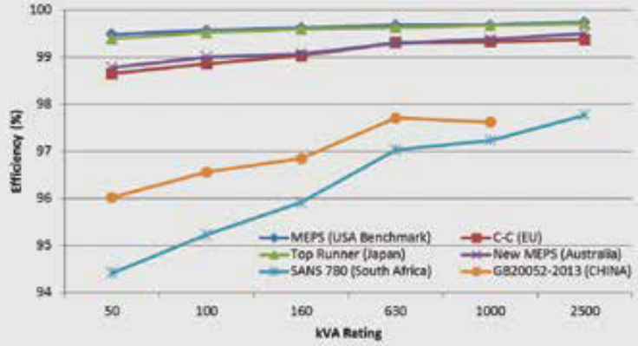
SANS 780’s benchmark with respect to other international countries.
Source: Reducing South Africa’ s electrical distribution transformer losses in ‘Electricty and Control’, by Amadi, A. and De Kock, J.

The first standard regarding transformers was issued in 1966 by SABS (based on IEC standards at that time), known as SANS 780. The standard has been amended several times since then, but none of these have included transformer no-load and load losses. Not surprisingly, South Africa’s transformer efficiencies are trailing behind those not only those in first-world but also other BRICS countries (Brazil, Russia, China, India, and South Africa).

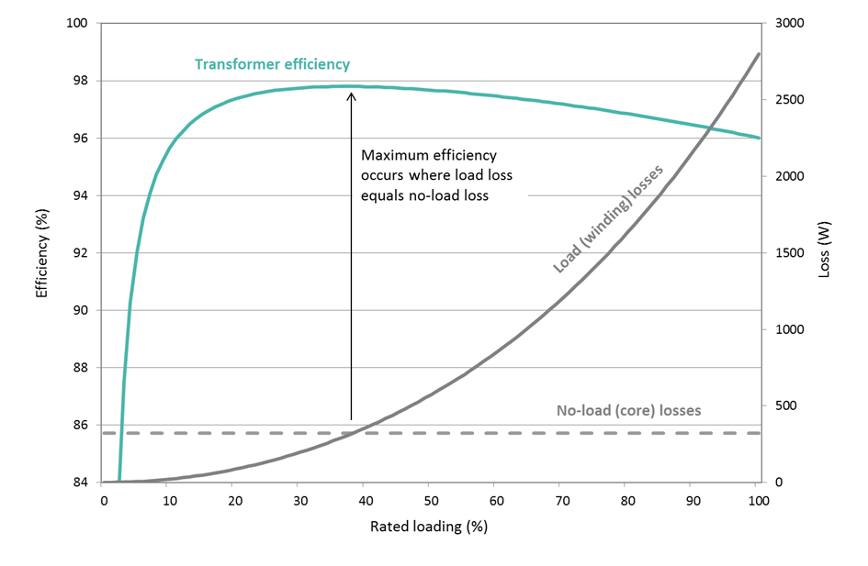
Box 33 Efficiency, losses and transformers

Transformers are devices in an electricity system that transfer power between circuits through electromagnetic induction (this enables energys avings in in power transport by increasing the voltage and decreasing the current). Transformers are installed at power stations to increase the voltage of the electricity to a level that will be suitable for transmission over long distances.
These transformers step up the voltage from, for example, 22 kV to 220 kV, 275 kV, 400 kV or 765 kV and feed the electricity into the national grid. Thus power is transported over large distance through the transmission grid at high voltage (110-275 kV) to the various distribution stations that are closer to the prospective users (toens, groups of villages, industry) and then tranformed by power transformers to medium voltage. When the electricity arrives at the distribution station in South Africa, bulk supplies of electricity at 22 kV are taken for primary distribution to towns and industrial areas, groups of villages, farms and similar concentrations of consumers. The lines are fed into intermediate substations where transformers reduce the voltage to 11 kV. Secondary distribution lines radiating from these substations carry the power into the areas to be supplied and terminate at distribution substations. Here the voltage is reduced to its final level of 380/220 V for use in shops, office buildings. In substations the voltage is decreased by step-down transformers.
Generally, transformers can be grouped in a) large power or high-voltage (> 245 kV), medium-power, medium power (> 36 kV and < 230 kV), medium disttibution (< 36 kV. Small power or small voltage is typically found in the distribution circuits of commercial buildings or industrial facilities. In this section, we are mainly concerned with transformers in South frica power distribution system.
‘No-losses’ (also called ‘ iron losses’) in the core of a distribution transformers occur whenever the transformer is energised, but no activily transmitting a load (through hysterisis and eddy currents). ‘ Load losses’ (also called ‘ wiring’ or ‘ copper’ losses) occur when the transformer supplies a load (caused by the electric resistance in the wiring, and their magnitude varies with the square of the magnetic flux, see figure). The peak efficiency of a transformers occurs at the point where no-load losses are equal to load losses. For a given efficiency, the no-load losses and load losses are generally inversely related.
A transformer can be made more efficient by improving materials (e.g. better quality core steel or winding material) and by modifying the geometric configuration of the core and windings).
Most transformers have relatively high efficiency levels of around 98%. The importance of national energy savings occurs because they operate almost non-stop over a very long service lifetime (15-40 years) and their large numbers in the distribution grid. So, even small increments ( to 99%) can have a substantial impact on the national level.
Many countries around the world have estabished minumum energy performance standards (MEPS) for transformers. For example, European Union (EN50588-1:2014 and EU 548/2014, defining maximum core and coil losses at 100% load, mandatory, 3-phase 25-40,000 kVA), China (GB 20052-2013, maximum cor and coil losses at 100% load, mandatory, 1-phase 5-160 kVA and 3-phase 30-1600 kVA), Mexico (NOM-002-SEDE-1997, efficiency at 50% load, 1-phase 5-167 kVA, 3-phase 15-500 kVA) and USA (effciiency at 50% load, 10-CFR-431, mandatory, efficiency at 50% load, 1-phase: 10-833 VA, 3-phase 15-2500 Kva. Other countries have introduced comparative and/or endorsement labels on a voluntary or mandatory basis. When setting MEPS, countries usually follow IEC 60076 test methods.
Worldwide, transformer losses are about 5% of power consumption. By 2030, world energy consumption will be about 30,875 TWh/yr, including transformer losses of 1,462 TWh/yr. Adoption of MEPS could yield savings of 218 TWh/yr and in combination with best available technology (BAT) even up to 400 TWh/yr, resulting in CO₂ emission savings of 127-248 million tons (MEPS and BAT scenarios, respectively)
Source: Accelerating the Global Adoption of Energy-Efficient Transformers, UN Environment-GEF United for Efficiency (U4E, 2017); Eskom Fact Sheet Transmission and Distribution (2015)

Source: Eskom website (2017)
High-efficiency transformers built with amorphous iron cores have 70% lower no-load losses (compared to best conventional designs using traditional core steel) and can achieve efficiencies up to 99.7% for a 100-kVA unit. Such premium-efficiency transformers improve the material characteristics or the method with which these are used, and at the same time cost, size and weight of the transformer are contained. However, only a few companies can produce high-efficiency transformers and change their production lines. For example, the amorphous technology uses thin ribbons for the core, but this makes more difficult to handle during manufacturing (and the windings have a different shape). Another constraint to increasing efficiency is access to better-quality steel and copper. Also, the newer transformers have to fit into existing mounting locations, placing a physical constraint on the maximum size (and efficiency) of the new transformers.

The manufacturers, a mix of both foreign and local companies, will need to invest in upgrading their production facilities, while also Eskom and municipalities will not want to see a drastic change in the transformer price. To change to high-efficiency transformers the manufacturers will need to upgrade their production facilities (e.g. oil filling under vacuum, separate oil storage facilities, newer winding machines and improved paint spray booths) at an estimated cost of ZAR 8 to 10 million.

One approach will be to reduce losses requirements incrementally over time. Rather than fixing losses at a generally low level, the load factors will vary greatly in different areas or type of applications in South Africa. For example, it does not make sense to force very low loss cores for areas with high loading, where load losses dominate. This would push manufacturers and utilities towards reducing losses and raise the awareness that TOC improvements can be made with drastic changes in the upfront cost of transformers. Municipalities already struggle to keep up with the infrastructure damage caused by cable theft, and the general overloading of electricity transformers due to illegal connections.

Transformers are not typical consumer products, unlike the lighting products discussed in the previous section E.2, and in South Africa may be less suited to energy labelling. ESKOM has been developing an internal efficiency standard, which is not yet published. This could be a basis for formulating the Minimum Energy Performance Standard (MEPS) for the country, not only to be followed by Eskom but by the municipal utilities as well. The MEPS might be based on voluntary agreements between the electricity companies and the government or as part of a mandatory regulatory and control framework.

The replacement of distribution transformers is typically done on an on-demand basis, as transformers fail or when networks are extended. The installation of new transformers falls under two central government programmes for electrification, one managed by ESKOM (ZAR 3.2 billion annually), another managed by the municipalities (ZAR 1.9 billion annually).

Most electricity utilities are typically regulated to some extent in terms of prices they can charge and operating costs that can be claimed. Typically, these regulatory frameworks allow system losses to be included in the overall operating costs, which are then passed on to consumers. National Treasury requires a “lowest cost” for the procurement of transformers and a certain amount of local content for qualifying equipment. Utilities therefore usually have no interest or incentive to increase the efficiency of distribution transformers that they install. Indeed, more efficient models will almost certainly have a higher capital cost, which acts as a strong disincentive for their selection. This impairs the purchase of higher efficiency equipment, and policies have to be modified to overcome this barrier. One way to provide an incentive for high-efficiency transformers may be to allow faster depreciation of high-efficiency models. This would provide some rebalancing of the financial penalties many utilities would see associated with high-efficiency transformers. Another approach would be to apply some form of tax, levy or other capital payment onto transformers that are below the target efficiency threshold to discourage their selection. However, there are no particular state or industry-funded programmes or initiatives to drive the adoption of energy efficient distribution transformers in South Africa.

Use of vegetable oil

Most distribution transformers used in South Africa are of the liquid-immersed type. Worldwide, vegetable-oil natural esters are increasingly being used in distribution transformers as insulating oil. The use of vegetable oil would add an additional 10% to the cost of a transformer. Apart from its greenhouse reduction impact as a replacement for mineral oils, vegetable oils have the advantage that these have a higher maximum operating temperature, meaning that a transformer can be loaded at higher rating (run at a higher load factor and extend the transformer’s life) and/or have an extended life (up to 40 years). In addition, vegetable oils have better fire safety (having a larger flash and fire point than mineral oils) and reduced spread (due to their higher viscosity) in spillage conditions.

Vegetable oils, such as rapeseed, soy or sunflower oils, are bio-degradable. The insulating oils could be recovered after the transformer’s service and processed to be used as biofuel. One proposal being discussed at Eskom is for new contracts on transformers, these will incorporate 30% ester oil in the first year, 60% in the second year and 100% as of the third year onwards.

  - Waste management and recycling

E-waste

Informal sector salvaging, both at the street level, and at the landfill, constitutes the bulk of recycling activities in South Africa. Recovered quantities and types of material are highly dependent on the market demand, price and industry organised collection, buy-back, and redemption systems. As a consequence, waste separation and formal recycling remain a concept foreign to many South African households.

Lighting waste has internationally been incorporated under e-waste (electric and electronic waste). Fluorescent lamps have a special status as these contain small amounts of mercury, which is a hazardous substance. Recovery options possible are retail outlets, buy-back centres, ESKOM offices, municipal facilities, and dedicated mobile units. An ESKOM-eWASA study mentions that the points of sale would constitute a central location for collection, but in low-income or rural areas these are often not ‘within walking distance’ and mobile units might offer a plausible solution. After collection, CFLs are taken to recycling centres. The first step of processing CFLs involves crushing the bulbs in a machine that uses negative pressure ventilation and a mercury-absorbing filter or cold trap to contain the mercury vapor. Then, the crushed glass and metal is stored in drums, ready for shipping to recycling factories. In South Africa, companies such as Reclite, Balcan Engineering, Crush Lamp, collect and/or recycle various types of lamps and separate into fractions, including the recovery of mercury.

There is currently no specific legislation that deals with e-waste in South Africa. However, the new National Environmental Management Waste Act (2008) has implications for e-waste management and makes it illegal for individuals or companies to send e-waste to landfills. DEA is considering to split the two categories, e-waste and lighting, and be dealt with separate waste management plans. In November 2011 the National Waste Management Strategy (NWMS) was established to achieve the objects of the Act.

PCBs

South Africa is a Party to the Stockholm Convention on Persistent Organic Pollutants (“Stockholm Convention”). Polychlorinated biphenyls (PCBs) form one of twelve) Persistent Organic Pollutants (POPs) governed by UNEP (United Nations Environmental Program) according to the outcome of the Basel Convention that was ratified in 2001, with South Africa being a signatory. The country published in July 2014 Regulations (# 37818) on the phasing out of the use of (PCBs) and PCB-contaminated materials. The Regulations prohibit the use, production, import and export and sale of PCBs or PCB contaminated materials, during the phase-out period, without registration. The use of PCBs and PCBs contaminated materials is to be phased out by the year 2023, with a further three years provided within which PCB holders have to dispose of their stockpiled PCB materials, PCB contaminated materials and PCB waste in their possession.

PCBs were formerly used in transformer oil, since they have high dielectric strength and are not flammable. Unfortunately, they are also toxic and not at all biodegradable, and difficult to dispose of safely. When burned, they form even more toxic products, such as chlorinated dioxins and chlorinated dibenzofurans. Starting in the 1970s and 1980s, production and new uses of PCBs were banned in many countries, due to concerns about the accumulation of PCBs and toxicity of their by-products. The main electricity supplier in South Africa, Eskom, still has does have power (transmission network) transformers and capacitors with PCBs, but a programme with the aim of a getting PCB-free system is in place. Eskom has also shipped some PCB-contaminated oil overseas for monitored incineration. Batch testing of Eskom’ s distribution transformers has shown that these do not contain PCBs. One can conclude that nation-wide only a small percentage of the remaining equipment contains PCBs in the oils, and these are being replaced as they become redundant. Eskom has procedures in place to prevent further contamination during transfers and maintenance.

  - Financing of energy efficiency and the market for energy services

The market for energy efficiency services

The energy services market uses many different definitions to reflect the varying interests of the broad spectrum of stakeholders involved. Consultancy services are provided by energy auditors, planning engineers, certified measurement & verification personnel (CMVPs), accountants, lawyers, and others. Payments for consultancy services are commonly agreed upon based on their inputs (hourly rates or a lump sum). Technology suppliers provide hardware, such as lighting, or software such as energy accounting or management packages. These are paid for the supply and/or installation or maintenance of these components, though typically not for their performance or outputs. Energy Service Companies (ESCOs) typically provide performance-based energy contracting, also referred to as ESCO or energy efficiency services. In the Energy Performance Contracting (EPC) business model, ESCOs provide energy savings measured in comparison with a previous energy cost baseline. Engineering Procurement Contractors provide the detailed engineering design of the project, procure all the equipment and materials necessary and then construct to deliver a functioning facility or asset to their clients.

The Department of Energy, with the Department of Public Works, has set an energy savings target of 15% for the government’s portfolio of nearly 100,000 public buildings. The standards SANS 1544 Energy performance certificates for buildings specifies the methodology for calculating energy performance in existing buildings. This standard is mandatory for all public buildings since 2016. These Energy Performance Certificates (EPCs) will be issued by trained assessors. Although the regulations will only apply to government buildings that have a floor area greater than 1,000m², it is expected that the regulations will be extended to the commercial sector by 2020 (SANAS, 2016). This creates opportunities for many players in the energy efficiency value chain, including technology providers, project developers, installers, and financiers, or ESCOs offering consolidated solutions in existing buildings (i.e. retrofits) and in new buildings.

An IDC-commissioned report estimates the EE market in 2011 in South Africa as 12,993 MW, of which 939 MW in the residential, 115 MW in the commercial and 116 MW in the industrial sectors for efficient lighting. Over the period 2012-2020 another 5,500 MW would be added. Out of this potential, the market for energy efficiency service providers (ESCOs) would be 6,000 MW (at least ZAR 2.6 billion with an estimated 26 million GWh savings) .
‘

Financing models

1) Standard project development – grant and debt funding

The traditional model separates the project development from the funding of energy efficiency projects. The end-client develops a set of requirements and runs a selection process for the installation of the project in a process separated from the acquisition of funding for the project. It requires the end-clients to be technically competent in the development of adequate Terms of Reference for the project and be able to analyse the technical proposals from the supplier/installer.

In grant funding cases, the funds are provided as long as the projects meet certain criteria (that can be very detailed and cumbersome to analyse for the client). The reason is that grant funding often has a higher-level objective, and the grants are only provided with a very strict set of criteria that perfectly matches this objective. This creates the risk of developing projects that are suitable for this higher-level objective but would otherwise have limited demand from the end user (uncertain ‘ownership’ by the client). The performance risk stays with the client.

Public sector clients typically follow very strict and regulated processes for capital expenditure projects such as energy efficiency projects. In the case of South Africa, these activities are primarily regulated by the Municipal Finance Management Act (MFMA) and the Municipal Systems Act (MSA). Important differences exist between the different types of municipalities, in areas such as their credit ratings, their revenue generating capacities and the level of financial support from the central government. The larger metropolitan municipalities (metros) generate a substantial part of their revenues from internal sources and the grants from the central government represent a much smaller portion of their funding. They also have investment-grade ratings, facilitating their borrowing processes and achieving similar borrowing costs as those of the central government.

South African municipalities have a clear incentive to reduce energy consumption from their own infrastructure, as the energy costs of street lights and distribution transformers are attributed to the municipality either indirectly (as non-chargeable electricity consumption) or directly (in the case that ESKOM manages the electricity supply to a certain area, street-light electricity bills are issued to the municipality). On the other hand, any reduction of electricity consumption from private end-users would have a negative financial impact on the municipality, due to reduced revenue from the sale of electricity. However, due to the continuous strain on the electricity system municipalities are in general supportive of energy efficiency programs if they help to reduce peak loads and increase the security of supply.

In South Africa, examples of government grant schemes are the Municipal Energy Efficiency and Demand Side Management (MEEDSM, administered by DOE), see Box 34 and the Municipal Infrastructure Grant (which excludes the metropolitan municipalities), administered by the Department of Cooperative Governance, see Box 22). Other examples are the Integrated National Electrification Program (both for municipalities and ESKOM), and the Urban Settlements Development Grant (which is focused on providing housing to reduce the numbers of informal settlements; administered by National Treasury).

These programs, in their current form, have been proven insufficient to address the transition towards higher efficiency LED lighting and distribution transformers, and funding is often used to reduce the backlog of issues in the infrastructure. Despite the insufficient grant funding available from the central government, municipalities, in particular, those from rural areas, are accustomed to sourcing a substantial part of their revenue from grants, and it is an integral part of their expectations to receive grant funding for energy efficiency projects.

Box 34 Government-sponsored schemes for energy efficiency and municipal energy efficiency

Under the Municipal Energy Efficiency Demand-Side Management (MEEDSM) programme, established by the Department of Energy, allocated by the National Treasury, through the Division of Revenue Act (DORA), municipalities can receive grants for the planning and implementation of energy efficient technologies ranging from traffic and street lighting to energy-efficient technologies in buildings and water service infrastructure. By means of Calls for Proposals, municipalities can submit EE and DSM proposals. The cumulative energy saved as a result of the programme based on projected targets is approximately 1.8 PJ, mainly through street lighting retrofits. The programme has delivered grants to 68 municipalities in South Africa since 2009 with a budget of ZAR 1264 million (2009-2015/16) and planned energy savings of 500 GWh (1.8 PJ), benefitting over 32 million people. With GIZ-support, DoE is implementing the EE Street Lighting Retrofit Project (2014-2019), which provides technical assistance, capacity building (at national and municipal level hardware infrastructure investments aiming at retrofitting about 12,000 MV as well as retrofitting HPS with LED (highways, high masts, and BRT corridors). The budget is approximately EUR 5 million, of which EUR 3.2 million for procurement (street lighting).

For the coming years, the MEEDSM programme will continue with a budget of about ZAR 200 million a year (ZAR 215 million in the 2018-19 budget). Nonetheless, the programme has reached annually just 12% of the municipalities in South Africa. To make more funding avilable to more municipalities, DoE is now discussing the possibility to reduce the level of grant funding under the MEEDSM from 100% of the project value to a lower percentage as a way to leverage the grant program, increase the number of projects and municipalities that receive funding and let the obtain funding from other sources. However, such a proposal will be opposed by many of the financially constrained municipalities.

DoE has made funds available through the Approach to Distribution Asset Management (ADAM) programme that will deal with the funding of the maintenance. Most of the infrastructure used by municipalities and Eskom is over 40 years old and it needs billions of Rand to be replaced or refurbished. In 2008, the maintenance backlog was ZAR 27 billion and in 2014 this had increased to ZAR 68 billion (municipalities: ZAR 32 billion and ESKOM: ZAR 36 billion). Municipalities collectively owe Eskom ZAR 11 billion over failure to pay the power utility and growing at the alarming rate of R 2.5 billion per annum (based on a study adone by Electricity Distribution Industry Holdings, EDIH). The National Energy Regulator of South Africa warned that 6% of electricity revenue of municipalities should go to the maintenance of infrastructure,

In response to the power shortage and load shedding situation (described earlier), Eskom’s Energy Efficiency and Demand-side Management programme (EE-DSM, now called, IDM, Integrated demand management) embarked in 2008 on a campaign to exchange incandescent bulbs in homes for more energy efficient CFL bulbs (free-of-charge, primarily in the low-income households). As of January 2017, more than 65 million had been distributed to homes across South Africa, making it one of the biggest energy-saving initiatives. Eskom has directly procured these lamps for delivery to householders with a door-to-door campaign method*. The electricity supply situation has stabilised, and since 2016 there has been an over-supply. In this context and given ESKOM’s funding constraints (described earlier), ESKOM is scaling back its IDM initiatives, now focussing solely on the residential CFL mass rollout and the ESCO programme.** However, the CFL exchange program will end and Eskom has no plans to continue it (with LED technology) in the foreseeable future.

* The ESKOM EE-DSM programme also had a component that serves commercial buildings and the services are the Standard Offer (SO) and Standard Product (SP) most suited for residential and small commercial buildings, including efficient lighting (SP is for savings up to 250 kW). Eskom put the SO and SP rebate programmes on hold in 2014.
** The ESCO pgramme considered funding for commercial and industrial sector project that were able to shift electrical load outside Eskom's evening peak periods.Project proposals were invited from ESCOs, project developers, or businesses with a turnover of less than ZAR 50 million

Debt instruments include loans from a traditional (commercial) banks or a concessional loan from development banks or development partners, often through a specialized vehicle such as a sustainable energy or climate change mitigation fund. The debt funding limits the provision of funds to those clients with higher credit-worthiness. It also requires a credit analysis of the end-client, which in non-specialized lenders typically follows the same procedure as a loan for non-energy projects. This neglects the effects that the energy efficiency project will have in the cash flow situation of the client, which, depending on the scope of the project may indeed have substantial implications to the financial situation of the end-client. A hybrid source of funding is the utilization of grant or concessional funding to provide a loan with favourable terms and conditions. In this case, the criteria to provide funds is relaxed compared to a pure grant-funding scheme, and it allows the development of a sustainable mechanism that does not require a constant replenishment of funds (particularly in the first years). Such a mechanism also provides an economic incentive to end-users to take commercial sources of debt by lowering the overall financing costs. As with grant financing, it requires ‘technically competent’ clients (or outside project preparation support).

For small-scale investment projects of similar type by similar end-clients (e.g. street lighting for small municipalities or LED lighting for households) this model may benefit from a joint procurement approach, whereby the aggregation of projects achieves economies of scale in the purchasing process. This approach may also be applied through an intermediary (distributor/reseller) of equipment. A graphical summary of this model is indicated below.

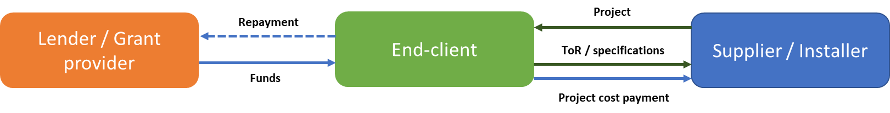

The Development Bank of Southern Africa (DBSA) is a development financial institution (DFI) with a focus on the public sector in Southern Africa particularly for the financing of infrastructure projects). In South Africa, DBSA’s loan portfolio heavily concentrated on municipalities, with 34% of the loan portfolio and on public utilities (primarily ESKOM) with 35% of the loan portfolio. DBSA has been implementing a number of programmes:
- The Green Fund (and to which DEA added ZAR 800 million) has been supporting project development and investment, capacity building and policy research in green projects by means of grants, loans and equity, including energy efficiency (within its focus areas of ‘green cities and towns’ and ‘low-carbon economy’). The Fund closed in 2018 for new proposals.
- The Bank is accredited to the Global Environment Facility (GEF) and the Green Climate Fund (GCF)
  - With GEF support, DBSA is currently implementing two energy/urban-related projects, Cities-IAP: Building a resilient and resource-efficient Johannesburg: increased access to urban services and improved quality of life (GEF 9415; GEF funding: USD 8.09 million) and the SP-IPPPP: Equity Fund for the Small Projects Independent Power Producer Procurement Programme (GEF 9085, GEF funding: USD 15 million);
  - The GCF-funded Climate Finance Facility (CFF) is in its latest development stages and pending finalization with the private financing providers. It was approved by GCF in October 2018 to receive a total of USD 55.6 million of funding. DBSA and other private financiers are co-funding this program which is expected to achieve a total size of ZAR 2 billion. The CFF will be structured as a self-sustaining debt facility and will evaluate and finance projects, drawing capital from multiple dedicated sources, to provide credit enhancement and debt funding (in various forms) to drive private investment The Facility targets climate-friendly (e.g., renewable energy, water, transportation and waste) projects in the four countries that comprise the common monetary area of southern Africa (South Africa, Namibia, Lesotho and Swaziland. The CFF will be structured as an independent special purpose vehicle (SPV). Funds committed to the CFF will not sit on the DBSA balance sheet, but rather within this distinct legal vehicle.
  - Another GCF project is the Public & Private Sector Energy Efficiency Programme (PPSEEP). This program aims to provide funding (with low-interest rates) to medium-sized energy efficiency projects both for public and private clients (direct funding), as well as providing additional support to the ESCO market as a critical element of off-balance sheet funding and risk sharing. The PPSEEP is currently in its formulation stage. On a broad description, it builds on the National Business Initiative (NBI) and a large set of energy audits previously developed by the Carbon Trust.

Rural municipalities have a higher cost of external finance, are heavily dependent on central government grants and some of them are currently in debt recovery status. The funding allocation from all the infrastructure grant programs has resulted in that rural municipalities are accustomed to receiving grant funding for these projects and makes it difficult for non-grant programs to be developed. On the other hand, metropolitan municipalities receive relatively little grant funding for these purposes. The eight larger, metropolitan municipalities have good access to capital markets. They are considered investment-grade, with interest rates marginally superior to those of the national government (e.g. 10-year South African government bond currently yields 9.2%). Considering their substantially stronger revenue generation and their investment-grade status, a financial mechanism that includes a debt component may, therefore, be suitable for the metropolitan municipalities. It is worth noting that the municipalities do not typically request debt funding for specific projects once their project preparation phase is completed, rather the capital expenditures for the following three fiscal years are planned in a very well-defined budget development process. If external funding is deemed to be required for the approved budgets, the treasury department of the municipality issues a tender for the provision of such funding. DBSA regularly participates in such tenders and currently has credit lines open to most of the major municipalities.

2) ESCO models

This financing model introduces the Energy Services Company (ESCO) concept. This is a special service provider that combines procurement of goods, project installation capability and a post-installation service. ESCOs work on ‘energy performance contracting (EPC)’ basis, which provides energy savings measured in comparison with a previous energy cost baseline and in which the ESCO’s remuneration depends on the respective outputs of the services provided. In principle, customers can have off-balance financing that will pay for the project through energy savings. A major advantage is that customers can fund the project over time and can do so with very little or no discretionary budgets and at relatively low risk. The models do require a proven ESCO presence in the energy efficiency market.

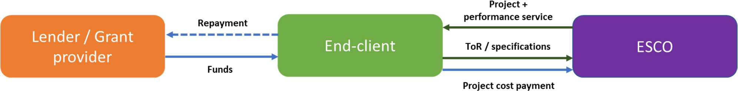
In the guaranteed savings (or performance guarantee) modality, the client makes the investment (from his own funds or the banks, or leasing) but the ESCO provides a guarantee for the energy savings realised. Based on end-user or third-party financing, this model has the advantage that interest rates are usually much lower and therefore more energy efficiency investment is possible. At the same time, the risk for the end-client is reduced by transferring to the ESCO the responsibility that the project will perform correctly. Penalties are applied to the ESCO should the performance of the project not meet the contractually agreed terms. A graphical summary of this model is indicated below.

This model has similar advantages and disadvantages to the standard project development but transfers part of the project performance risk to the ESCO. Typically, ESCOs build a portion of these performance risks in the project cost, increasing the capital investment requirements. Additional measurement and verification costs also need to be included which may result in the end-clients perceiving the project cost as “inflated” compared to a traditional project development case.

The more technically-competent end- clients like the metropolitan municipalities in South Africa may see a limited value on this model. The rural municipalities with less internal capacity are also more financially constrained, which means that they may not be able to access competitive sources of funding.

A variation of the modality is lease-purchase, in which the end-client leases the assets implemented by the ESCO and receives ownership at the end of the lease contract. Typically, the ESCO arranges the financing solution for the end-client with a leasing institution. This is a common model in energy efficiency projects in the public sector in developed ESCO markets. Despite its higher headline interest rates, it is a good alternative to traditional debt financing sources (loans, bonds) as they are much faster to deploy (it also allows the organization to pay for facility upgrades by using funds that are already allocated in its annual energy budget, which simplifies their internal approval processes). The modality does not require technically- competent client and the performance risk is transferred to the ESCO. However, it requires leasing companies to understand the ESCO model and clients to be financially competent (or have additional project preparation & post implementation support). A graphical summary is given below:

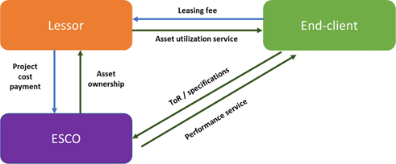

In the case of South African municipalities, the management of public finances follows an integrated plan with clearly defined processes, which would result in implementation timelines of this model similar to others. This model also requires the utilization of a specialized financial institution with deep knowledge of the ESCO model (not present currently in South Africa) and internal capacities to assess the projects and take ownership of the assets. Applying the model in the Project’s Financial Instrument (EEFI) may lead to duplication of efforts with the shared-savings model for energy efficiency in public buildings implemented under the V-NAMA programme (see Box 35).

In the shared savings modality, the ESCO guarantees the performance of the installation and invests or provides financing, and recoups this through the contracting fee, i.e. the cost savings (due to reduced energy consumption and maintenance) are shared by the ESCO and the client at a pre-determined percentage for a fixed number of years. Thus, the ESCO guarantees a certain level of cost savings to the customer, assuming both the performance and the credit risk. Maintenance of the facilities is also typically included in the scope of the ESCO.

A regular measurement and verification (M&V) report assesses the actual savings achieved during the period analysed and determines the savings split. This report is typically performed on an annual basis and is used to reconcile the amounts due to the ESCO and the scheduled payments performed by the end-client under the contract. Depending on the result of the M&V report, an additional payment is performed by the client or by the ESCO to settle the balance. The savings split may include the allocation of excess savings to the end-client in order to align its incentives into achieving good performance.

This model has several advantages. It substantially reduces the risk for the end-client and does not require any upfront capital. It also shifts the credit assessment to the ESCO, instead of the end-client and allows the reduction of transaction costs by packaging multiple projects from one ESCO into a single loan. The main disadvantage of this model is that it increases the complexity of the program management, as payments to be made to the ESCO depend on the monitoring and verification (M&V) of the savings. In less-developed markets, ESCOs may not offer this model due to the inherent risk for them and inexperience with actual project implementation and verification of savings. There are options to mitigate this complexity and potential delay in the payments, such as the establishment of a fixed annual fee (aligned with the expected savings of the project) into an escrow account, or the addition of an energy service agreement, whereby the utility bills are channelled through the ESCO and the client pays a predetermined fee that takes into account the expected cost reductions. In both options, an annual settlement of the achieved savings is required, unless a simplified M&V option (e.g. IPMVP type A) is utilized. This M&V option determines the energy savings at the beginning of the contract and payments are based on this initial performance assessment. A graphical summary of this model with the escrow account option is indicated below:
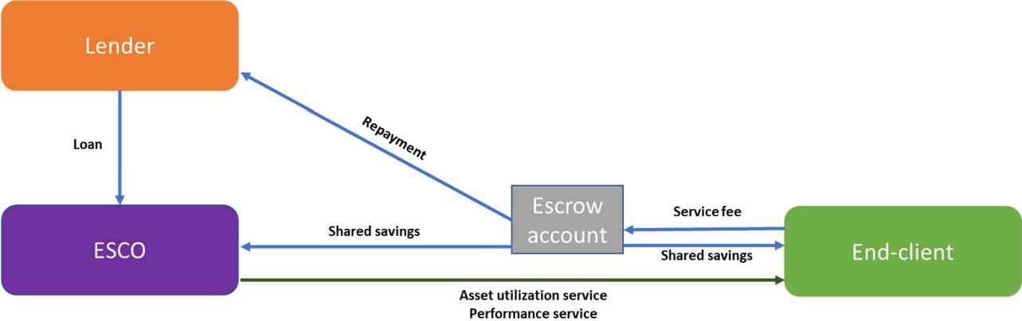

This model represents a valuable proposition for South African municipalities with limited technical capabilities and low credit ratings. It allows the transfer of infrastructure development, performance risk and potentially maintenance costs to an external company, the ESCO. This model is also a valuable approach for industrial and commercial clients, as the small size of energy efficiency projects from these clients does not typically justify a credit assessment process. The main advantage for the metros is the possibility to finance these projects from an OPEX standpoint, which is more stable and with pre-allocated amounts, facilitating the decision-making process. Municipalities are very risk-averse with their finances and want to avoid over-indebtedness. Due to the nature of the municipal budget approval, CAPEX projects have to be approved by the city council (or funded through grants).

However, currently, there is unclarity in the accounting policies of municipalities’ treasury departments regarding the shared-savings model. These contracts frequently contain at the same time elements of a rental, a service, a purchase and a loan agreement, which makes its recording complex and potentially ambiguous. The underlying reason for the ambiguity is whether the equipment installed by the ESCO is in effect municipally-owned or not. If municipal-owned, the accounting should not be different than a contract for the procurement of assets combined with a service contract and a loan liability to the ESCO. This means that these projects are considered a capital expenditure with a corresponding debt increase in the balance sheet of the municipality. This accounting approach would void one of the main potential advantages of the shared-savings model, which is the off-balance sheet financing of this infrastructure upgrade (booking it as an operational expenditure, in a similar way as an operating lease). Public sector ESCO procurement will benefit from a process being developed to allow municipalities to procure energy services for longer than three years. A standardised Request for Proposals (RFP) format is being created, funded by the GIZ. The RFP seeks to overcome the hurdle for municipalities to enter into long-term service agreements by creating a template that all municipalities can easily adopt, adapt and follow in procuring services from ESCOs.

A variation of this model introduces the role of a Super-ESCO, which acts as an additional agent between the ESCO, the lender and the end-client. The Super-ESCO manages most aspects of the project, including the detailed technical design, sourcing funds, providing performance guarantees to the client, selecting smaller ESCOs for project implementation, aggregating projects and overall management and coordination of the implementation and performance guarantee phases.
This option greatly simplifies the program for the end-client, reduces transaction costs for the lender, and supports the development of internal competencies amongst local or more inexperienced ESCOs. It also achieves economies of scale thanks to mass procurement of energy efficiency equipment. The main disadvantage is that a Super-ESCO may grow to dominate the ESCO market, creating a monopolistic situation.

In India, the Super-ESCO model has been successfully applied and showcased in LED public lighting projects. Energy Efficiency Services Limited (EESL) is a super ESCO set up by the Ministry of Power. EESL typically operates with a government guarantee scheme as risk mitigation in the case of performing ESCO services. EESL replaced about 92,000 HPS and TL street lights with LED lighting, resulting in 50% energy savings and improved road illumination levels in the city of Vizag, and is working with the Indian Bureau of Efficiency in other municipalities. EESL has performed a mass LED rollout program known as UJALA that as of November 2018 has distributed over 330 million LED lamps. This program heavily relies on electricity distribution companies in India (DISCOMs) to distribute the lamps to the end-consumers. These lessons and the potential role of equipment supplier could be useful for the setup of a lighting rollout program in collaboration with the municipalities in South Africa.
Box 35 Energy Efficiency in Public Buildings and Infrastructure Programme (EEPBIP)

The V-NAMA* Energy Efficiency in Public Buildings and Infrastructure Programme (EEPBIP) uses the procurement potential of the public sector to strengthen the market for energy service companies (ESCOs) in order to establish a critical mass of projects in the market, and it incorporates already existing expertise in identifying energy efficiency potentials in public buildings into which ESCOs are invited. EEPBIP will be implemented with a EUR 20 million budget during 2019-2023. In its financial component (EUR 15 million), a Project Preparation Facility enables provinces and municipalities to develop bankable energy efficiency investment plans for their public buildings. About ZAR 12.3M may be dedicated to the partial guarantee for loans. The Guarantee Fund supports private ESCOs in raising the necessary finance for entering contracts with the public owners of these buildings to finance and implement these plans (based on the “shared-savings” ESCO model, without the Super-ESCO; see main text). The financial partner may be the Industrial Development Corporation (IDC). In its technical component (EUR 5 million), a Service Desk advises provinces and municipalities on energy efficiency opportunities in public buildings by helping to raise awareness, understand the potential for energy efficiency and associated profits and carbon savings, set baselines and targets and finally identify concrete energy saving opportunities. The desk supports the government in measuring the EEPBIP’s results and it supports further development of mechanisms that promote energy efficiency.

* Vertically integrated Facility funded by the German Federal Ministry for the Environment and Nature Conservation and the Department for Business, Energy and Industrial Strategy (BEIS) of the United Kingdom (UK) in 2013 with GIZ provided technical assistance. Other donors have contributed to its various Calls for Proposals (Denmark, European Union).

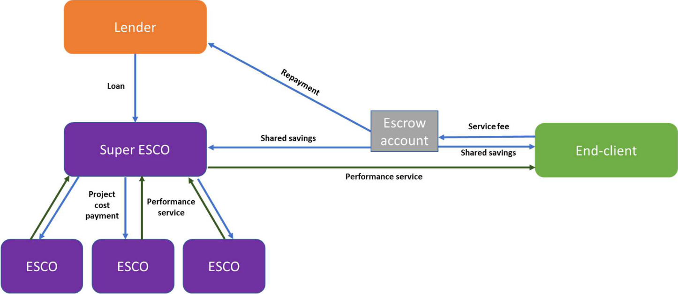
A graphical presentation of the Super-ESCO model is given below:

3) On-bill financing

On-bill financing model allows end-clients to pay for energy efficiency investments through their utility bill. Typically, the range of investments is limited to a set of pre-approved technologies that the utility deems relevant for the program. Funding for the measures may be provided directly by the utility with their own funds, a revolving fund or by a third-party finance provider. As utilities already have a commercial relationship with the end-client and the projects are bundled in a credit facility, this model allows for a simplified process, reducing transaction costs for small energy efficiency investments. It also allows access to energy use profiles of the client, which may be useful for the technical project design.

This on-bill financing model reduces the risk of credit default as the contracts typically allow for disconnection of the service to customers who fail to make their loan payments. When correctly implemented this also results in a net cash-positive or at least cash-neutral financing system for the end-client, who sees in the utility bill an energy cost reduction equivalent to the loan repayment amount. These characteristics make this model suitable for large number of clients, where it is not feasible to perform individual credit assessments and cases where the electricity consumption reduction will be noticeable in the bill by the end-clients, effectively limiting its scope to private end-clients. This model has the difficulty that it requires an update the billing system of the utility to incorporate these charges as well as an information exchange platform with the financing provider if this is a third party. A graphical summary of this model is indicated below.

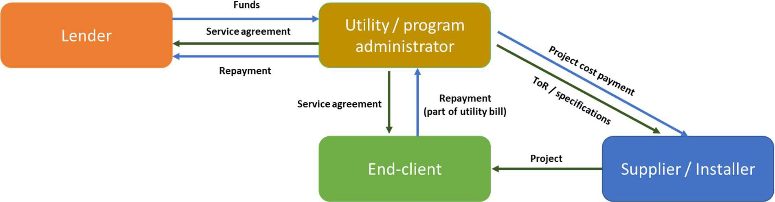

This model poses the challenge that municipalities obtain a substantial portion of their revenue through the sale of electricity (which they buy at bulk prices from ESKOM and supply to end-clients adding their own margin); at first look, they would not be interested in cutting this revenue by encouraging their clients to consume less. However, other considerations, such as overall peak demand reduction play an important role. For example, City Power states that peak demand reduction is the primary goal of their “energy management” efforts. The reason is that high peak demands are costly for the municipalities. Their bulk electricity purchases at peak times have the highest price per kWh and include a monthly peak demand charge. Municipalities are not able to directly pass these costs to residential users, which are instead included in a flat monthly fee based on the type of connection or blended with the unit price. High peak demands also result in high maintenance costs for municipalities as overloaded transformers fail at those times. Utilities pay a fixed price for peak capacity demanded from the network. This cost is not directly transferred to the consumers, but built into fixed charges or the kWh price.

A further LED penetration and price reduction may be achieved through a mass procurement program that channels the lamps through an existing network of distributors. Synergies with other residential energy programs such as the Shisa solar program in Durban, the smart-meter rollout in Johannesburg or the social housing programs that all municipalities manage would facilitate the deployment of this technology. This program could be deployed in collaboration with the utilities supplying electricity to these clients, which would open the possibility to include an on-bill financing program. Such a program would enable a streamlined process for the project sourcing, implementation, and fund deployment.

Let us look at municipal efficient residential lighting programme, in which the users repay the cost of the LED through a small charge in their utility bill (on-bill financing). The installation of efficient technology, i.e. LED lamps, results in a reduction of the connected load in the system, which in turns reduces the demand charges that the utilities face and that are not passed on to the residential users. This results in a positive impact in the municipal utility charges that balances the revenue sales loss. It also generates a reduction in electricity consumption that may be allocated to industrial or commercial users with a higher tariff. Together, this could allow the municipal utility to ‘repay’ the LED lamp programme in a period of 3-10 years.

Thus, several municipalities have supported the introduction of energy efficiency. The expected collaboration with municipalities on the development and financing of projects related to their own-consumption may be leveraged to introduce an on-bill financing mechanism for private commercial and industrial end-users once the Project is operational.

4) Public-private partnership model

The public-private partnership model consists of a long-term collaboration agreement (typically 20-30 years) between public and private entities. The contracts are typically used in large infrastructure projects, where the private sector installs and maintains the assets. The private entity also typically raises the required funding under a project-finance structure through a Special Purpose Vehicle (SPV). The public entity then pays an agreed-upon fee for the provision and utilization of the infrastructure. The aim of this model is to reduce life-cycle infrastructure costs, by gaining cost efficiencies in the design, installation and operation phases of the infrastructure, even if the financing costs are typically higher for the private sector than for the public sector. Experience has shown that this type of model is only suitable in certain situations, where a large infrastructure investment is required and supportive policy environment exists in the country.

Street lighting projects have been included in the scope of some PPPs within a municipality, but mostly PPPs are in large infrastructure development and maintenance projects such as roads, bridges, traffic signals, etc. Although South Africa has legislation that supports this type of contracts, the application to the municipal level is done through the MFMA framework with some additional requirements. The complexities of the PPP model and the tight control that the municipalities have over the electricity distribution and street lighting infrastructure makes the viability of this model questionable for the deployment of street lighting and distribution transformers in South Africa.

Procurement guidelines and energy efficiency

Local government often struggle to digest procurement guidelines, environmental requirements, and new procurement funding approaches. Performance contracting does not fit easily with standard procurement procedures, raising issues around asset ownership (of installed equipment) and requiring financial arrangements very different from the ‘pay-on-delivery-of-a-specified-service’ model. Local government finances tend to be tightly controlled by the national governments. In the case of South Africa, these are governed by the Municipal Financial Management Act (MFMA). The MFMA does not have any provision for the allocation of financial liabilities to ESCOs. It also includes a restriction to municipal finances that is key for energy efficiency project. It limits the municipalities to engage in financial obligations that span for more than three years (with some exclusions, such as long-term debt, which follows a specific procedure). Any municipality intending to enter into a service contract for a period of time longer than three years is required to follow a rather complex approval procedure. These aspects of the MFMA represent important barriers (not insurmountable, but barriers, nonetheless) to the implementation of an ESCO model where the financing for the equipment is provided to the ESCO.

In addition, electricity expenditure savings do not appear as budget line items, making the benefits of the ESCO project less apparent to the ‘system’. Further to these challenges, procurement systems traditionally resist purchasing goods, which have higher capital cost, even if they have lower life-cycle costs. This is a constraint to implementing many EE options, and also has been a deterrent within individual departments as capital budgets and operating budgets are set and treated separately. Saving in operating costs through efficiency interventions does not automatically link to increased capital budget.
Box 36 Advantages and disadvantages of various financing models
Model | Advantages | Disadvantages | Assessment for South African Market
Standard project development - Grant funding. | Acceptance by end-clients.  Applicable to all clients. | Requires technically competent clients or project preparation support.  Requires constant replenishment of funds.  Performance risk stays with the end-client.  Uncertain end-client "ownership" of the project. | Feasible, requires 3rd party co-financing to achieve scale.
Standard project development - Debt funding. | Keeps end-client in control of infrastructure.  Self-sustainable. | Requires technically competent-clients or project preparation support.  Requires credit-worthy clients.  Performance risk stays with the end-client.  Funding cycles from municipalities are defined.  Costly administration. | Limited to credit-worthy municipalities.
Standard project development - Concessional Debt funding. | Lowers overall cost of funding.  Allows co-financing structure, leveraging public funds.  Allows co-existence with other financial mechanisms.  Keeps end-client in control of infrastructure.  May be self-sustainable. | Requires technically competent-clients or project preparation support.  Requires credit-worthy clients if external co-financing is needed.  Requires repayment of funds.  Funding cycles from municipalities are defined.  Costly administration. | Feasible.
ESCO model, performance guarantee - Financing the end-client. | Less limited by the technical capability of end-clients.  Performance risk transferred to ESCO.  Self-sustainable. | Limited additional benefit for end-clients that understand the technologies.  Requires credit-worthy clients.  Requires the presence of ESCOs in the market. | Limited benefit.
ESCO model, performance guarantee - Lease-purchase agreement. | Does not require technically-competent clients.  Performance risk transferred to ESCO.  Bundles projects into a single funding recipient.  Potential OPEX funding for end-client.  Self-sustainable. | Requires leasing companies that understand the ESCO model.  Requires the presence of ESCOs in the market.  Requires financially-competent clients or project preparation & post implementation support.  Public clients must be willing to transfer the operation of critical infrastructure to private company.  Unclarity on municipal financial accounting in SA. | Not feasible.
ESCO model, shared savings - Financing the ESCO. | Does not require technically-competent clients.  Performance risk transferred to ESCO.  Potential OPEX funding for end-client.  Bundles projects into a single funding recipient.  Self-sustainable. | Requires sophisticated financial companies that understand the ESCO model.  Requires the presence of ESCOs in the market.  Requires financially-competent clients or project preparation & post implementation support.  Public clients: requires acceptance to transfer the operation of critical infrastructure to private company.  Unclarity on municipal financial accounting in SA.  Perception that this model is associated with a whole-facility M&V model (requires main-utility bills) | Feasible, existing programs untested.
On-bill financing. | Suitable for small investments in the private sector  Self-sustainable  Potential for off-balance sheet financing through SPV | Complex administration.  Requires adequate billing system infrastructure.  May be perceived as a “commercial” activity by municipalities. | Not feasible for municipalities. Feasible but complex administration for private end-users.
Public-Private Partnership (PPP) model. | Suitable for long term infrastructure investments | Complex mechanism, not suitable for unsophisticated municipalities  Limited benefit for typical EE project durations.  MFMA still the governing structure for municipalities. | Limited added benefit.

Summary, financing models

A brief summary table of the advantages and disadvantages of each model is indicated in Box 36. The result of the analysis is that there are two feasible models for implementation of energy efficiency projects in the municipal space: standard project development (with a varying degree of concessionality in the funding), and the shared-savings ESCO model (which still has some important barriers for deployment).

  - Key consideration for the Project-supported Energy Efficiency Financial Instrument (EEFI)

Target groups

Three key target groups have been identified as potential funding recipients. These groups are private energy users (households and commercial/industrial users), municipalities, and local equipment manufacturers.

Households
The ESKOM lighting exchange program launched in 2005 addressed precisely this market segment, providing subsidized lamp replacements (with CFLs) for households. The low-income households were the main target group of the Eskom lighting programme. Now the CFL replacement programme has ended, once CFL lamps reach their end-of-life, residential users purchase the replacements. LED yield relatively attractive returns on the investment at current prices, as LED prices in the market have fallen substantially and have reached levels comparable to CFL (but with the added benefit that their lifetime is longer). The mid/high income households were a much smaller part of the ESKOM lighting exchange program. A large part of the lighting installed in these households consists of halogen spotlights. This technology is extremely well-suited for a replacement for LED lamps, and thanks to recent price drops of LED, they are more economical to install (and operate) than the halogen lamps. However, the current lack of minimum standards leads to dumping of these lower-cost, low quality LED on the market. This gives the product a bad name, and households (lower and middle/higher income households alike) may, therefore, stick to the technology they know.

To accelerate the transition towards LED lamps, the main levers of the proposed Financial Instrument (EEFI) consist of a reduction on the cost of these lamps. This can be encouraged by means of the implementation of a mass-procurement program that further reduces the price of LED lights and pushes the market to adapt to these prices. This will go together with increased awareness of the benefits of this technology, through a communication campaign for end users (Output 2.1) and the implement of labelling schemes and enforcement mechanisms to ensure that low quality LED lamps are removed from the market (Output 1.2).

Commercial and industrial buildings
In the case of commercial and industrial buildings, several financial institutions have dedicated funding available for energy efficiency programs. Deployment of funds has been nonetheless slow due to the high transaction costs associated with the small size of these investments. Many of these clients are still credit-worthy, and the key to providing funding lies in reducing those transaction costs (for example, aggregating projects through ESCOs, or financing through a lower default instrument such as on-bill financing).

Local equipment providers
Thanks to the combination of the GEF-supported activities that supplement the existing programmes of DoE and ESKOM, local equipment manufacturers and suppliers will see a substantial increase in demand for LED products and high-efficiency transformers. It is expected that they will also see the need to invest in new or upgraded manufacturing facilities to meet the demand. To finance this, local equipment manufacturers can access existing funding sources from commercial banks and private sector programmes of development financial institutions, such as the Industrial Development Corporation.

Municipalities
Currently, the municipalities have available grant programs for the financing of infrastructure that may include energy efficient lighting projects and electricity distribution (as described in the previous Section E.5 and in Box 34). These programs, in their current form, have been proven sufficient to address a full transition towards higher efficiency LED lighting and distribution transformers, and funding is often used to reduce the backlog of issues in the infrastructure. Despite the insufficient grant funding available from the central government, municipalities, in particular. those from rural areas, are accustomed to sourcing a substantial part of their revenue from grants, and it is an integral part of their expectations to receive grant funding for energy efficiency projects. At the same time, many municipalities still have the capacity to raise debt, especially the metropolitan municipalities. This debt funding takes place as part of an integrated budget planning, i.e. in general, financing is obtained by the municipality as a whole for the balance of their funding needs, and not for a specific project.

DBSA already performs lending activities to the about 107 municipalities and has several credit lines open from which the municipalities can draw funds. Integration of EEFI into existing credit analysis processes of DBSA would be a basic element to reduce transaction costs if the funding recipients are the municipalities. Another important measure to minimize transaction costs is the standardization of processes, including the project development templates, procurement documents, contractual arrangements between the various parties, etc. The utilization of such standardized processes is key to ensure a smooth deployment of funds, and it is therefore suggested to utilize available grant funding to develop such set of processes and documents. If the municipality does not have access to debt funding, the utilization of an ESCO company may be valuable to reduce the transaction costs of a potential new facility and also to reduce the project preparation costs. This would be typically the case for smaller municipalities, which are associated with smaller projects and lower internal capacities to develop such projects. These municipalities would, however, require specific training on the procurement and accounting procedures for such ESCO-based programs. The capacity building can be provided by the Project and in collaboration with the V-NAMA program (see Box 35).

Description of financing options – grants funding and debt funding

One element of EEFI is the provision of attractive funding costs. The simplest and most accepted option for end-users would be to provide grant funding for the project implementation. The simplicity of this option reduces transaction costs; however, it limits the scale of the program and its sustainability. On the other hand, the provision of debt funding allows the re-utilization of the available funds, a priori enhancing the sustainability of funding. This improvement may be offset with the higher cost of operation of a debt facility, which requires a credit analysis, legal and other back-office costs.

An assessment of the setup and operational costs of the facility has been performed, allowing the cost-benefit comparison of this debt-funding structure (with zero % interest) to a grant funding scheme with a partial credit guarantee component for projects developed through ESCOs. The setup costs of the two options is given in the tables of Box 37. As expected, the setup costs of the grant facility are lower than those of the debt fund, due to the additional legal and compliance requirements of a debt facility.

For a debt financing fund of just USD 4 million initially, with highly integrated lending and reporting processes, an expense ratio of 5% of the Net Asset Value has been estimated (general fund management cost of 5% of USD 4 million = USD 200,000). In addition, there are transaction-related expenses. The minimum annual reporting costs for the strictly necessary back-office loan management and reporting activities has been estimated in USD 87,500. In addition to the general management expenses, each loan disbursed by the fund requires an additional effort from the commercial, legal, credit assessment and administration teams, as indicated in the tables of the Box.
Box 37 Transaction cost of grant-based vs. debt financing by EEFI

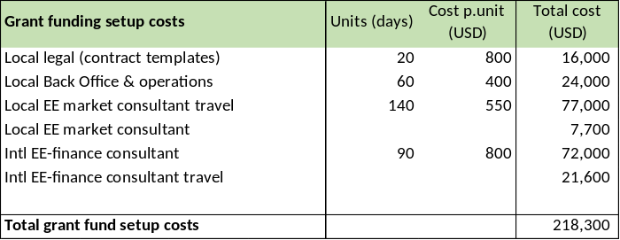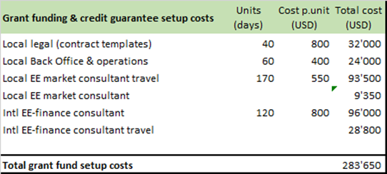

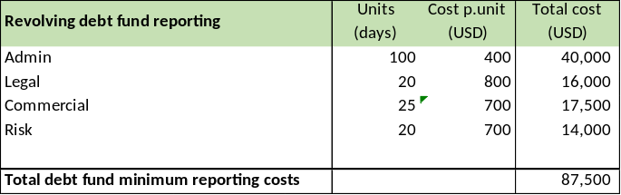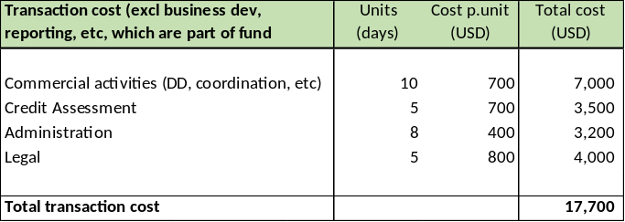

* Vertically integrated Facility funded by the German Federal Ministry for the Environment and Nature Conservation and the Department for Business, Energy and Industrial Strategy (BEIS) of the United Kingdom (UK) in 2013 with GIZ provided technical assistance. Other donors have contributed to its various Calls for Proposals (Denmark, European Union).

These basic conditions and parameters (management and transaction of Box 37) together with other parameters (expected loan volume, loan impairment ratio, municipality financing cost) are given in Box 38 for both modalities in which EEFI could operate (i.e. providing grant funding or as a debt financing facility). Regarding the latter, the loan amount for each project has been limited in the first year by the expected project size, while the amount of funding available is the main limiting factor following the depletion of the initial funds. For operational reasons an alternative approach may be utilized, consisting of the accumulation of loan repayments across several years to accumulate cash and be able to provide a larger loan size.

The loan impairment ratio has been determined using data from DBSA’s current municipal portfolio. The key performance indicators of the fund have been summarized in the tables of Box 38 for the two envisaged function of EEFI as a grant or as debt facility. The grant fund utilizes larger co-financing requirements than the debt facility. The limited operational costs of the grant funding mechanism and the higher co-funding requirement result in that this mechanism achieves lower co-financing results as the revolving fund. However, the biggest difference is in funding cost for the municipalities, which is 40% better than in the revolving fund thanks to the grant nature of this funding. Another advantage is the expected lower fund setup costs, which allow the utilization of further resources to project development support mechanisms.

Box 38 Basic fund data and key indicators, EEFI

Option – debt financing facility
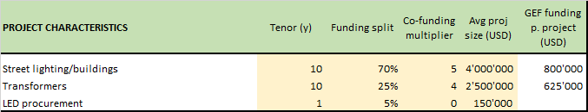

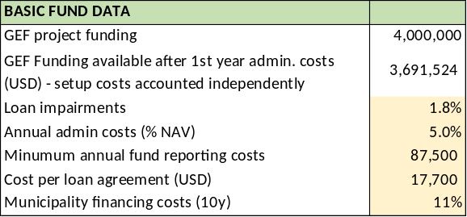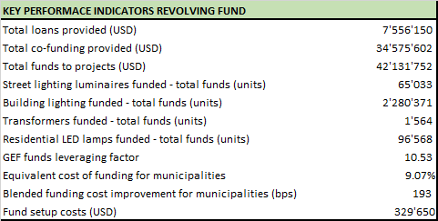

Option – grant funding
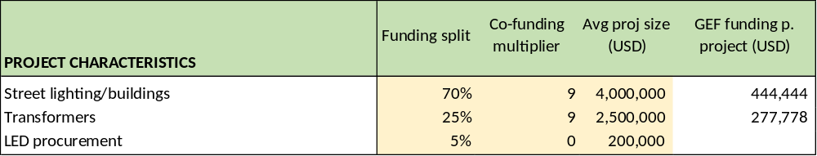

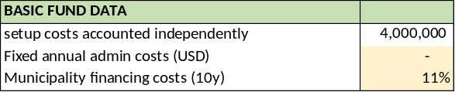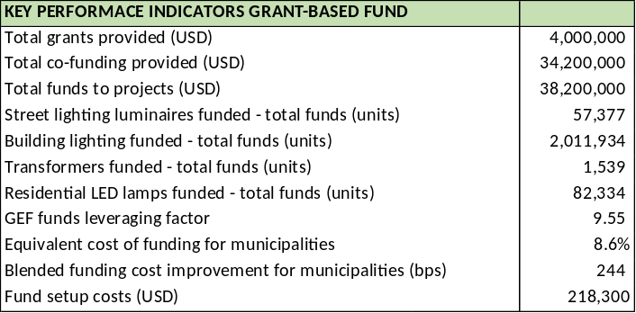

* Vertically integrated Facility funded by the German Federal Ministry for the Environment and Nature Conservation and the Department for Business, Energy and Industrial Strategy (BEIS) of the United Kingdom (UK) in 2013 with GIZ provided technical assistance. Other donors have contributed to its various Calls for Proposals (Denmark, European Union).

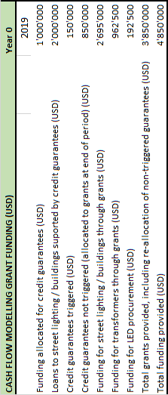
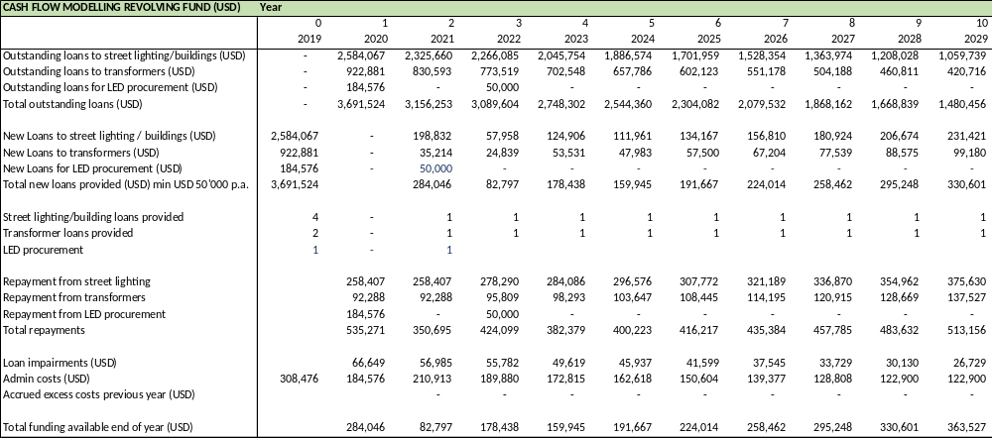
Box 39 Cash flow modelling

A detailed cash-flow simulation has been prepared to assess the performance of EEFI over the lifetime of the project. The main outcome is the substantial portion of operating costs that are derived from operating a debt facility, which result in a low recycling rate of the original funding.

Left: debt revolving fund
Below: grant funding & credit guarantee

- GEF CORE INDICATORS AND calculations of greenhouse gas emission reductions

GEF projects typically focus on facilitating future market development, addressing the causes of the development and environmental problem, and addressing barriers to put the right conditions in place so that emissions and energy needs will not rise or rise less in future. A requirement of any GEF climate change mitigation project proposal is to provide estimates of the emission reductions, “direct” emission reduction (caused by demonstration projects of leveraged investments during the project’s implementation), and “indirect” emission reduction (caused by the implementation of the policy framework, standards and labelling, capacity building and financial mechanisms put in place). The term “consequential” emission is now often used for what previously called ‘indirect’.

The “Leapfrogging South Africa’s markets to high-efficiency LED lighting and high-efficiency distribution transformers” Project has long-term and strategic market development approach. The baseline situation is not determined by a single investment, but is the overall state of the market of LEDs and distribution transformers and described in the ‘baseline scenario’. The project’s outputs capacity building, technical assistance, development and implementation of government policies supporting investment and consumer purchase, are the necessary preconditions for avoiding greenhouse gas emissions in the long run and the corresponding state of the market is described in ‘alternative scenario’.

The United for Efficiency initiative (U4E) completed a Country Assessment for South Africa in December 2016. This assessment sets forth baseline conditions and potential for energy savings, avoided energy costs, and avoided GHG emissions from the adoption of minimum energy performance standards (MEPS) for refrigerators, room air conditioners, distribution transformers, industrial electric motors, and lighting. A summary of the U4E assessment is given in Box 40.
Box 40 South Africa – pathway to energy efficiency (U4E)

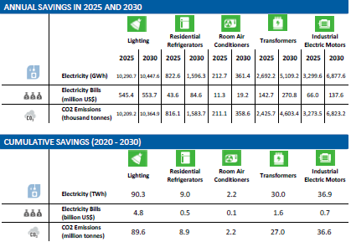
The savings potential assumes minimum energy performance standards (MEPS) are implemented in 2020 at level equivalent to the present day (2015) best global MEPS that are currently implemented. The analysis uses CLASP‘s and Lawrence Berkeley National Laboratory's Policy Analysis Modeling System (PAMS) to forecast the impacts from implementing policies that improve the energy efficiency of new household air conditioners and refrigerators. For lighting, electric motors, and power and distribution transformers individual – models were developed, taking into account country level data, expected GDP growth, and industrialization levels
Source: U4E Country Assessment, South Africa (Dec 2016); en.lighten, United for Efficiency

Source: Eskom website (2017)
Box 41 Assumptions and base data calculations, HE transformers, energy savings and GHG reduction

Information on the number of transformers in South Africa’s distribution system is based on data from the regulator NERSA and the state utility Eskom. Unfortunately, the latest consistent set of data is from the year 2012. Data have been extrapolated to estimate the amount in Eskom’s grid and the municipal power distribution grids in 2017, the base year for the scenario analysis of Box 25. According to Eskom about 10,000 new transformers are added each year and a similar number of old transformers replaced, i.e. 20,000 in total, a growth of about 3% a year. It is assumed that in the baseline that not all of these are replaced with HE (high-efficiency) equipment. In the baseline, to the stock 2,500 HE distribution transformers are added in 2019 and thereafter, in each year 2,500*(1+3%). In the alternative scenario it is assumed not only all that all the 20,000 transformers sold are high-efficient, but that the penetration rate increases also; are added; in the alternative scenario this is 20,000*(1+9%).
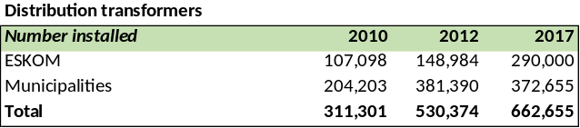
Source: NERSA, Electricity Supply Statistics (2012), 2017 data are estimates, ESKOM, p.c., DHV-GL Country Profile: South Africa (2018)

The following table shows how the energy savings of a high-efficient transformer is calculated:
Losses of a transformer (in kWh/yr) = (P_{LL}*365*24*load factor + P_{NL}*365*24) * (cost of power)
Total owning cost (TOC) = purchase price + present value of future (no load losses + load losses).
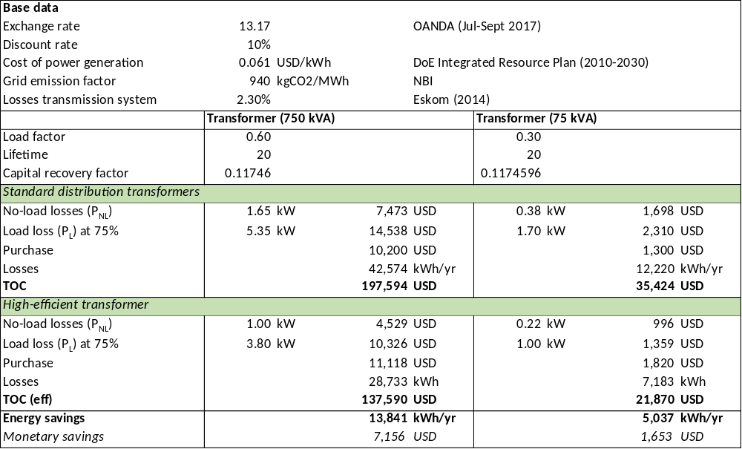
Estimates on transformers in DHV-GL (2018) give 662,655 with an average size of 315 kVA (11 kV/0.4 kV). Transformers come in different size, ranging from 25 to 2,500 kVA, but there are no statistics on numbers per size category. The table gives two calculation examples, for a 750 kVA and a 75 kVA transformer. Assuming that 35% are 750 kVA (or the average of 300-1500 kVA) and 65% are 75 kVA (or the average of the range 25-300 kVA) gives an average szie of 318 kVA.
The present value is calculated by dividing monetary value of the loss by the capital recovery factor*. Prices of standards and efficient transformers are based on data provided by Eskom; infon on International Copper Association (see Introduction to Transformer Losses from Premium-efficiency Motors and Transformers) and the articles Reducing South Africa’s electrical distribution transformer losses (Amadi, DeKock, 2015) and Low-loss transformers in a South African context (Stanford et.al., PowerTech Transformers)

* CFF = I * (1+i)^{n} / ((1+i)^{n}-1) with I = discount rate = 10% and n = lifetime of the transformer (20 years)

The savings potential assumes minimum energy performance standards (MEPS) are implemented in 2020 at level equivalent to the present day (2015) best global MEPS that are currently implemented. The analysis uses CLASP‘s and Lawrence Berkeley National Laboratory's Policy Analysis Modeling System (PAMS) to forecast the impacts from implementing policies that improve the energy efficiency of new household air conditioners and refrigerators. For lighting, electric motors, and power and distribution transformers individual – models were developed, taking into account country level data, expected GDP growth, and industrialization levels
Source: U4E Country Assessment, South Africa (Dec 2016); en.lighten, United for Efficiency

Source: Eskom website (2017)
Box 42 Assumptions and base data calculations, LED lighting, market share and prices (2017)

Information on the stock of lamps is taken from the U4E country assessment for South Africa as well as information on the average wattage per lamp and the estimated usage per day of lamps. It is difficult to get reliable information on prices of lamps. These may differ per sales outlet. We have tried as much as possible use a consistent set of data (number of lamps, prices of lamps, exchange rate) with as base year 2017. Assuming the stock of lamps to grow annually with population growth (1.5%; www.ieconomics.com), the stock of lamps in 2017 is 698.39 million units (total of all sectors, residential, commercial/industrial, public sector, incl. street lighting)
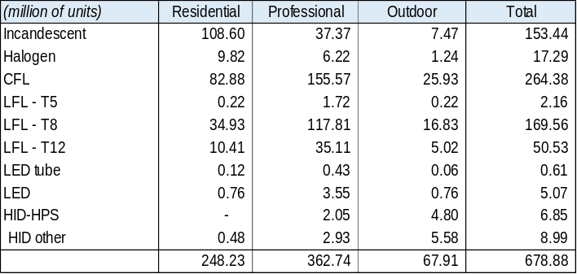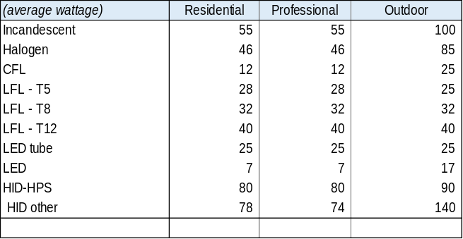

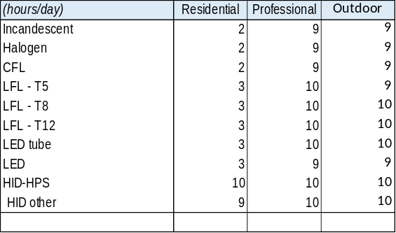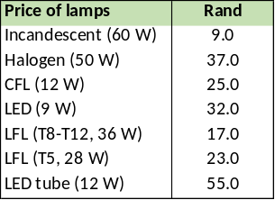

Source: U4E Country Assessment, South Africa (Dec 2016); en.lighten, United for Efficiency, South Africa_Lighting_U4E Assessment_.xlsx
Price of lamps (2018) taken from various website (makro.co.za; www.pricecheck.co.za; livecopper.za; www.builders.co.za; lightingwarehouse.za).
UNDP has also conducted a separate analysis of potential energy savings and avoided GHG emissions using the methodology explained below. Using the same input data for lighting stock as the U4E assessment for the project (2017-2021) and similar post-project timeframes of the project (2022 up to 2030, the U4E Country Assessment’s end year of 2030), the estimated energy savings and avoided GHG emissions calculated in this Annex F are roughly the same as the U4E Country Assessment. For distribution transformers the U4E assessment does not give baseline data for transformers; the GHG calculation uses data from Eskom and NERSA reports (see Box 41)

The direct GHG and consequential GHG emissions reductions and energy savings are determined, guided by the latest directives on GHG emission methodologies (GEF/C.48/Inf.09 of May 2015). The tables in Box 44 and Box 45 show the energy consumption in baseline and alternative scenario for lighting products and distribution transformers, the corresponding annual energy savings and GHG emission reduction. Also, the tables provide an estimate of the peak power reduction and the avoided use of mercury and/or release into the environment.

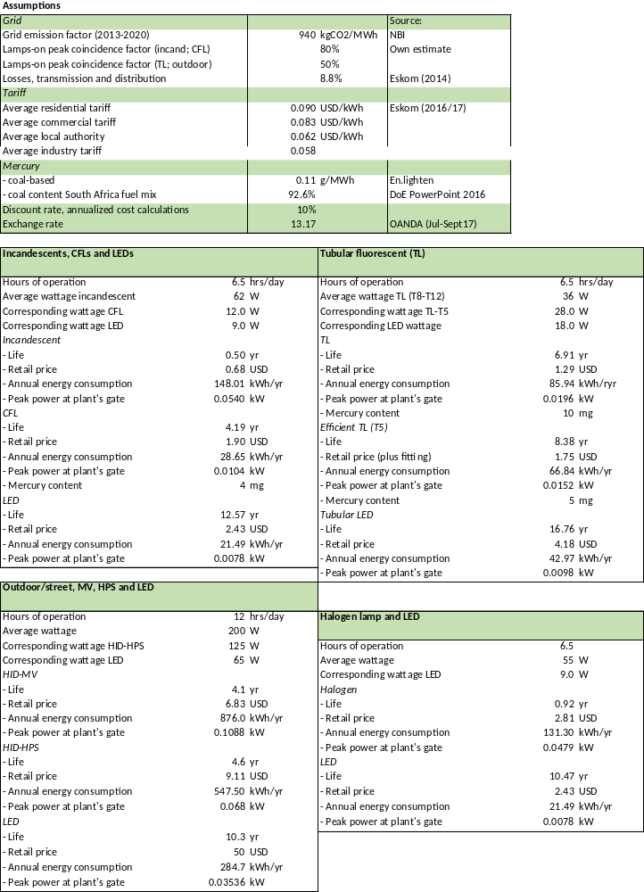
Box 43 Assumptions and base data calculations, LED lighting, energy consumption per device

Source: ESKOM website, Historical average price and increase (2017), transmission and distribution losses (2014). Exchange rates from OANDA website; South Africa’s Grid Emission Factor, National Business Initiative (2013).
Using the market data of Box 42, and assumptions on lifetime and average wattage of the lamp, the tables show the calculation of energy and monetary savings per type of replacement: a) LED replacing CFL and incandescent, b) tubular LED replacing fluorescent tubular lamps (TLs), c) LED replacing a halogen lamp, and d) LED replacing HPS (high-pressure sodium) and mercury vapour (MV) lamps, used in street lighting and other applications. The annual consunmption data are used as input fort the annual energy consumption calculations of Box 44 (= consumption per lamps x number of lamps in yr 20XY)

Box 44 LED and other lamps stock South Africa – energy consumption and GHG emissions in baseline and GEF alternative scenario over 2017-2030

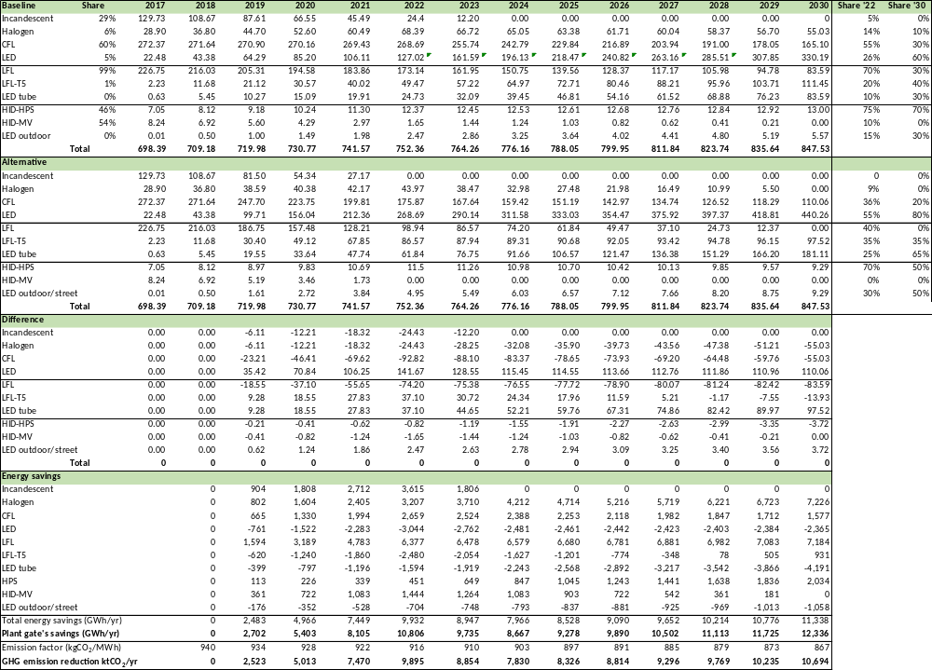

Note: In the calculation the following lifetime of lamps is assumed: incandescent, 1200 hours; CFL: 10000 hours; halogen: 2200 hours, LFL: 16500 hours; LFL-T5: 20000 hours; LED: 30000 hours; LED tube: 40000 hours, HID-mercury vapour: 18000 hours; HID-HPS: 20000 hours.

Box 45 Distribution transformers stock South Africa – energy consumption and GHG emissions in baseline and GEF alternative scenario, 2017-2030

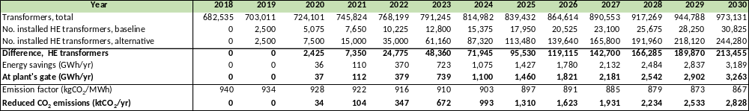
Note: The energy savings at plant’s gate follow from multiplying the calculated annual energy savings by (1+T) for transformers and (1+T+D) for the lighting products, where T: % transmission losses and D: distribution losses.

Box 46 Peak power demand reduction and avoided mercury content

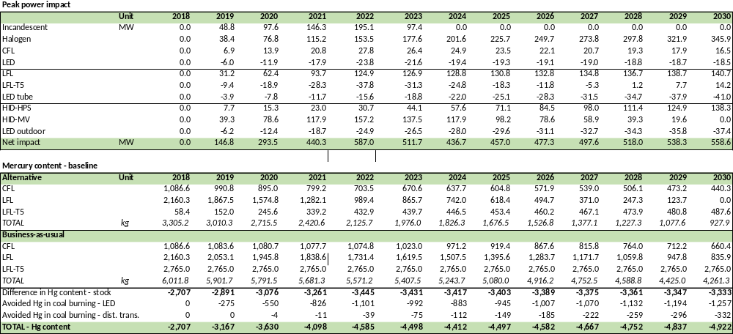
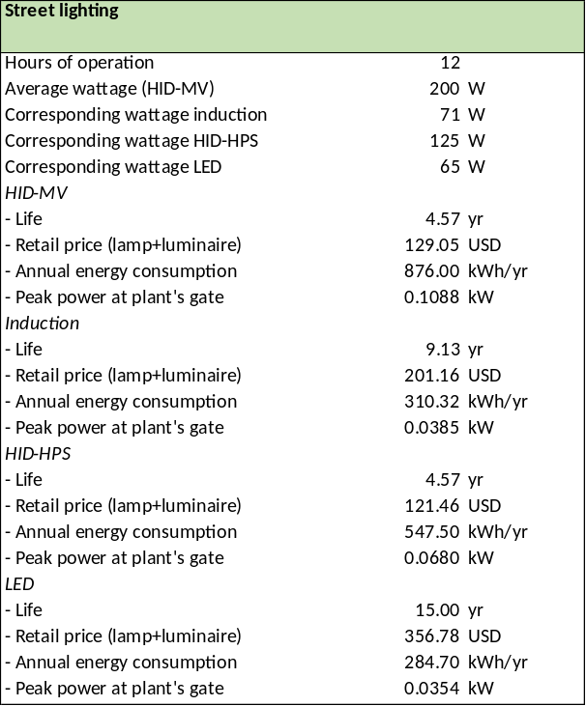
The alternative scenario differs from the baseline scenario by calculating the market share of LEDs in the years 2022 and 2030 for three categories, a. incandescent, CFLs, halogen lamps and LEDs, b. tubular lamps (LFLs and LED tubes) and c. high-power, outdoor and street lighting lamps (HID-MV, HID-HPS and LEDs). The shares of the intermediate years 2018-2021 and 2023-2029 are determined by interpolation. One can observe that the total number of lighting points (i.e. installed lamps) in the baseline and the alternative scenario is the same, but that the distribution of lamps is shifted towards more energy efficient products in the alternative scenario.
Box 47 Monetary savings due to replacement per type of lamp

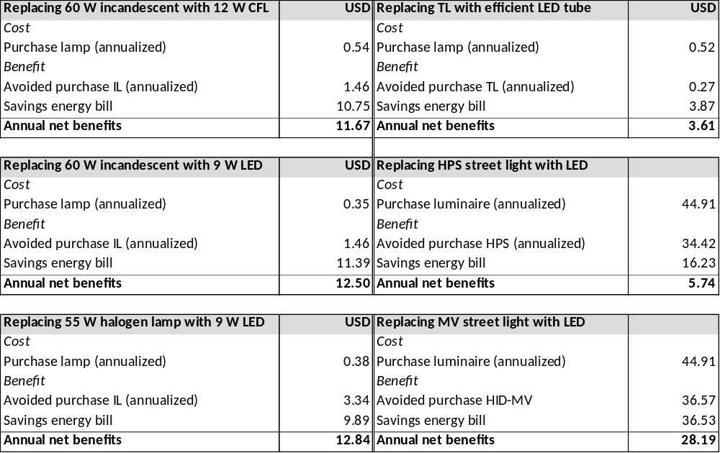

Based on the energy consumption estimates, lifetime, and tariff assumptions and calculations of Box 43, the table above provides estimates of monetary savings of switching an efficient lamp for a less efficient one (in USD per lamp per year) for different lamp replacement combinations.
Notes:
- For comparing lamps, the residential Eskom tariff is used, for street lighting the public tariff
- Annualised cost are calculated by multiplying the purchase price with the capital recovery factor CFF = I * (1+i)^{n} / ((1+i)^{n}-1) with I = discount rate = 10% and n = lifetime of the lamp
- Street lighting is compared not by using the cost of the lamp, but the cost of the luminaire (plus lamp). Cost data are based on the before-mentioned CSA Public Lighting Guide (2012) and the calculations in the table on the left.

As fewer fluorescent lamps are installed in the alternative scenario, this will result in avoided mercury content (compact, linear and circular fluorescent lamps contain small amounts of mercury), starting with 3.13 tons in 2018 up to 5.03 tons of mercury in 2030 that would otherwise have been deposited into the environment (unless the mercury of these lamps is recovered in recycling facilities). Coal contains some small amounts of mercury, so the avoided use of coal (due to lower electricity consumption) implies that less mercury is released into the environment.

Many lamps will be used during hours of peak power demand (the proportion of time used during peak hours and off-peak is expressed by the ‘peak coincidence factor’), so the use of more efficient lamp technology will result in lowering the maximum power peak demand, an estimated 117 MW in 2018 (over the baseline) to about 559 MW in 2028, i.e. equivalent to the avoided construction and operation of a power plant.

Greenhouse gas emission reduction

For the emission factor of the electricity grid, 0.94 kgCO₂/MWh is used for the base year 2017. Following the baseline scenario of the Integrated Resource Plan for Electricity 2010-2030 of the Department of Energy, emission factors are used that slightly decline from year to year, which can be attributed to the slight increase of renewables in South Africa’s power mix.

Our calculations yield estimates of the potential electricity savings and avoided emissions similar to those of the U4E country assessment by the year 2030 (lighting: 12.3 TWh and 10.69 million tCO₂ in comparison with U4E’s 10.45 TWh and 10.2 million tCO₂; transformers: 4.36 TWh and 3.78 million tCO₂ in comparison with U4E’s 5.1 TWh and 4.6 million tCO₂), assuming a compliance rate of 100 percent.

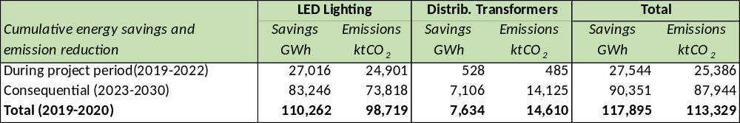

The project’s target for direct emissions reductions includes only for devices sold during the project period of 2017-2022 (“direct GHG emissions reductions”, what the GEF defines as the result of equipment sold during the project implementation period, for the lifetime of those appliances.) To avoid overstating what a realistic goal would be for the project, we adjusted the assumed compliance rate down to 60% (causality factor). And so, the target for GHG emissions reduction from the sale during the project implementation period is 18.250 million tonnes of avoided CO₂ emissions. This figure is entered in the Project Results Framework and in the GEF Core Indicators template. Consequential emissions reductions were estimated during the during the period of influence (after the end of the project) about 106.345 million tonnes of avoided CO₂ emissions from devices sold during 2023-2030. Using a smaller causality factor (rate of 40%), the estimated consequential GHG emissions reduction is 63.807 million tonnes. This figure is entered in the GEF Indicator Table on the next page.

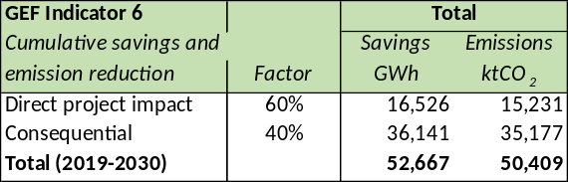

GEF Core indicators

Core indicator 6: Greenhouse gas emissions mitigated
GHG emission type | Metric tons CO₂-eq (expected at PIF) | Metric tons CO₂-eq (expected at CEO ER) | Metric tons CO₂-eq (expected at MTR) | Metric tons CO₂-eq (expected at TE)
Lifetime direct project GHG emissions mitigated | 58.3 million  (over 2020-2030)  See Box 48 | 15.23 million  (over 2019-2022)
Lifetime direct post-project emissions mitigated | 58.3 million  (over 2020-2030)  See Box 48 | --
Lifetime indirect GHG emissions mitigated | 58.3 million  (over 2020-2030)  See Box 48 | 35.18 million  (over 2023-2030)
Box 48 Potential energy savings and avoided emissions in South Africa in 2030

Equipment/Appliance Type | Energy savings (GWh/yr) | Avoided CO₂ emissions  (thousand tonnes/yr) | Cumulative CO₂ emissions reductions, 2020-2030  (million tonnes)
Lighting | 10,448 | 10,365 | 89.6
Distribution transformers | 5,109 | 4,604 | 27.0
TOTAL | 15,557 | 14,969 | 116.6

Under the umbrella of the global project “Leapfrogging markets to high efficiency products (appliances, including lighting, and electrical equipment”, no official PIF was formulated for the South Africa ‘child’ project. Instead a ‘child concept note’ was formulated that does not give an estimate of the direct project and indirect lifetime GHG emission reduction, except for mentioning annual GHG reduction in the year 2030 of about 17 million tCO₂ approximately. This rough estimate itself is based on calculations (based on minimum energy performance standards assumptions consistent with current world best practices: “best MEPS”) presented in the U4E United for Efficiency South Africa Country Assessment (for assumptions and data sources, see http://united4efficiency.org/countries/country-assessments/ (see table). As these calculations do give a cumulative GHG emission reduction, the figure from the Country Assessment is used (multiplied by a compliance factor of 50%) as the value for ‘Core Indicator 6’ at PIF stage. The PIF value of 58.3 million tCO₂ over 2020-2030) compares with the lifetime direct + indirect CO₂ emission reduction at CEO ER stage of 50.41 million tCO₂.

Core indicator 11: Number of direct beneficiaries (individuals) disaggregated by gender (GEF and co-financing)
 | Total number (expected at PIF) | Total number (expected at CEO ER) | Total number (achieved at MTR) | Total number (achieved at TE)
Women | -- | 3.8 million
Men | -- | 3.8 million
Total | -- | 7.6 million
Note:
The number of beneficiaries is based on estimates of households that have changed to efficient lamps in 2022 in the alternative scenario of Box 44, which is about 4.1 million. The average members in one household is 3.1. Other beneficiaries will be the building owners (or the tenant that pays the power bill), with office workers indirectly benefitting. Similarly, the direct beneficiaries of HE distribution transformers are the municipalities (and ESKOM).

- Stakeholder engagement and communication plan

Project preparation
During the project preparation (PIF and PPG stage), several stakeholder consultations were held with an objective of project design and activities to be as inclusive as possible and in line with the existing relevant policies, and electrification plans and existing off-grid electrification initiatives. The following summarizes the stakeholder engagement activities to date:
- An initial stakeholder workshop was held in July 2017 and a stakeholder Validation workshop in March 2019
- Bilateral meetings conducted with the relevant government department, development partners, NGOs and universities/institutions, and development banks during the PPG phase

Project inception and implementation

The table below presents the Stakeholder Engagement plan and summarizes different categories of stakeholders, which are described in Section 4.2 and Annex E.
Stakeholder group or organisation | Means of engagement
Government ministries and agencies | Policymakers, officials and technical staff within government ministries will play a crucial role in the implementation of the proposed program.  The Department of Energy, will be in the Implementing Agency (IA) and will take a leadership role in the Project Board in providing direction to the Project. DOE staff will work closely with full-time project staff and short-term experts on many aspects of implementation, particularly policy-related aspects, regulatory aspects, capacity building and awareness creation and promotion.  DEA is the government institution responsible for environmental issues, policy and planning, and will play a key role because climate mitigation activities as well as mercury control competencies rely on this body. DEA is the GEF Operational Focal Point, and therefore has an overall interest in the Project. DEA will in particular be involved in Component 4 on environmentally sound management of lighting and transformers  The Department of Trade and Industry (DTI) is responsible for the transformation and the development of the trade and industry sectors, and will be interested promoting local production (Output 2.3). Its agencies for standards and quality control (SABS, NCRS, and SANAS) will be involved (with DoE) in administration and implementation of a mandatory MEPS and labelling system for lighting and regulation of standards
Eskom and municipal energy service providers | Eskom and the municipal utilities have an incentive to encourage efficiency to lower capital costs for infrastructure (see, e.g., the peak load demand reduction estimates in Annex F).  Eskom will participate in communication, campaign and awareness through its IDM (Integrated Demand Management). Eskom will particularly play a role in defining a standard and MVE system for transformers (Outcome 1), providing data for market assessment, and general in capacity building and promoting local production activities of efficient transformers (Outcome) and environmental aspects (Outcome 3).  Municipalities play an important role in designing municipal green and sustainable energy plans and propose investment projects on public buildings (incl. lighting) and infrastructure (incl. street lighting, distribution networks), and play an important role in awareness creation for their citizenry on sustainable practices (incl. proper waste disposal and efficient lighting.
Testing laboratories and technical institutions | Test procedures are an important technical foundation for MEPS. Testing laboratories will take part in the process of developing standards and quality control measures (Component 1)

Environmental, consumer and women’s groups and organisations | Non-governmental organizations that advocate responsible energy policies will contribute their perspectives during the development of the national strategy for energy-efficient products. They will provide a balancing perspective to manufacturers with regard to the stringency of MEPS and MVE schemes. Input from civil society consumer groups can ensure that regulations do not require overly expensive or less functional lighting, appliance products and equipment. This includes the role of women groups and organisations to stress the importance of women-led households, women-owned businesses (WOB) and in the Project itself, gender-sensitive data gathering and reporting.
Manufacturers, importers, distributors and retailers of lighting products, and transformer equipment | Manufacturers, importers, distributors and retailers are directly affected by energy efficiency regulations. They have valuable information about production costs and market structures. MEPS necessarily impose some burdens on manufacturers and importers, but these can be acceptable as long as they affect all companies equally and also introduce new business opportunities. Domestic and international firms will provide their input. Equipment retailers will comment on the proposed program and its future implementation by characterizing the market and consumer response to product efficiency and pricing.  In order to ensure industry readiness of local industry, the program offers support to local manufacturers and assembly companies to ensure the can produce LED products and high-efficiency distribution transformers in a sustainable manner.

The Project will effectively engage the stakeholders involved in the project to get their support and guide the project implementation to achieve higher results.
- Project outreach proposed includes project website, media (print/audio-visual), workshops, training etc.
- The PMU and the Project Board will ensure that the Gender Action Plan recommended by the project is pursued and implemented. The various groups especially women will be engaged during the consultation meetings, prioritized to avail the program and be included in the different capacity building programs. The project will also ensure that it is in line with the (baseline) national energy, climate change, gender, and waste management policies and plans (described in Annex E);
- Meetings, monitoring visits, surveys, and written communications will be used to receive feedback to continue the ongoing dialogue as well as during the course of implementation.
- The project will follow a participatory approach in decision making by engaging all the relevant stakeholders. The Government agencies, NGOs, CSOs, and the private sector actors will be actively involved during the project implementation.

Responsibilities
The PMU is primarily responsible for carrying out the specified stakeholder engagement activities. The stakeholders will be engaged while carrying out various assessments and studies, training and workshop events.

Grievance mechanism
People concerned with or potentially affected by the project can express their grievances for consideration and redress. The Project Management Unit will receive grievances and will try to resolve at the PMU level if possible. If not possible then the issues will be referred to the Project Board that will try to settle the issues amicably. In the event the party is not accepting the decision then he/she can put the case to Arbitration. Any person or group of persons affected by a UNDP-supported project can make a claim to the Claims to the UNDP Social and Environmental Complains Unit (SECU) and the SRM (Stakeholder Response Mechanism) through https://undp.tnwreports.com and by e-mail (https://undp.tnwreports.com).

Monitoring and reporting
The project stakeholders would be engaged at various levels to carry out the monitoring activities. Then the PMU will laisse with relevant Government agencies and other partners and collect data and monitor the activities on a regular basis. The PMU will report back the results to the stakeholders at the earliest through letters or conduct meetings both individually as well as through engagement of all relevant agencies.

Communications plan

The LCUD project will also emphasize strong communications with a broader range of stakeholders. Key elements of the project’s communication strategy are outlined in the table below:

Key element | Relevant group | Means
1. Project governance meetings; Project Board meetings; Advisory Committee and working group meetings | All stakeholders that are members of the Board or its Working Groups or are invited to attend | Meetings
2. Seminars/workshops and training events, including the Inception workshop, and End-of-project workshop | National and city-level government officials  Financial and private sector  NGOs and CSOs  Municipalities and municipal associations | Workshop, meeting, seminar, training  On-the-job training
3. Project documents, thematic reports and publications | Various government departments and decision-makers | Direct dissemination (e.g. email or hard copy) to persons.  Access via the Project website
4. Technical and financial-economic reports. | Development banks and other financial intermediaries; energy service companies  Engineers and persons working or interested in working in lighting, EE in buildings, electricity distribution, and environmental issues  Energy, waste and urban planners and city officials  Development partners and NGOs | Direct dissemination (e.g. email or hard copy/ USB-drive)  Access via the Project website to reports and documents and database and info systems
5. Project knowledge capturing and info dissemination | Government (national, city) officials  Financial and private sector  Development partners and NGOs  Citizenry and community groups | Online access to all project materials and other relevant low-carbon and green development information
6. Reports (feasibility assessments; non-confidential parts of business plans; monitoring) of investments in EE lighting and transformers application and production | Various national and municipal level officials; CSOs  Financial and private sector  Development partners  Technical professionals; experts/ academics | Direct dissemination to person directly involved  Summaries with non-confidential info access through the website

Budget available is part of the various project activities. The budget for seminar/workshops/events and printing of reports and documents, etc., is, together, about USD 850,000

Reporting to GEF will be shared with U4E to keep the global project informed on progress on the national activities, sharing experiences (from South Africa to other countries and vice versa) and providing technical guidance. In addition, the Global Project (U4E) will convene regular conference calls with the South Africa Project Management Unit to assist in this process as well.

- Additional budget and co-financing tables

GEF resources, managed by DBSA (shaded area) and UNDP:

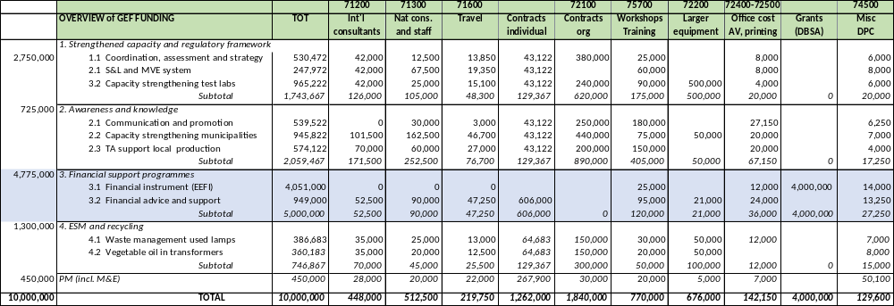

Summary of GEF and co-financing per source and per outcome:

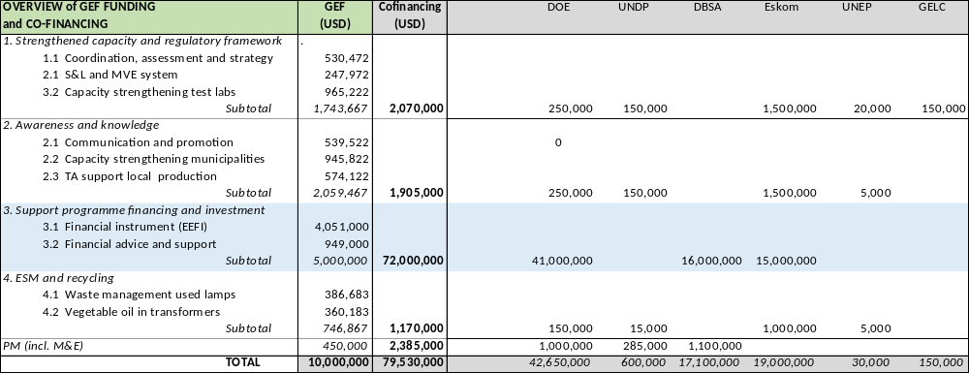

- Social and environment screening report

Project Information

Project Information
- Project Title | Leapfrogging South Africa’s markets to high-efficiency LED lighting and high efficiency distribution transformers
- Project Number | 5728
- Location (Global/Region/Country) | South Africa

Part A. Integrating Overarching Principles to Strengthen Social and Environmental Sustainability

QUESTION 1: How Does the Project Integrate the Overarching Principles in order to Strengthen Social and Environmental Sustainability?
Briefly describe in the space below how the Project mainstreams the human-rights based approach

This project seeks to expand the availability of high-quality household appliances and open, accurate market information via national standards, product labelling, testing and certification, and promotional outreach. The project also includes rebates and coupons specifically to support access by low-income citizens to such appliances.

All policies will be designed with an emphasis not only on environmental sustainability, but also on consumer protection applied equally for the benefit of all of South Africa’s citizens. The project will partner with local consumer and women’s organisations in advancing consumers’ and women’s rights. Design of policies and consumer outreach, including low-income support, will be based on widely inclusive market research, including opportunities for citizens of all economic situations to register their input directly.

Briefly describe in the space below how the Project is likely to improve gender equality and women’s empowerment
The development challenge of increasing GHG emissions from appliances and equipment, as well as related issues of energy costs, consumer choice, and assurances of product quality for both municipalities, enterprises and individual citizens, affect all citizens of South Africa equally, without regard to gender. The intended outcomes of the project should also therefore create benefits for all citizens with regard to gender. Market assessment during the project preparatory period indicates that women in South Africa do play a role equal to and often conjoined with that of men in choosing appliances and managing household income. Therefore, in improving access to high-quality appliances and reliable market information, the project will generate benefits that will be enjoyed equally by female and male consumers. In its research and outreach involving consumer preferences and choices, the project will directly target both women and men (of all ages, marital status, income levels, etc.) In particular, market research activities will include both surveys that allow for breakdowns by gender.

Briefly describe in the space below how the Project mainstreams environmental sustainability
Environmental sustainability - specifically, climate change mitigation - is the central focus of the project. By promoting energy efficiency of lighting and distribution transformer equipment, the project will achieve major reductions of electricity consumption and associated emissions of greenhouse gases and other pollutants from predominantly coal-fired power plants. The project also supports Kazakhstan’s ongoing efforts to develop and implement policy on safe disposition of electronic waste (in particular mercury recovery) and possible use of vegetable oil replacing mineral oil in certain types of transformers.

Part B. Identifying and Managing Social and Environmental Risks

QUESTION 2: What are the Potential Social and Environmental Risks?  Note: Describe briefly potential social and environmental risks identified in Attachment 1 – Risk Screening Checklist (based on any “Yes” responses). If no risks have been identified in Attachment 1 then note “No Risks Identified” and skip to Question 4 and Select “Low Risk”. Questions 5 and 6 not required for Low Risk Projects. | QUESTION 3: What is the level of significance of the potential social and environmental risks?  Note: Respond to Questions 4 and 5 below before proceeding to Question 6 |  |  |  |  | QUESTION 6: What social and environmental assessment and management measures have been conducted and/or are required to address potential risks (for Risks with Moderate and High Significance)?
Risk Description | Impact and Probability (1-5) | Significance  (Low, Moderate, High) |  | Comments |  | Description of assessment and management measures as reflected in the Project design. If ESIA or SESA is required note that the assessment should consider all potential impacts and risks.
Risk 1: Low-level participation by municipalities and resistance from consumers as well as low-level participation by the private sector actors including ESCOs, manufacturers and distributors | I = 2  P = 2 | Low | Items 3.2 (risks from hazardous material), 7.1 (potential release of pollutants) and 7.2 (generation of waste) in the SESP checklist show a “no” response but refer to this section for elaboration.  Note that this risk involves acceleration of the creation of waste, but not the generation of new waste, as all existing electronic equipment is destined for decommissioning and disposition sooner or later. Because of ongoing policy and program efforts of the Government, with added support from the project, it is anticipated that even with a short-term expansion in the volume of spent appliances, the project will lead to a reduction, not an expansion, of risk from waste, pollution, and hazardous substances. See the entry in the next column. |  |  | Broad inclusiveness of stakeholders in development, review, and comment regarding new energy standards will help to retain this consensus by involving the private sector key players from the project design stage in the action formulation (Component 1). Among domestic manufacturers, technical support for compliance will also help to reduce resistance, as well as the effective communication to manufacturers and suppliers about the benefits and economic opportunities to be gained from supplying LED lighting and high-efficiency transformers.  Building on Eskom’s IDM efforts, awareness creation will help to reduce confusion, social burdens on the consumer side and communicate the benefits of LED lighting. Capacity technical and financial support within Component 3 will overcome political opposition and institutional barriers (e.g. lack of resources and skills) at the municipal level.
Risk 2: Hazardous substances (mercury, PCBs, etc) in existing and/or new products are not properly handled during production, lifetime and end of life | I = 1  P = 2 | Low | Note that this risk involves acceleration of the creation of waste, but not the generation of new waste, as all existing electronic equipment is destined for decommissioning and disposition sooner or later. Even with a more rapid replacement of of CFLs (and other fluorescent, HID lamps) by LEDs in the short run, the project will lead to a reduction, not an expansion, of risk from waste, pollution, and hazardous substances. See the entry in the next column. The same applies to transformers. |  |  | Already the Government addresses collection, handling, and disposition of electronic waste in policy-making. Awareness creation and training will be carried out both policymakers and practitioners on proper handling substances (e.g. lamp disposal and mercury recovery) are an integral part of Component 4 of the Project. The issue of PCB in oil-filled transformers is dealt separately with in a proposed DBSA-implemented project on PCB-contaminated oil.
Significance:  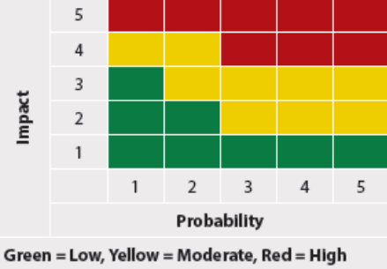  1: slight, 2: not likely, 3: likely, 4: very likely, 5: expected | QUESTION 4: What is the overall Project risk categorization?
 | Select one (see SESP for guidance) |  |  |  |  |  | Comments
 | Low Risk |  |  |  | ☒ |  | Following the UNDP guidance on project categorization and results of the completed SESP checklist, this project has been assessed as the low-risk project with no or minimal adverse environmental impacts. Please see responses to Questions 2 and 3 above.
 | Moderate Risk |  |  |  | ☐
 | High Risk |  |  |  | ☐
 | QUESTION 5: Based on the identified risks and risk categorization, what requirements of the SES are relevant?
 | Check all that apply |  |  |  |  |  | Comments
 | Principle 1: Human Rights |  |  |  | ☐
 | Principle 2: Gender Equality and Women’s Empowerment |  |  |  | ☐
 | 1. Biodiversity Conservation and Natural Resource Management |  |  |  | ☐
 | 2. Climate Change Mitigation and Adaptation |  |  |  | ☐
 | 3. Community Health, Safety and Working Conditions |  |  |  | ☐
 | 4. Cultural Heritage |  |  |  | ☐
 | 5. Displacement and Resettlement |  |  |  | ☐
 | 6. Indigenous Peoples |  |  |  | ☐
 | 7. Pollution Prevention and Resource Efficiency |  |  |  | ☐

Final Sign Off

Signature | Date | Description
QA Assessor
QA Approver and PAC Chair

- SESP Attachment 1. Social and Environmental Risk Screening Checklist

Checklist Potential Social and Environmental Risks
Principles 1: Human Rights | Answer  (Yes/No)
1. Could the Project lead to adverse impacts on enjoyment of the human rights (civil, political, economic, social or cultural) of the affected population and particularly of marginalized groups? | No
2. Is there a likelihood that the Project would have inequitable or discriminatory adverse impacts on affected populations, particularly people living in poverty or marginalized or excluded individuals or groups? | No
3. Could the Project potentially restrict availability, quality of and access to resources or basic services, in particular to marginalized individuals or groups? | No
4. Is there a likelihood that the Project would exclude any potentially affected stakeholders, in particular, marginalized groups, from fully participating in decisions that may affect them? | No
5. Is there a risk that duty-bearers do not have the capacity to meet their obligations in the Project? | No
6. Is there a risk that rights-holders do not have the capacity to claim their rights? | No
7. Have local communities or individuals, given the opportunity, raised human rights concerns regarding the Project during the stakeholder engagement process? | No
8. Is there a risk that the Project would exacerbate conflicts among and/or the risk of violence to project-affected communities and individuals? | No
Principle 2: Gender Equality and Women’s Empowerment
1. Is there a likelihood that the proposed Project would have adverse impacts on gender equality and/or the situation of women and girls? | No
2. Would the Project potentially reproduce discriminations against women based on gender, especially regarding participation in design and implementation or access to opportunities and benefits? | No
3. Have women’s groups/leaders raised gender equality concerns regarding the Project during the stakeholder engagement process and has this been included in the overall Project proposal and in the risk assessment? | No
4. Would the Project potentially limit women’s ability to use, develop and protect natural resources, taking into account different roles and positions of women and men in accessing environmental goods and services?  For example, activities that could lead to natural resources degradation or depletion in communities who depend on these resources for their livelihoods and well being | No
Principle 3: Environmental Sustainability: Screening questions regarding environmental risks are encompassed by the specific Standard-related questions below
Standard 1: Biodiversity Conservation and Sustainable Natural Resource Management
1.1 Would the Project potentially cause adverse impacts to habitats (e.g. modified, natural, and critical habitats) and/or ecosystems and ecosystem services?  For example, through habitat loss, conversion or degradation, fragmentation, hydrological changes | No
1.2 Are any Project activities proposed within or adjacent to critical habitats and/or environmentally sensitive areas, including legally protected areas (e.g. nature reserve, national park), areas proposed for protection, or recognized as such by authoritative sources and/or indigenous peoples or local communities? | No
1.3 Does the Project involve changes to the use of lands and resources that may have adverse impacts on habitats, ecosystems, and/or livelihoods? (Note: if restrictions and/or limitations of access to lands would apply, refer to Standard 5) | No
1.4 Would Project activities pose risks to endangered species? | No
1.5 Would the Project pose a risk of introducing invasive alien species? | No
1.6 Does the Project involve harvesting of natural forests, plantation development, or reforestation? | No
1.7 Does the Project involve the production and/or harvesting of fish populations or other aquatic species? | No
1.8 Does the Project involve significant extraction, diversion or containment of surface or ground water?  For example, construction of dams, reservoirs, river basin developments, groundwater extraction | No
1.9 Does the Project involve utilization of genetic resources? (e.g. collection and/or harvesting, commercial development) | No
1.10 Would the Project generate potential adverse transboundary or global environmental concerns? | No
1.11 Would the Project result in secondary or consequential development activities which could lead to adverse social and environmental effects, or would it generate cumulative impacts with other known existing or planned activities in the area?  For example, a new road through forested lands will generate direct environmental and social impacts (e.g. felling of trees, earthworks, potential relocation of inhabitants). The new road may also facilitate encroachment on lands by illegal settlers or generate unplanned commercial development along the route, potentially in sensitive areas. These are indirect, secondary, or induced impacts that need to be considered. Also, if similar developments in the same forested area are planned, then cumulative impacts of multiple activities (even if not part of the same Project) need to be considered. | No
Standard 2: Climate Change Mitigation and Adaptation
2.1 Will the proposed Project result in significant greenhouse gas emissions or may exacerbate climate change? | No
2.2 Would the potential outcomes of the Project be sensitive or vulnerable to potential impacts of climate change? | No
2.3 Is the proposed Project likely to directly or indirectly increase social and environmental vulnerability to climate change now or in the future (also known as maladaptive practices)?  For example, changes to land use planning may encourage further development of floodplains, potentially increasing the population’s vulnerability to climate change, specifically flooding | No
Standard 3: Community Health, Safety and Working Conditions
3.1 Would elements of Project construction, operation, or decommissioning pose potential safety risks to local communities? | No
3.2 Would the Project pose potential risks to community health and safety due to the transport, storage, and use and/or disposal of hazardous or dangerous materials (e.g. explosives, fuel and other chemicals during construction and operation)? | No  (See part B, risk 1)
3.3 Does the Project involve large-scale infrastructure development (e.g. dams, roads, buildings)? | No
3.4 Would failure of structural elements of the Project pose risks to communities? (e.g. collapse of buildings or infrastructure) | No
3.5 Would the proposed Project be susceptible to or lead to increased vulnerability to earthquakes, subsidence, landslides, erosion, flooding or extreme climatic conditions? | No
3.6 Would the Project result in potential increased health risks (e.g. from water-borne or other vector-borne diseases or communicable infections such as HIV/AIDS)? | No
3.7 Does the Project pose potential risks and vulnerabilities related to occupational health and safety due to physical, chemical, biological, and radiological hazards during Project construction, operation, or decommissioning? | No
3.8 Does the Project involve support for employment or livelihoods that may fail to comply with national and international labor standards (i.e. principles and standards of ILO fundamental conventions)? | No
3.9 Does the Project engage security personnel that may pose a potential risk to health and safety of communities and/or individuals (e.g. due to a lack of adequate training or accountability)? | No
Standard 4: Cultural Heritage
4.1 Will the proposed Project result in interventions that would potentially adversely impact sites, structures, or objects with historical, cultural, artistic, traditional or religious values or intangible forms of culture (e.g. knowledge, innovations, practices)? (Note: Projects intended to protect and conserve Cultural Heritage may also have inadvertent adverse impacts) | No
4.2 Does the Project propose utilizing tangible and/or intangible forms of cultural heritage for commercial or other purposes? | No
Standard 5: Displacement and Resettlement
5.1 Would the Project potentially involve temporary or permanent and full or partial physical displacement? | No
5.2 Would the Project possibly result in economic displacement (e.g. loss of assets or access to resources due to land acquisition or access restrictions – even in the absence of physical relocation)? | No
5.3 Is there a risk that the Project would lead to forced evictions? | No
5.4 Would the proposed Project possibly affect land tenure arrangements and/or community based property rights/customary rights to land, territories and/or resources? | No
Standard 6: Indigenous Peoples
6.1 Are indigenous peoples present in the Project area (including Project area of influence)? | No
6.2 Is it likely that the Project or portions of the Project will be located on lands and territories claimed by indigenous peoples? | No
6.3 Would the proposed Project potentially affect the human rights, lands, natural resources, territories, and traditional livelihoods of indigenous peoples (regardless of whether indigenous peoples possess the legal titles to such areas, whether the Project is located within or outside of the lands and territories inhabited by the affected peoples, or whether the indigenous peoples are recognized as indigenous peoples by the country in question)?  If the answer to the screening question 6.3 is “yes” the potential risk impacts are considered potentially severe and/or critical and the Project would be categorized as either Moderate or High Risk. | No
6.4 Has there been an absence of culturally appropriate consultations carried out with the objective of achieving FPIC on matters that may affect the rights and interests, lands, resources, territories and traditional livelihoods of the indigenous peoples concerned? | No
6.5 Does the proposed Project involve the utilization and/or commercial development of natural resources on lands and territories claimed by indigenous peoples? | No
6.6 Is there a potential for forced eviction or the whole or partial physical or economic displacement of indigenous peoples, including through access restrictions to lands, territories, and resources? | No
6.7 Would the Project adversely affect the development priorities of indigenous peoples as defined by them? | No
6.8 Would the Project potentially affect the physical and cultural survival of indigenous peoples? | No
6.9 Would the Project potentially affect the Cultural Heritage of indigenous peoples, including through the commercialization or use of their traditional knowledge and practices? | No
Standard 7: Pollution Prevention and Resource Efficiency
7.1 Would the Project potentially result in the release of pollutants to the environment due to routine or non-routine circumstances with the potential for adverse local, regional, and/or transboundary impacts? | No (see part B, and 2)
7.2 Would the proposed Project potentially result in the generation of waste (both hazardous and non-hazardous)? | No (see Part B, risk 2)
7.3 Will the proposed Project potentially involve the manufacture, trade, release, and/or use of hazardous chemicals and/or materials? Does the Project propose use of chemicals or materials subject to international bans or phase-outs?  For example, DDT, PCBs and other chemicals listed in international conventions such as the Stockholm Conventions on Persistent Organic Pollutants or the Montreal Protocol | No
7.4 Will the proposed Project involve the application of pesticides that may have a negative effect on the environment or human health? | No
7.5 Does the Project include activities that require significant consumption of raw materials, energy, and/or water? | No

See Box 1 and Electricity Generated and Available for Distribution, STATS SA (2017) and Integrated Resources Plan for Electricity 2010-2030, Department of Energy. Emission factor taken from South Africa’s Grid Emission Factor, National Business Initiative (2011).
Own estimates, based on data presented in Annex E
GEF-6 Programming Directions,(Extract from GEF Assembly Document GEF/A.5/07/Rev.01, May 22, 2014
Identify, Assess, and Design a Market-Based Economic Incentive(s) for Energy-Efficient Appliances in South Africa; Final Report (Danish Embassy, Department of Energy)
See for example, State of Energy in South African Cities 2015 (SACN)
For example, the GIZ EE Street Lighting Retrofit programme will continue until 2019
MEEDSM program, the project team presented to the MEEDSM program manager at the DoE the possibility to reduce the level of grant funding under the MEEDSM from 100% of the project value to a lower percentage as a way to leverage the grant program, increase the number of projects and municipalities that receive funding and let the municipalities obtain funding from other sources
Including the SADC Centre fort Renewable Energy and Energy Efficiency (SACREEE), based in Namibia
The regulations can be under DOE and/or DTI, with the administration handled by SANEDI and/or NCRS, supported on technical issues by SABS, IESSA and/or NMISA
www.savingenergy.org.za
In order to encourage the technologies supported by the Project, the blended cost of funding for these technologies shall depend on the financial and social attractiveness of the project. For example, the financing cost improvement for LED street lighting (which has a payback of ca. 5 years and brings a substantial impact on the daily life of South African citizens), should require a smaller improvement than the upgrade to a higher efficiency class of transformers (which have a longer payback and limited additional benefit for the citizens).
For example, Lawrence Berkeley National Laboratory estimated in 2004 that standards implemented at a cost of USD 2 in federal government spending per household had triggered investment in energy-saving features equaling USD 1,000 per household, resulting in USD 2,170 gross savings per household in fuel costs, and an increase of more than USD 1000 of net present value per household to the U.S. economy during the operating lifetimes of the affected products. See Meyers, S, J. McMahon, and M. McNeil. 2004. Realized and Prospective Impacts of U.S. Energy Efficiency Standards for Residential Appliances: 2004 Update. Berkeley, CA, Lawrence Berkeley National Laboratory, LBNL-56417
A similar analysis in 2003 by the International Energy Agency determined that EESL in OECD countries would lead to cumulative net cost savings of EUR 137 billion by 202. Source: 0IEA (International Energy Agency). 2003. Cool Appliances: Policy Strategies for Energy-Efficient Homes, OECD/IEA, Paris, France.
See http://www.undp.org/content/undp/en/home/operations/transparency/information_disclosurepolicy/
See https://www.thegef.org/gef/policies_guidelines
see https://info.undp.org/global/popp/ppm/Pages/Closing-a-Project.aspx
The table only includes co-financing (cash and in-kind) confirmed by means of a signed cooperation (co-financing) letter, attached in Annex J. Other stakeholders will also contribute (municipalities, companies) but this could not be confirmed by means of agreement as this project preparation stage,
Over 4 years, at exchange rate USD 1 = 14 ZAR. USD 20 million = 300 million x 4 x 23% / 14. Note: budget for EEDM in 2019-20 will be ZAR 318 million (see https://vulekamali.gov.za/2019-20/national/departments/energy)
The total INEP budget will be about ZAR 5.5 billion in 2019-20 (see https://vulekamali.gov.za/2019-20/national/departments/energy)
Employment Equity Act (2015) – Department of Trade and Industry
See “The Current Status of Policies, Practices, Measures, and Barriers regarding Women-owned Businesses in Government Procurement”, report prepared for the Businesswomen’s Association of South Africa (BWASA).
See South Africa’s National Policy Framework for Women’s Empowerment and Gender Equality; The Office on the Status of Women.
The Women Matter Africa Report (August 2016), McKinsey and Company, South Africa.
Wits Business School, Journal (2011); Stats South Africa - Mid Year Population Estimates (2016)
Article by Alison Treadaway, Marie Claire (August, 2016); Stats South Africa (QLFS third quarter, 2015)
Statisticd South Africa (STAT SA) - Quarterly Labour Survey (1st Quarter, 2017)
See Box 18. The imported hydro comes from the Mozambique Cahora Bassa dam;
NERSA, Energy Supply Statistics for South Africa 2012
STATS SA, Electricity generated and available for distribution (Preliminary), June 2018 * The Report has been formulated by the PPG team leader, J. Van den Akker, with contributions from the other PPG members; M. Tsikata, Z. Shibe (who drafted the gender analysis of Annex D) and V. Minguez (the Annexes E.5 and E.6 are based on his draft report Financial mechanisms for the LED and Distribution transformer industry in South Africa, DBSA, 2019).
Eskom plans to bring online over 12,000 MW of new electricity installed capacity (US Energy Information Administration, 2015), of which 8770 MW coal-fired, 2097 wind power, 400 concentrated solar, 1094 solar PV plants, 33 MW landfill gas/biomass (Wikipedia, List of power stations in South Africa (2017/18).
Source: UNDP/GEWF S&L Project
Energy Efficiency Eskom plans to bring online almost 12,000 MW of new electricity installed capacity Country Study: Republic of South Africa, LBNL Report 6365E, Du la Rue Can, S., Letschert, V., Leventis, G., Covary, Th., Xia (2013)
ESKOM website, Historical Average Prices and Increase. See Box 19).
Due to economic stagnation and downward pressures on commodity markets, rising electricity costs and energy efficiency and conservation efforts.
ESKOM ZAR 413 billion, of which ZAR 218.2 billion of the company's debt consist of government guarantees. http://www.creamermedia.co.za/article/electricity-2018-a-review-of-south-africas-electricity-sector-pdf-report-2018-03-14
Wikipedia, List of power stations in South Africa (2017/18). In response to chronic power shortages and the need to ensure a more diverse fuel supply, South Africa began a procurement program in 2011 to purchase power from renewable sources and lower-emitting energy plants funded by IPPs. South Africa’s capacity target from IPP procurement is 29 GW by 2025.
NERSA, Energy Supply Statistics for South Africa 2012
State of Energy in South African Cities (2015), Energy performance contracting by municipalities (2016), A case for renewable energy & energy efficiency (2014), Modelling Energy Efficiency Potential in SACN Cities (2014). Sustainable Energy Africa (SEA) has developed a handbook for South African city officials and planners titled How to implement renewable energy and energy efficiency options: Support for South African local government. The document was produced in partnership with North Energy Associations Ltd and funded by the Renewable Energy & Energy Efficiency Partnership (REEEP).
The reader may note that the AMEU has set up a Women in Electricity Interest Group
By Development Associates ApS for the Department of Energy, by Harris et.al (May 2017)
CFLs also were given to large commercial companies in South Africa to facilitate bulb replacement among employees, including at Eskom’s major offices. This allowed penetration of CFLs into higher-income groups
The report Technical Market Review, Country Profile South Africa (DHV-GL, 2018) mentions, based on visits to several retail stores, a stock at the store of 38% LED, 43% CFL and FLs, and 19% halogens
Study to identify electronic assemblies, sub-assemblies and components that may be manufactured in South Africa (DTI, 2010). See also Box 28
Technical Market Review, Country Profile South Africa (DHV-GL, 2018)
Modelling Energy Efficiency Potential in Municipal Operations in the Nine Member Cities (SACN, 2014)
Source: Eskom, p.c.; NERSA, Electricity Supply Statistics 2012; DHV-GL Country Profile: South Africa (2018)
With reduced losses of 50%, that is NLL from 0.84 to 0.42 kW and LL from 3.8 to 1.9 kW
Low-loss distribution transformers in a South African context, by Stanford, G, Jones, G. and Withing (Powertech Transformers), 63rd AMEU Convention (2012)
There are about 17 distribution transformer manufacturers in South Africa. Brands include Actom Distribution, Revive Electrical Transformers, PowerTech Transformers, Electro Inductive Industries, WEG, Transfix, and Wegezi.
Some countries have introduced labelling schemes to differentiate between the performances of transformers based on the same rating, like in India (1 - 5 Star scheme), China (Grade 1 – 3 (CRGO), Australia and New Zealand (MEPS and HEPL levels), EU (Harmonised HD428: List A – C).
Most CFLs contain about 3-5 mg of mercury and a T12 linear fluorescent about 5 mg of mercury, which is a bio-accumulative toxicant that is easily absorbed through the skin, respiratory and gastro-intestinal tissues.
Recovery of Compact Fluorescent Lamps from the general household waste stream, eWASA, Eskom, Alakriti Consulting
See IDC (2013) Developing a vibrant ESCO Market – Prospects for South Africa’s energy efficiency future; GreenCape Market Intelligence Report (2015, 2016, 2017)
For these reasons and due to its focus on larger investments, this has made it difficult to propose CFF as DBSA co-financing for the “Leapfrogging LED and Transformers” project.
The private sector target companies may include ESCOs performing projects for the municipalities as long as the risk is taken by the ESCO, which aligns quite well with the shared-savings model
In the case of South Africa, all the metros and ca. 75% of the local municipalities purchase electricity in bulk from ESKOM and supply it to the local residents. This means that the electricity consumption associated with street lighting is concealed in the bulk electricity purchases and accounted either as losses or as self-consumption. In those cases, there is no “street-lighting electricity bill” to be paid to ESKOM, and clients are forced to use other M&V types. Despite the fact that the energy consumption for this infrastructure is typically hidden in the bulk electricity purchases, it still represents the largest component of own-consumption for municipalities. As example, in the case of Johannesburg, street lighting represents ca. 95% of “non-billable” electricity usage (the rest is composed of own-buildings electricity consumption and the “free-basic-electricity” subsidy). It is therefore important for the project to raise awareness within municipalities that are not conscious of this point.
Proven Delivery Models for LED Public Lighting: Super-ESCO Delivery Model Case Study, World Bank, ESMAP
The Public Finance Management Act (1999), National Treasury Regulations (2005), and the Municipal Finance Management Act (MFMA) of 2003, govern the financial and supply chain management functions of Local Government. One of the prescribed minimum standards of procurement is value for money in terms of acquisition cost. The National Environmental Management Act (NEMA) and policy (NEES) encourage the adoption of resource efficient procurement – value for money option taking into consideration “life-cycle cost” of product to reduce resource usage.
South African metropolitan municipalities have investment-grade credit ratings, and their current financing costs are in the region of 11% for 10-year loans. In the experience of DBSA, it is common that municipalities decide on the funding provider by margins of ca. 0.5% or less. These margins, however, apply to projects that are already approved in the budget of the municipality. These projects have to be deemed valuable enough for the city council to dedicate its own resources and potentially engage in the sourcing of debt, therefore the importance to support the preparation of convincing business cases to the city council. An improvement in the cost of funding of ca. 1.2-1.4%, combined with the internal promotion measures for budget approval should encourage the uptake economically attractive projects. It is recommended that projects with a lower economic attractiveness for municipalities should see a reduction in the cost of funds of 2%. This marginal improvement is suggested to provide a consistent approach to the treasury department and reduce the risk of “free-riding” of projects just to obtain the lower cost of funds. A simple mechanism to achieve this flexibility would consist of using the GEF grant funding to setup a 0% interest revolving debt facility or a pure grant facility financing partially the projects (i.e. with a co-financing requirement from the end-users). The portion of the project financed by the concessional loan could be then adjusted based on the technology to achieve the desired financing cost improvement.
South African metropolitan municipalities have investment-grade credit ratings, and their current financing costs are in the region of 10% for 10-year loans. In the experience of DBSA, it is common that municipalities decide on the funding provider by margins of ca. 0.5% or less. These margins, however, apply to projects that are already approved in the budget of the municipality. These projects have to be deemed valuable enough for the city council to dedicate its own resources and potentially engage in the sourcing of debt, therefore the importance to support the preparation of convincing business cases to the city council.
National Business Initiative, South Africa’s Grid Emission Factor (2013).
In 2023, 173 million lamps will have change to LED lighting over the baseline, of which the households’ share is 63 million lamps in 4.1 million households. Applying the same ‘causality factor’ of 60%, this implies the number of households that have changed to more efficient lighting is 2.46 million (over the baseline, i.e. households that would have changed to EE lighting anyhow are not counted), or 7.6 million people.
Prohibited grounds of discrimination include race, ethnicity, gender, age, language, disability, sexual orientation, religion, political or other opinion, national or social or geographical origin, property, birth or other status including as an indigenous person or as a member of a minority. References to “women and men” or similar is understood to include women and men, boys and girls, and other groups discriminated against based on their gender identities, such as transgender people and transsexuals.
In regards to CO_{2,} ‘significant emissions’ corresponds generally to more than 25,000 tons per year (from both direct and indirect sources). [The Guidance Note on Climate Change Mitigation and Adaptation provides additional information on GHG emissions.]
Forced evictions include acts and/or omissions involving the coerced or involuntary displacement of individuals, groups, or communities from homes and/or lands and common property resources that were occupied or depended upon, thus eliminating the ability of an individual, group, or community to reside or work in a particular dwelling, residence, or location without the provision of, and access to, appropriate forms of legal or other protections.

